**Using Novel Human-Computer Interaction Mechanisms to Enable Dementia Patients' Creativity**

**M. Eng. Thesis**

By

**Andrew McGlynn, B. Eng.**

Department of Electronic Engineering,

School of Engineering,

Galway-Mayo Institute of Technology.

Research Supervisor

**Paul Dunne**

Submitted to the Higher Education and Training Awards Council,

June 2012

**Declaration**

I hereby declare that the work presented in this thesis is my own work and that it has not been used to obtain a degree in this Institute of Technology or elsewhere.

_________________________________

Andrew McGlynn

*To my girlfriend Mary and my family,*

*for their continuous encouragement and support.*

Contents

List of Figures vii

List of Tables ix

Acronyms x

Acknowledgements xii

Abstract xiii

CHAPTER 1: INTRODUCTION 1

1.1 Introduction 1

1.2 Aim and Objectives 2

1.2.1 Project Aim 2

1.2.2 Project Objectives 2

1.3 Research Outputs 3

1.4 Thesis Structure 4

CHAPTER 2: LITERATURE REVIEW 8

2. 1 Introduction 8

2.2 Dementia and the Ageing Population 9

2.2.1 Alzheimer's Disease (AD) 10

2.2.2 Vascular Dementia (VaD) 11

2.2.3 Risk Factors 12

2.2.4 Financial Cost 12

2.2.5 Dementia Prevention 13

2.2.6 Dementia Interventions 13

2.2.7 Therapies 13

2.2.8 Technologies Developed for Dementia Sufferers 16

2.2.9 Computer Gaming 21

2.2.10 Summary 22

2.3 Human-Computer Interaction 23

2.3.1 Introduction 23

2.3.2 Input devices 24

2.3.3 HCI and the elderly 25

2.4 Summary 28

CHAPTER 3: MULTI-TOUCH TECHNOLOGY REVIEW 29

3.1 Introduction 29

3.2 Multi-touch Technology 29

3.2.1 Camera-Based Multi-Touch Sensing 30

3.2.2 Sensor-Based Multi-Touch Systems 37

3.3 Summary 44

CHAPTER 4: RESEARCH METHODS 45

4.1 Introduction 45

4.2 Developing a Hardware Solution 46

4.3 Developing a Software Solution 46

4.4 Acquiring Ethical Approval 47

4.5 Conducting a Pilot Study 48

4.6 Collecting Data 49

4.7 Data Analysis 51

4.8 Summary 51

CHAPTER 5: SYSTEM DESIGN AND DEVELOPMENT 52

5.1 Introduction 52

5.2 Requirements 52

5.3 Hardware Design 53

5.4 Ergonomics 54

5.5 Hardware Development 55

5.6 Interaction Design 56

5.7 Software Design and Development 58

5.7.1 Multi-touch Software Architecture 59

5.7.2 Recreational Activity Development 60

5.7.3 Data Collection Facility 79

5.8 Summary 85

CHAPTER 6: PILOT STUDY 86

6.1 Introduction 86

6.2 Ethical Approval 86

6.3 Prototype Installation 87

6.4 Data Collection Methods 88

6.4.1 Automatic Data Collection 88

6.4.2 Questionnaires 88

6.4.3 Interviews 89

6.4.5 Observation 95

6.5 Summary 96

CHAPTER 7: RESULTS 97

7.1 Introduction 97

7.2 Quantitative data 97

7.2.1 System Overview 99

7.2.2 Activity usage 99

7.2.3 User Interface Usage 103

7.3 User Feedback 104

7.3.1 Questionnaire Analysis 105

7.4 Summary 110

CHAPTER 8: CONCLUSIONS 111

8.1 Introduction 111

8.2 Conclusions 112

8.3 Recommendations for Further Work 114

REFERENCES 115

APPENDICES 124

Appendix A: Presentations Associated with this Research 125

Appendix B: Published work associated with this research 127

Appendix C: Pilot Study Forms and Questionnaires 132

Appendix D: Multi-touch Hardware Development 143

Appendix E: PlayStation 3 Eye Camera Modifications 157

Appendix F: Projectors and Projection Materials 159

Appendix G: Community Core Vision 163

# List of Figures

**CHAPTER 3: MULTI-TOUCH TECHNOLOGY REVIEW**

Figure 3.1: Total Internal Reflection [76] 32

Figure 3.2: Frustrated Total Internal Reflection [77] 32

Figure 3.3: Inverted Frustrated Total Internal Reflection [79] 34

Figure 3.4: Diffuse Illumination [77] 35

Figure 3.5: Diffuse Surface Illumination [77] 36

Figure 3.6: Laser Light Plane [77] 37

Figure 3.7: Resistive Touch Screen Layout [85] 38

Figure 3.8: Resistive Touch Screen Circuit [88] 39

Figure 3.9: Generated Photocurrent from FTIR [89] 40

Figure 3.10: SFTIR Scan Operation [89] 41

Figure 3.11: ThinSight Setup [90] 42

Figure 3.12: LED Based Multi-touch sensing [92] 43

Figure 3.13: Diamond Touch System Setup 44

**CHAPTER 5: SYSTEM DESIGN AND DEVELOPMENT**

Figure 5.1: Multi-touch Component Interaction 53

Figure 5.2: Multi-touch Screen Design 54

Figure 5.3: Multi-touch Hardware Solution 55

Figure 5.4: Multi-touch Frame 56

Figure 5.5: Multi-touch Software Architecture 59

Figure 5.6: Multi-touch Application Architecture 60

Figure 5.7: System Navigation 61

Figure 5.8: Home Button 61

Figure 5.9: Main Menu 62

Figure 5.10: Paint Activity Interface Design 64

Figure 5.11: Implemented Paint Activity User Interface 65

Figure 5.12: Paint Event Functionality 66

Figure 5.13: Music Activity Interface 67

Figure 5.14: Music Activity Class Diagram 69

Figure 5.15: MTKey Event Behaviour 69

Figure 5.16: MTKey Update Functionality 70

Figure 5.17: Game Activity User Interface 71

Figure 5.18: Game Activity Layout 72

Figure 5.19: Game Activity Update Loop 73

Figure 5.20: Reaction Activity Interface 74

Figure 5.21: Relocate Task Functionality 76

Figure 5.22: Photo Activity User Interface 77

Figure 5.23: Image Event Procedure 78

Figure 5.24: Data Collection Facility Functionality 80

Figure 5.25: SessionUtils Class Interaction 81

Figure 5.26: Data Logging Functionality 82

Figure 5.27: Timeout Sequence Diagram 83

Figure 5.28: Activity Inheritance Structure 84

Figure 5.29: Generic Activity Layout 84

**CHAPTER 7: RESULTS**

Figure 7.1: Data Analysis Tool 98

Figure 7.2: Activity Popularity 101

Figure 7.3: Heat-map Showing System Use 103

# List of Tables

**CHAPTER 5: SYSTEM DESIGN AND DEVELOPMENT**

Figure 5.1: Interaction Gestures 57

Figure 5.2: Music Grid Note Structure 68

**CHAPTER 7: RESULTS**

Table 7.1: Activity Popularity 100

Table 7.2: Activity Engagement 102

Table 7.3: Close-Ended Questionnaire Results 106

Figure 7.4: Close-Ended Questionnaire Results 108

# Acronyms

ACM Association for Computing Machinery

AD Alzheimer's Disease

ADC Analog to Digital Converter

API Application Programming Interface

CCV Community Core Vision

CIRCA Computer Interactive Reminiscence and Conversational Aid

CLI Command Line Interface

COACH Cognitive Orthosis for Assisting Activities in the Home

DI Diffuse Illumination

DSI Diffuse Surface Illumination

FTIR Frustrated Total Internal Reflection

GPS Global Positioning System

GUI Graphical User Interface

HCI Human-Computer Interaction

IFTIR Inverted Frustrated Total Internal Reflection

IR Infrared

IR LED Infrared Light Emitting Diode

LBS Location Based Sensing

LCD Liquid Crystal Display

LED Light Emitting Diode

LED LP Light Emitting Diode Light Plane

LLP Laser Light Plane

MCI Mild Cognitive Impairments

MIDI Musical Instrument Digital Interface

MT Multi-touch

MT4j Multi-touch for Java

NUI Natural User Interface

OS Operating System

OT Occupational Therapy

PDA Personal Digital Assistant

SIGCHI Special Interest Group for Computer-Human Interaction

SQL Structured Query Language

TUIO Tangible User Interface Protocol

UDP User Datagram Protocol

UX User Experience

VaD Vascular Dementia

XML Extensible Markup Language

# Acknowledgements

I would like to express my appreciation and gratitude to everyone who assisted in this research project. In particular, I would also like to thank Mr. Paul Dunne, whose help and guidance made this research project possible. Thanks to Dr. Patrick Delassus for facilitating this project. Thanks to John Sherry, Tom Frawley, Mike Keaveney, and Martin O'Flaherty for their help throughout the project. I would like to express my thanks to Mr. Shaun O'Keeffe, Consultant (Geriatrics), NUI Galway, and the staff in Merlin Park Hospital for their help throughout the research project. I would also like to thank my parents and family for their help and moral support through my college years. I would like to thank my girlfriend, Mary for her help and endless support throughout this entire project.

# Abstract

Dementia is a neurodegenerative illness which is likely to occur to people in later life. Dementia is a growing problem worldwide. The number of people diagnosed with dementia is expected to rise rapidly.

*"Caring for people with dementia will be a major challenge in all countries of the world in the 21st century. The number of people with dementia is projected to increase due to demographic changes which are taking place worldwide, with the number of older people proportional to the younger population growing steeply"* [1].

There is currently no cure or reversal for dementia, however, research has shown that participation in creative activities can improve quality of life. Recreational activities for people with dementia are quite limited especially in a hospital or nursing home. This thesis outlines the design and development of a large multi-touch surface suitable for dementia sufferers to engage in creative and recreational activities.

Published work and Presentations associated with this Thesis

**Publication:**

Andrew McGlynn, Paul Dunne, Shaun O'Keeffe

*HCI for Dementia Sufferers: Developing a Large Multitouch System for Recreational Activities*

Irish Human-Computer Interaction (iHCI) Conference, Cork Institute of Technology, Cork - 2011

**Presentation:**

Andrew McGlynn, Paul Dunne, Shaun O'Keeffe

*Developing a Computer-based Recreational Tool for Dementia Sufferers to Improve Quality of Life*

Centre for Ageing Research and Development in Ireland (CARDI) Conference, Croke Park, Dublin - 2011

# CHAPTER 1: INTRODUCTION

## 1.1 Introduction

This thesis describes a research project in the general field of human-computer interaction as applicable to dementia sufferers. The primary assertion is that a computer system combined with a large multi-touch surface offers an engaging portal to recreational activities for people suffering with age-related disabilities, such as dementia. The research hypothesis asserts that large multi-touch surfaces offer potential benefits for elderly people, suffering with dementia, in the areas of leisure, reminiscence and creative activity thereby delivering a higher quality of life.

According to the United Nations, the world population reached approximately seven billion on the 31st of October 2011 [2]. Advances in medical care and treatments have allowed people to live longer lives. It has been predicted that the number of people aged 80 and over in the year 2050 will be 30% of the world's population, which is double that of the over-80 year old population in 1999 [3].

Unfortunately, people are likely to lose cognitive function with age and are likely to develop cognitive conditions such as dementia [4]. Dementia is an irreversible progressive neurodegenerative disorder which is likely to occur in later life. Since the risk of dementia increases with age, there are various estimations that there will be a significant increase in the number of people, worldwide, who will develop dementia in the future [5, 6].

Currently, on average, older people have significantly less computer experience than younger people [7]. However, it is reported that the use of new technologies by the elderly population significantly contributes to a better quality of life, improving daily living, getting about, communicating and participating in social life [8]. New-technologies are being developed for older people: assessing if an elderly person has fallen [9] or has gone wandering [10] and assistive technologies such as intelligent prompting systems [11] are also being developed.

However, very few technologies that cater for the recreational and leisure needs of people with dementia are being developed. Research has shown that recreational and leisure activities have beneficial effects on people with dementia [12]. Some research projects [13-15] present dementia sufferers with small, single-touch, user interfaces.

The hypothesis of this research is that large scale, multi-touch, user interfaces can offer an engaging, enjoyable, therapeutic and beneficial experience for dementia sufferers. It is also asserted that these systems can accommodate those who do not have any previous computer experience. Additionally, it is asserted that these systems can be constructed at a fraction of the price of commercial systems.

## 1.2 Aim and Objectives

### 1.2.1 Project Aim

The principle aim of this project was to design and build a bespoke, low cost, large scale multi-touch system and develop a suite of recreational applications, for the system, and demonstrate that the system offered an engaging, enjoyable, rewarding and therapeutic experience for dementia sufferers.

### 1.2.2 Project Objectives

1. Design and build a low cost, large scale, bespoke multi-touch system
2. Design and build a suite of computer applications that offered an engaging, enjoyable and therapeutic experience for dementia sufferers
3. Pilot the use of the system in a geriatric hospital ward
4. Use data collected from the pilot study to evaluate the effectiveness of the system

## 1.3 Research Outputs

The main contribution of the research was the successful design, development and roll-out of a bespoke multi-touch surface with custom-built software for people with dementia.

The research has shown that it is possible to design, build and rollout a system that is sympathetic to the needs and abilities of dementia sufferers and their carers.

Currently available systems for dementia sufferers were identified and assessed. A new, novel multi-touch surface was identified as a potential candidate system that could be of benefit to dementia sufferers.

A multi-touch hardware solution was built that consisted of a polycarbonate sheet coated with a frosted glass finish, ultra-short throw projector, infrared emitters, four modified webcams, and a custom-built frame.

In addition, the research produced a custom-built software system which offered a suite of recreational applications for dementia sufferers. The software system was developed in the Java programming language.

Following ethical approval, the system was deployed and installed in a day-hall within a geriatric hospital unit. Relevant staff members were trained in the use of the system. The system was available around the clock, to the patients, their carers and medical staff. The system continuously gathered usability data unobtrusively. User feedback data was gathered through the means of questionnaires.

This research project was presented by the author at the Centre for Ageing Research and Development in Ireland (CARDI) conference 2011. The theme of this international conference was "Ageing Locally, Ageing Globally". An abstract, *"Developing a Computer-based Recreational Tool for Dementia Sufferers to Improve Quality of Life"* was published in the conference proceedings. A copy of this abstract is included in Appendix A.

As part of this project, a paper *"HCI for Dementia Sufferers: Developing a Large Scale Multitouch System for Recreational Activities"* was presented by the author at the 5th annual Irish Human-Computer Interaction (iHCI) conference 2011. The theme of the conference was on 'integrated practice' and 'inclusivity design'. A copy of this paper, which was published in the conference proceedings, is included in Appendix B.

## 1.4 Thesis Structure

This thesis is subdivided into a number of chapters. This section describes the structure of the thesis and briefly introduces the content of the remaining chapters.

**Section 2 Literature & Technology Review**

*Chapter 2: Literature Review* - reviews the current research literature in the area of dementia and the factors affecting the use of computer technology by dementia sufferers. The chapter also reviews human-computer interaction and identifies the best practices for developing computer systems for elderly people suffering with dementia.

*Chapter 3: Multi-touch Review* *-* details a comprehensive review of current multi-touch technologies, focusing specifically on multi-touch sensing technologies.

**Section 3 Research Methods**

*Chapter 4: Research Methods* - this chapter outlines the approach and methods used in the research.

**Section 4 Prototype Design and Development**

*Chapter 5: System Design and Development* - describes in detail, the design and development of a large multi-touch prototype system, with accompanying recreational software suitable for people with dementia.

**Section 5 Pilot Study**

*Chapter 6: Pilot Study -* presents the details of a pilot study where the system was deployed in a geriatric ward of Merlin Park Hospital, Galway, Ireland. The chapter also gives details on how data was gathered in the pilot study

**Section 6 Evaluation of Research Findings**

*Chapter 7: Results* - presents the data collected from the pilot study. Quantitative data was collected by an automatic data collection facility. User feedback was gathered through the use of questionnaires.

*Chapter 8: Conclusion* - outlines the conclusions of this research project and identifies future research possibilities.

References and a number of Appendices follow after Chapter 8.

# CHAPTER 2: LITERATURE REVIEW

## 2. 1 Introduction

This chapter presents the results of a comprehensive literature review, undertaken to provide a deeper insight and understanding of the subject areas. The literature review is broken up into a number of distinct sections:

* Dementia: The focus of the review was to develop a deeper understanding of the illness and the effects that it has on those suffering with it and how it impacts on their ability to learn new skills.
* Technologies for dementia sufferers: Explores the various technologies which have been and are being developed for dementia sufferers, including assistive technologies and recreational technologies.
* Human-Computer Interaction: A literature review was undertaken to identify best practices for designing and developing usable computer systems for elderly people who are suffering with dementia. An understanding of human-computer interaction in terms of design, development and evaluation techniques is needed to develop usable systems.

## 2.2 Dementia and the Ageing Population

Medical and health care advances have allowed many lives to be saved from terminal conditions. These advances in medical care have also increased average life expectancy. O'Brien and Taylor report that Irish men had a life expectancy of 57 years and Irish women had a life expectancy of 58 years in the 1920's [16]. They further report that in 2009, the average life expectancy for Irish women was 81.6 years and 76.8 years for Irish men. With the life expectancy rate increasing, the number of people getting diagnosed with dementia is thought to increase in comparison to earlier years [17]. As people progress through their life, the risk of developing dementia increases. Dementia is a syndrome which is likely to occur to people aged 65 and over [18]. One third of people aged 80 and over develop the illness [19].

IJsselsteijn et al. write that the ageing European population will increase such that one in four of the European population will be aged over 60 by the year 2020 [20]. Citing the United Nation's predictions, Blythe et al. discuss that there will be more people aged 60 in the world than people aged 15 by the year 2050 [3]. They further highlight that the number of people aged 80 and over in the year 2050 will be 30% of the world's population, which is double that of the over 80 year old population in 1999 [3]. With the expected increase in ageing people, there is expected to be a rapid increase in the number of dementia sufferers within the population.

Dementia is an age related progressive neurodegenerative illness which affects a person’s cognitive abilities. The irreversible illness is likely to occur in later life; although elderly people are more likely to develop the illness, it can occur at any age resulting from an injury or disease [7]. Dementia and other age related memory problems are not newly recorded phenomenon, there were recorded reports of dementia in early history; the ancient Egyptians were aware of memory problems associated with old age [21].

Dementia progresses over time due to brain cells being damaged [22]. Dementia is not a specific disease but a syndrome, an umbrella term that categorises various cognitive impairments that can in turn, affect a person's cognitive functioning [19]. The cognitive changes usually result in disturbances with the patient such as mood, behaviour and personality [4]. There are several types of dementias, including, Alzheimer's disease, Vascular dementia, Frontotemperal dementia and Lewy bodies, although dementia is not limited to just these illnesses.

Dementia sufferers typically have difficulty staying engaged at a task; making decisions; following instructions; and commonly forget what they were doing [15]. The disorder commonly affects the human memory. Human memory is essential in our day to day lives, it is critical to perform tasks and manage our lives, relationships and create our identity [23]. The symptoms of dementia, specifically the degrading short term memory, can cause the dementia sufferers to become isolated, preventing them from interacting with other people socially and also to be isolated from activities [24].

Ritchie and Lovestone state that the mortality rate for people is higher with dementia than those without; they state that the average survival from time of diagnosis to time of death is approximately 8 years [4]. They also cite that the length of survival typically depends on the type of dementia that is diagnosed [4].

### 2.2.1 Alzheimer's Disease (AD)

The leading type of dementia is Alzheimer's disease (AD), accounting for approximately 80% of dementia cases [25]. Alzheimer's disease is named after Alois Alzheimer after he first documented the disease in 1906 [26]. Although Alois Alzheimer's first description of the disease was discussed in 1906, the disease dates back to ancient Greek and Roman philosophers and physicians [26].

Alzheimer’s disease is a slowly progressive disease with symptoms that include progressive memory loss, disorientation, loss of spatial orientation and loss of awareness of personality; these symptoms are caused by the loss of nerve cells [1, 10, 27]. The symptoms can cause problems when trying to remember appointments, people and places, all of which can affect the dementia sufferers feelings and can cause anxiety [10, 23]. Disorientation in the patient is a serious problem that can cause them to wander, which in turn, can lead them into life threatening situations, often the patients are under constant watch by their caregivers [10]. First signs of the illness can be recognised by the gradual decline of the short term memory [1].

Dementia is a rapidly growing problem not just in Ireland but worldwide. According to the Alzheimer Society of Ireland, there are currently almost 44,000 people in Ireland who are diagnosed with dementia [6]. They also estimate that there will be 104,000 people in Ireland who will be suffering with dementia by the year 2036 [6]. Approximately 5,000 people are diagnosed with dementia every year in Ireland [28], the annual number of new cases of dementia is expected to increase with the growing population [28]. The World Alzheimer Report estimates that there was 35.6 million people living with dementia worldwide in the year 2010 [5]. They project that the number of people suffering from dementia worldwide will rise to 115.4 million by the year 2050 [5].

### 2.2.2 Vascular Dementia (VaD)

Vascular dementia (VaD) is the second most common form of dementia and accounts for 20-25% of dementia cases [29]. VaD is an illness which is caused by the reduction of blood to the brain [30]. The reduction of blood supply is caused by an occurrence of a stroke or by many smaller, harder to recognise strokes [1]. Symptoms of this illness include but are not limited to, memory loss, depression, anxiety, confusion and problems walking [30]. This devastating illness has a shorter survival time after diagnosis in comparison with AD [4]. Although AD is common in many countries across Western Europe and North America, VaD is the most common form of dementia in China, Japan and Russia [4].

### 2.2.3 Risk Factors

When a person has developed dementia, it is difficult to specify what exact factor has caused the onset of the illness. This is due to the fact that there are many risk factors associated with developing dementia. Chen et al. discuss some of the many possible risk factors with developing the illness [29]. Age, sex, physical activity, genetic effects, smoking, use of drugs, alcohol consumption, body-mass index and environmental factors are all highlighted as risk factors for developing dementia. Ritchie & Lovestone add that high levels of education have been associated with low rates of Alzheimer's disease [4]. They also note that possible risk factors for developing Alzheimer's disease include diabetes and alcohol. Although these risk factors were discussed, they were not a validated scientific fact but are being re-evaluated with improved methodologies [4].

### 2.2.4 Financial Cost

It is clear that the effects of dementia are devastating on the individual; however, the financial cost associated with the care of dementia sufferers is significant. O'Shea estimates that the cost of dementia care in Ireland in 2006 was just under €400 million [31]. The World Alzheimer Report has estimated that the economic costs of dementia worldwide in 2010 was $604 billion [5]. With the number of dementia sufferers to increase, so is the cost of dementia care.

Dementia has been recognised as a serious problem and there have been research into various interventions, therapies and even preventions of dementia. The following section explores this research.

### 2.2.5 Dementia Prevention

There is currently no cure or reversal for dementia, however, early detection and prevention plays a significant role in the well being of the people who are diagnosed [18]. While there have been developments with interventions for people with dementia, dementia prevention is also being researched. Research suggests that a brain workout on a regular basis such as solving puzzles can reduce the risk of developing dementia [28]. Computer interaction has also been recognised as a potential mechanism to prevent the onset of Alzheimer's disease. Makedon et al. discuss that the deterioration brain tissue due to the affects of Alzheimer’s disease can be slowed down by engaging in interactive activities [32].

### 2.2.6 Dementia Interventions

Pharmacological interventions are available for people with dementia for disturbed behaviour; however, there has been research into alternative methods of intervention for this behaviour. For example Hsieh et al. cite that reminiscence therapy is effective in addressing psychological health while pharmacological interventions may not be effective and could cause harm to the person [33]. Research by Sung et al. has found that music with movement such as dancing has a significant impact on reducing the occurrence of agitated behaviour over time [34].

### 2.2.7 Therapies

##### Occupational Therapy

Occupational therapy (OT) is a mainstay of non-pharmacological therapy for elders and people suffering with dementia. The purpose of OT is to promote the wellbeing of a patient through engaging in purposeful and meaningful activities [35]. It is suggested that OT is even suitable for the late stages in the dementing disorder [36]. OT can improve the level of autonomy, and can also help people to retain their independence. A study by Baldelli et al. suggests that occupational therapy may be a valid therapy for people with severe cases of dementia, resulting in less daily medication required by the dementia sufferer for behavioural disorders [36].

##### Reminiscence Therapy

Eliciting memories or reminiscing is a pleasant experience for human beings. Reminiscing usually starts with a sensory cue which gives you access to an associated memory [23]. A study by Cosley et al. found that reminiscing is usually involuntary triggered by an external source such as other people, sounds, text, materials, photographs and other mementos [37]. Reminiscence therapy is a commonly practised therapy for people with cognitive disabilities such as dementia. It is reported that reminiscence therapy brings peace of mind to patients to help reduce behavioural disturbances and to initiate conversations [28, 38]. Kuwahara et al. describe that in reminiscence therapy sessions, a therapist brings stimulus such as toys, photos, paintings relating to the dementia sufferer from their earlier life, to elicit memories [38]. This stimulus acts as a cue to start the reminiscence process, which then triggers the person to recall different memories.

Computing technology is being recognised as a powerful tool for reminiscence therapy. These technologies that assist people in reminiscing can come in many different forms, from social networking websites such as Facebook to actual purpose built reminiscence systems such as the CIRCA reminiscence tool. Video hosting websites such as YouTube and Vimeo have been used in reminiscence therapy sessions due to the vast amount of material available of the websites. A study conducted by Dr. Ronan Collins [39] used YouTube, as stimulus to help in the reminiscence process. The study took advantage of the vast amount of uploaded video material on the websites and used it for reminiscence purposes. The study found that some dementia sufferers who were involved with the study recalled previously lost memories. There was also a significant increase in mood in the dementia sufferers who participated.

##### Creative Activity

Creativity is defined as the phenomenon whereby a person creates something new that has some kind of value [40]. People can express their emotions through different forms of non verbal creative activities such as music, sculpting, dancing, painting etc. The process of being creative is not directly related to age. Hannemann writes that there has been evidence of some people being creative even until the end of their lives; he backs up this fact by referring to renaissance sculptor/painter, Michelangelo Buonarroti [41].

Although creativity is believed to be linked to personal experiences and memory [41], people can be creative even when suffering from memory and cognitive related declines such as Alzheimer's disease. According to [42], Willem de Kooning, an abstract expressionist artist of the 20th century is the most famous example of a person to retain their artistic productivity even when diagnosed with Alzheimer's disease. Studies show that being isolated socially or not being allowed to be creative can impair brain functionality. Participation in creative activities has been shown to be important in positively influencing the wellbeing of a person's mental health by reducing depression and isolation [41, 43]. Hannemann believes that when people with dementia participate in creative activities, such as art, it helps them in expressing their feelings and even their unspeakable emotions [41].

Hannemann's research found that people with dementia that participated in creative artistic activities had reported improvements in mood and self esteem [41]. Toughill's research shows similar results to Hannemann's study regarding the positive effects of participating in creative activities [44]. A study conducted by Toughill found that introducing creative activities to people with dementia, influenced them positively with their manners, conversations and even appetites [44]. This study shows that participating in activities produces significant improvement in the wellbeing of dementia patients with improvements in mood, less antisocial behaviour and being happier, even if the activity is as mundane as putting rings on a rod. The activities offered the dementia sufferer an opportunity to make their own decisions and choices.

###### Art Therapy

The previous section outlined that engaging in meaningful creative activities can improve the quality of life of dementia sufferers. It is being recognised that non-pharmacological therapies should be approached before pharmacological treatments [45]. One such non-pharmacological therapy is art therapy. The goals of art therapy are to provide meaningful stimulation, promote autonomy and independence through creative activities while keeping the dementia sufferer meaningfully engaged [15, 45]. Engaging in artistic activities is also claimed to increase the dementia sufferers ability to engage with their environment, and can also provide an emotional outlet to express their unspeakable emotions [46].

### 2.2.8 Technologies Developed for Dementia Sufferers

Currently older people tend to have significantly less computer experience than younger people but the number of older people with computer experience is rising [7, 47]. In a study conducted by the Technology Research for Independent Living (TRIL) group noted that one participant of their study stated that "older Irish adults are not used to technology" [48]. This was felt by the participant possibly because the elderly have not grown up with computer technology in a domestic setting, making it more difficult to adapt to computer technology. Although is true for some older adults, it is not true for all. Approximately 22% of adults aged 65 and over use the internet regularly [49]. However, the the age group of 65 and over are the least likely age group to use the internet [20]. Although the elderly may not be computer savvy, technologies have been developed for dementia sufferers with the 'ease-of-use' in mind.

Advances in technology have also lead to many different computer systems being developed for people with dementia. For example, wandering is a common symptom associated with dementia. This was seen as a serious problem, as wandering can lead to sometimes life threatening situations [10]. A possible solution to this problem was proposed and discussed by Müller et al. [10]. This solution involves location based sensing (LBS), which used the global positioning system (GPS) to keep track of the dementia sufferer's location.

Other technologies which are being developed include fall detection [9]. This technology alerts a carer if a person with dementia has fallen. The following sections explore some of the current technologies which are developed for dementia sufferers, including assistive technologies, recreational technologies, and even early detection of the illness.

#### 2.2.8.1 Technologies for Early Detection of Dementia

Detecting dementia as early as possible provides an opportunity to treat the condition in its early stages. Early detection of dementia can play a major role in the wellbeing and independence of a person. There are computer based solutions which are being developed to help recognise early detection of dementia in an unobtrusive fashion in the home. Jimison et al. conducted a study which monitored the cognitive performance of the user through their performance in a computer game [49]. Performance was also measured by evaluating tests on verbal memory, language, attention, processing speed, and working memory. It is believed that the results of these tests can flag if the user is suspected of developing dementia over a period of time.

#### 2.2.8.2 Assistive Technologies

Computing technology presents new possibilities to people with disabilities, such as retaining their independence and preventing social isolation. Assistive technology is a term used for technologies which assist people in their everyday lives and help them to overcome their disability to achieve certain goals. Assistive technologies have been and are being developed for many types of disabilities including cognitive disorders such as dementia. Assistive technologies are being developed for people with dementia to aid them in performing certain tasks; typically these technologies are "prompting services" which provide the dementia sufferer with cues, such as, alarms to take medication, to intelligent prompting services within the home.

##### COACH

A sophisticated assistive technology which was developed by Mihailidis et al. is the Cognitive Orthosis for Assisting Activities in the Home (COACH) system [11]. COACH is a prompting system developed for people with dementia to retain their independence [11]. The system aids dementia sufferers with the task of washing their hands. The system would prompt the dementia sufferer with a command or cue if they became “stuck” at a certain step of the task. The system would provide audio cues such as “use the towel”. With the aid of these cues, the dementia sufferers could complete the task independently.

##### COGNOW

COGNOW is a research project which was developed by Mulvenna et al. [18]. COGNOW was developed to improve quality of life for people suffering with mild cases of dementia, while retaining their independence. The aims of the COGNOW project were to help people remember, help to maintain social contact, help with everyday life and provide a feeling of safety.

The system consisted of various nodes; a touch-screen tablet computer, a mobile hand-held device, various sensors positioned around the home, and a server. The tablet acted as a hub for sensors which were positioned around the home, and provided services to the person with dementia. The server stored information relating to users and managed settings such as reminders. Information was synchronised between the server, tablet and hand held devices. These devices provided memory support, managing activities of daily life, support to maintain social contacts, and to enhance the feeling of safety. Family members or care-givers were given remote access to the system allowing them to manage services.

#### 2.2.8.3 Recreational Technologies

There have been many assistive technologies developed for elderly people with dementia to retain their independence. Quality of life is being recognised as an important factor for a person’s wellbeing. However, in comparison to the vast amount of assistive technologies being developed, very few recreational technologies are being developed for people with dementia. This section discusses the few recreational technologies which have been developed for dementia sufferers.

##### CIRCA

Alm et al. designed and developed a recreational computer tool to support reminiscence and communication between a dementia sufferer and their carer; the system was named “Computer Interactive Reminiscence and Conversation Aid” (CIRCA) [13]. The CIRCA system was created by a team with expert knowledge in different disciplines ranging from, psychology to software engineering. The system was developed to enable people with cognitive disabilities such as dementia to reminisce through the means of nostalgic photographs, video clips and music. The system used a touch-screen interface. The evaluation of the system showed that it was quite successful. The users of the system successfully reminisced and they recalled memories which were not previously discussed.

##### ExPress Play

Express Play is a recreational musical tool developed for people suffering with dementia [14]. The aim of this tool is to promote musical creativity in dementia sufferers. The system used a touch-screen interface as input to the system. The users of the system were able to make music by performing simple gestures such as tapping and dragging with their finger across the screen. The evaluation of this system found that the navigational aspects of the system proved to be problematic for people with dementia; they needed prompting to help them navigate through different screens. Overall, the system received positive reviews from the dementia sufferers who enjoyed playing music with it.

##### Picture Gramophone

Picture Gramophone is a music-based recreational multimedia system for people with dementia [43]. The aim of the system was to stimulate people with dementia through music and images. The system consisted of a touch screen as input to the system and provided a simple user interface to the users. With this system, users could select a song to play; when the song was playing, images associated with the song would appear on screen as well as the lyrics. The system had positive effects on most dementia sufferers who used the system.

##### Art Tool

Blunsden et al. devised a tool which assisted art therapists working with people with dementia [15]. The tool presented a painting program to the user, where an outline of the painting already existed. The user was then required to colour-in the various parts of the painting. Interaction with the system was achieved through a touch-screen interface. The tool aimed at keeping a user engaged as long as possible with an artistic activity. The tool used computer vision and decision theory to estimate if the user is engaged with the activity. This was achieved by monitoring the person's face; if the person was not engaged, i.e. looking away from the system, the system would provide a prompt, as a cue, to re-engage the user with the system.

##### 

### 2.2.9 Computer Gaming

Computer gaming can be considered as a childish activity, however, research has shown that playing computer games has several benefits, including, improving hand/eye coordination, increasing attention span, motor control skills, as well as improving short term memory, problem solving and reaction time [50]. Mental stimulation is claimed to postpone the onset of dementia, and perhaps, might actually reverse the process [12]. It is believed that many elders enjoy playing computer games and plan them routinely [49]. In fact, according to Jung et al. [50], in the year 2000, the number of elderly people playing computer games in developed countries has surpassed the number of children playing computer games.

A study was conducted by Jung et al. [50], which investigated the impact of playing games on the physical and psychological well-being of elderly people. This study involved elderly people playing computer games on the Nintendo Wii gaming console. Results from this study show that playing games on the Nintendo Wii console is beneficial to the well-being of the elderly. The study also showed that participants involved in the study, were better off in their psychological well-being than those who engaged with traditional activities. Although this study was not based directly at people with cognitive disabilities, it could be assumed that the beneficial effects of playing computer games could be transferred to people with dementia.

### 

### 2.2.10 Summary

This section looked at the illness, dementia, and the various technologies which have been developed for dementia sufferers. To develop usable computer systems for dementia, an understanding of human-computer interaction is required; the next section focuses on the human-computer interaction discipline.

## 2.3 Human-Computer Interaction

### 2.3.1 Introduction

Human-computer interaction (HCI) is defined by many as a cross-disciplinary study of the interactions between humans and computers. Dix et al. describe HCI as the study which qualifies the interaction between humans and machines [51]. The Association for Computing Machinery (ACM) special interest group in computer-human interaction (SIGCHI) define it as a discipline concerned with the design, evaluation and implementation of interactive computing systems for human use and with the study of the major phenomena surrounding them [52]. HCI has also been known as computer-human interaction and has been named previously as man-machine interaction [51].

The goals of HCI are to produce usable and safe systems, as well as functional systems [53]. Dix et al. state that this relies on understanding both the capabilities and limitations of both the human and the computer [51]. There are many different factors in play when trying to understand computers; knowledge of platforms, tools as well as hardware capacities and limitations that need to be understood. On the other hand, understanding the human requires knowledge of many fields, including psychology, social aspects, ergonomics of the human body and human error.

Humans interact with computers through a user interface (UI). A UI is the mechanism in which the user can interact with a system through the use of various controls and visual feedback. Typically users enter data into a computer system through an input device and data is provided visually through the use of a visual feedback device.

The common computer UI has progressed through time from the command line interface (CLI) to the graphical user interface (GUI) and to the natural user interface (NUI). Although these are common user interfaces, user interfaces are not confined to these types. CLIs were used, and are still used, by systems where interaction to the system is done through keyboard entries and output from the system is provided by a command line which displays characters and strings of text to the user. The command line interface was introduced in the 1960's and is still in use today but its use is less commonly nowadays.

GUIs are currently the most used user interfaces for desktop and laptop computers. The user inputs data through a pointing device, such as a mouse and also through a keyboard. Visual feedback is provided to the user in the form of various graphical widgets.

NUIs are typically touch based systems where the user can interact directly with virtual, visual objects and widgets. This type of interface removes the intermediary keyboard and mouse devices from the interaction routine.

### 2.3.2 Input devices

Input devices allow a human to interact with a computer. An input device is a part of the user interface which allows the user to input data to the system through the use of a sensor. The purpose of an input device is to convert an action of a human to a computer action [54]. Most common desktop computer workstations typically use the alphanumeric keyboard and mouse input devices. A keyboard is a commonly used input device which consists of a matrix of switches. Inputting data into a system requires the user to close one of the switches in the matrix.

Input devices have evolved from basic switches to more novel devices which are used in computer gaming. Newer computer gaming consoles, such as the Nintendo Wii and Microsoft Xbox Kinect, use motion tracking and computer vision. There is a large variety of input devices available to interact with a computer; the decision to use a specific input device over another relies on the application, and the person using it. Novel input devices provide different mechanisms to input data into the system. The Nintendo Wii uses infrared optic data together with accelerometer data and button presses from the game controller to allow the user interact with the Wii console. Xbox released the Kinect in 2010; the input to the console is achieved by reading human skeletal information from a camera equipped with depth sensing. With the wide range of input devices available, this section will review the traits of input devices.

#### 2.3.2.1 Direct Input Devices vs. Indirect Input Devices

Input devices come in many forms; Jacobs describes that input to a computer system can be done in two ways, directly or indirectly [54]. This refers to the physical actions which are required to enter data.

When using indirect input devices, there is an intermediary device between the user and the computer. This requires conscious mental translation between the physical world and the computer action [55]. Indirect input is typically how people enter data on a common computer interface, through the use of a mouse. This is indirect since the physical act of moving the mouse forward, results in the movement of the cursor upwards on the screen. Citing Charness et al. [56], McLaughlin et al. state that indirect input devices are cognitively demanding to older people [55].

Direct input devices are where the user interacts directly with the interface without the intermediary device; touch screen devices are typical direct input device [54]. While these devices are less cognitively demanding there can be performance difficulties such as lack of precision and accidental input due to fatigue [55].

Designing user interfaces for people with dementia is a challenging task. Since people usually develop dementia over the age of 65, the following section will characterise a profile of computer users who are aged over 65, discussing the various impairments associated with old age.

### 2.3.3 HCI and the elderly

Disabled users require interfaces which suit their skills, abilities and assist them in overcoming physical and cognitive obstacles. Common computer interfaces take certain skills for granted e.g. sight, hand movement/control as well as hearing and cognitive abilities [57]. As people progress through their lives, there are a number of physical changes which are likely to occur. These physical changes need to be carefully considered when designing user interfaces for elderly users. This section describes some common physical and sensory declines associated with the ageing process.

#### 2.3.3.1 Visual Decline

The main sense for humans gathering information from the world around them is through sight [58]. Since most computer systems provided feedback through a visual display unit, it is important to fully understand the common vision problems associated with the ageing process, in order to create effective user interfaces for the elderly.

Declines in the human visual system is a common trait with ageing; in fact, 92% of people over the age of 70 years wear eye glasses [58]. There are various types of visual declines which are likely to occur with age. Common visual declines related with ageing include, visual acuity, presbyopia, peripheral vision and dark adaption [58]. Visual search skills have also been described to deteriorate with age [59].

Visual acuity is defined as the clearness of vision, which is dependent on the sharpness of the retinal focus within the eye [60]. When designing user interfaces for the elderly, their needs and abilities need to be carefully considered with respect to visual acuity, especially when designing interfaces which use text. Caprani et al. found from their research that text used in user interfaces should be made large to accommodate those with deteriorated vision [28]. Siek et al. cite that older people read faster with a larger, more legible text (such as 14-point san serif) [61]. They also found that older people prefer an icon size of 20mm, in comparison to younger people prefer icon sizes of 5-10mm [61].

Peripheral vision is described as a part of the vision which is outside the centre of gaze [62]. Problems with peripheral vision occur when an object moves from the central vision into the periphery. This can be problematic in user interface design when pop-ups appearing at the edges and corners of the screen may not be noticed by the user with peripheral vision problems [58].

Presbyopia, a condition in which makes it difficult to see objects up close caused by the elasticity of the eye lens, is part of the natural ageing process [63]. It is important to consider this visual decline with older adults when designing computer interfaces, especially when making the user shift focus from far away objects to objects close by [58].

Other problems found with the visual system were discussed by Czaja et al., who found that the viewing angle of a screen can cause a glare on a screen which can be overpowering to elderly people [59]. This finding is consistent with Siek et al., who found the same problems with elderly users using personal digital assistants (PDA), in comparison to younger users [61].

#### 2.3.3.2 Motor Control

Declines in the human motor control system in later life are likely to occur due to conditions such as arthritis [59]. These conditions can cause elderly people problems with movement speed, accuracy, and consistency [64]. Interacting with input devices, especially pointing devices can be difficult for elderly user due to the fine movement and control required to operate them [64]. Lopes highlights that people suffering with conditions like arthritis find it difficult to control the fine movement of the mouse and perform interactions, such as clicking and double clicking [65]. This shows that not all input devices are suitable for elderly users with fine motor control problems.

#### 2.3.3.3 Auditory changes

Impairments in the human-hearing system is quite common in elderly people [64]. Older adults may not hear high pitched constant sounds over 4KHz, while younger adults can hear frequencies up to 15KHz [58]. Elderly people find it difficult to differentiate and understand some words [58]. Because of the declines of the human auditory system, audible cues delivered by computer systems should designed to suit the abilities of the older adult.

## 2.4 Summary

The literature review set out to establish a background and understanding of various topics associated with developing new technologies for dementia sufferers. This chapter reviewed the illness dementia; including its background as well as interventions and therapies for the syndrome. Various technologies, developed specifically for dementia, including recreational, analysis and assistive technologies were reviewed.

It primarily focussed on providing an understanding into human-computer interaction and the needs and abilities of older computer users. This literature review was undertaken to identify best practices for designing and developing usable computer systems for elderly people who are suffering with dementia.

The literature review has shown that there will be a surge in people getting diagnosed with dementia in the future. It also showed that there is a lack of literature on the subject of recreational or leisure based technologies for people with dementia, especially on large scale multi-touch surfaces. The next chapter will review the state of the art in multi-touch technology, specifically, multi-touch sensing.

# CHAPTER 3: MULTI-TOUCH TECHNOLOGY REVIEW

## 3.1 Introduction

From the literature review, it is clear that touch-screen technology is an intuitive way for a person to interact with a computer system. Many sources [13-15, 47] have stated that this technology is suitable for the elderly and people suffering with dementia. Hoey et al. stated that multi-touch functionality in a system would allow more intuitive interfacing to that system [66]. Apted et al. [47] suggest that multi-touch tabletop interfaces are suitable for the elderly. This section will review the state of the art in multi-touch technologies; with a particular focus on touch-sensing.

## 3.2 Multi-touch Technology

Computing technology has progressed through the years; it evolved from the command line interface (CLI), to the graphical user interface (GUI), and now the natural user interface (NUI). The progression from each of these user interfaces resulted in more intuitive and interactive experiences to the user. The term natural user interface is being used for an interface which supports multi-touch interaction and gesture based interaction.

Although multi-touch technology is currently in vogue with many manufacturers, it is not a new concept. Bill Buxton experimented with multi-touch technology as early as 1985 [67]. Most of the major computer companies such as Apple, Microsoft, HP and Sony are incorporating multi-touch technology into many of their products.

Multi-touch technology is currently being developed in many different form factors, ranging from mobile phones, to large tabletop displays, to fully interactive multi-touch walls and even interactive floors [68, 69]. These direct input devices are quite intuitive since there is no need for an intermediate device between the user (input) and the screen (output).

Traditional GUI based computer systems use a pointing device such as a mouse as one of the primary devices for interaction. True multi-touch devices move away from the WIMP (window, icon, menu, and pointing device) interface by removing the pointing device. The user may interact directly with virtual objects through touch gestures. Single point touch-screen technology has been available for many years. These single point touch devices only allowed for single point recognition, which was essentially a novel way of moving the mouse pointer.

Multi-touch devices are inherently multi-user devices. True multi-touch technology, in theory, should enable many different users to interact with the interface at the same time; although, the number of users is restricted by the size of the display. Multi-touch walls can support more users than a multi-touch tablet due to the size of the device.

There are currently two main types of multi-touch systems being developed, sensor based touch sensing and computer vision based touch sensing. There are several different subtypes of these technologies. Each sensing technique has its own advantages and disadvantages. Generally computer vision based systems tend to be in larger form factors, such as tabletop and wall sized displays. Commercial multi-touch tabletop systems have been developed such as the Microsoft Surface [70] system. Large wall sized multi-touch displays are being developed by companies like Perceptive Pixel [71]. Sensor based systems tend to be used in smaller consumer electronic devices such as tablet computers, mobile phones and computer monitors.

### 3.2.1 Camera-Based Multi-Touch Sensing

Computer vision based multi-touch systems rely on one or more cameras to detect interactions. Many of the computer vision based multi-touch systems incorporate infrared light or laser technologies with infrared cameras to detect interactions. Infrared (IR) light is typically chosen because it is invisible to the human eye. It is also at the higher end of the visible light spectrum so visible light would not interfere with detecting interactions. Computer vision based systems are generally used in tabletop or wall sized systems. Tabletop multi-touch systems have been, and are currently being developed, by many universities and commercial companies. Microsoft announced the first version of their multi-touch tabletop computer, Microsoft Surface [70] in 2007. This system used computer vision to sense interactions with the tabletop. There is a growing online community of people who custom build their own multi-touch systems. The NUI Group [72] website includes extensive material as a "do it yourself" approach to building a multi-touch system. These systems can be built with a relatively small budget in comparison to commercial multi-touch tables which are generally quite expensive. The following sections review the various camera-based multi-touch sensing techniques.

#### 3.2.1.1 Frustrated Total Internal Reflection

A novel method of multi-touch sensing is discussed by Han [73]; Han's multi-touch sensing technique is based on the frustrated total internal reflection (FTIR) phenomenon. FTIR relies on the principles of total internal reflection (TIR). Freudenrich [74] describes total internal reflection as the phenomenon that occurs when a light passes from a medium with a higher refractive (n1) index to a medium with a lower refractive index (n2). The light either reflects or refracts, depending on the angle of the light. This angle is known as the critical angle. When the angle of the light (θ1) is less than the critical angle, the light refracts and passes through the medium with the lower refractive index (n2). However, when the angle of the light is greater than the critical angle (θ2), the light gets reflected internally within the material with the higher refractive index (n1). This is represented in Figure 3.1.

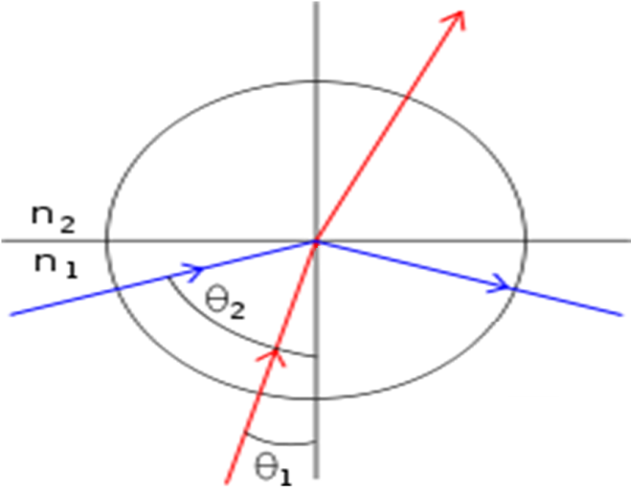

Figure 3.1: Total Internal Reflection [75]

The two media used in Han's system are air and acrylic. Since there is a significant difference between the refractive index of the acrylic and air, the light gets reflected internally, continuously, within the acrylic. Han systematically placed infrared light emitting diodes (IR LEDs) at the edges of the acrylic, making the IR light reflect internally through the acrylic. If a material that has a higher refractive index than acrylic comes into contact with it (a finger), the internally reflected light escapes from its normally reflected path and is refracted. The refracted light results in a blob of IR light were a touch has occurred. Han used this sensing technique in a functional multi-touch system. The system used IR LEDs together with an IR camera to sense interactions.

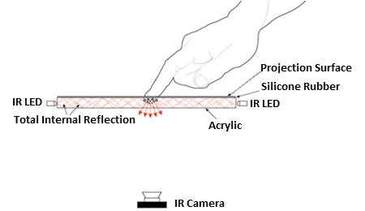

Figure 3.2: Frustrated Total Internal Reflection [76]

He further states that dry skin generates weaker blobs of IR light than greasy or wet fingertips. Dry fingertips can compensate for the poor generation of IR blobs by pressing harder on the surface. Han suggested a solution to this problem as a compliant surface overlay. The purpose of the compliant surface overlay is to mimic the properties of oily skin. Ahsanullah et al. [77] describe the compliant surface as a silicone rubber sheet which makes the system more resilient and incorporates good coupling between the finger contact and the acrylic sheet. Moore et al. [76] describe the compliant surface overlay with the more generic term of it acting as a proxy which triggers the FTIR effect when it is pressed, and when it is depressed, the FTIR effect does not occur. Han [73] writes about the compliant surface overlay used in his system as the "Rosco Gray" rear projection material. This material had a dual purpose in his system. It acts as the compliant surface overlay and also as the projection screen.

#### 3.2.1.2 Inverted Frustrated Total Internal Reflection

Echtler et al. [78] present their novel take on FTIR multi-touch sensing. They developed the inverted frustrated total internal reflection (IFTIR) multi-touch sensing technique. This sensing technique can add multi-touch sensing capabilities to an existing LCD display. The system consists of an acrylic sheet, IR LEDs, IR camera and the existing LCD display. In this case, the IR camera is placed in front of the screen unlike an FTIR multi-touch system where the camera is placed behind the touch surface. The acrylic touch surface is placed over the LCD panel with the IR LEDs positioned along the edges of the acrylic sheet, similar to Han's touch setup. The light behaves the same way, reflecting internally until a finger comes into contact with the surface. When the IR light is refracted, it is reflected by the LCD panel and back towards the camera. Echtler et al. [78] state that the human finger is not completely opaque; some transmissions of red light and IR light pass through it. IR cameras can then sense the IR light which is being produced around the finger and also the IR light being transmitted through the finger. The main benefit of this technique is that there is no space required behind the screen needed for the camera, resulting in a thin setup.

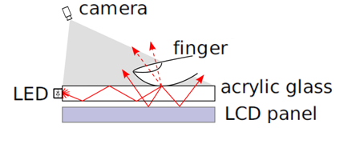

Figure 3.3: Inverted Frustrated Total Internal Reflection [78]

#### 3.2.1.3 Diffuse Illumination

Diffuse illumination (DI) is a multi-touch sensing technique in which IR light radiates from behind the touch-screen [79]. A diffuser material is placed either above or underneath the touch surface. A diffuser is a material which scatters light and provides a softer light [80]. Part of the IR light is reflected by the diffuser while the rest will pass through the diffuser. When objects are close to or touch the surface, they reflect more light than the diffuser material does by itself, although this depends heavily on the diffuser [81]. Sheikh et al. describe that the performance of a DI system relies heavily on the diffuser material; if too much light is absorbed by the diffuser, the contrast between interactions with the surface and surface will be low, making it difficult to detect interactions [82]. The IR reflections of objects can then be read in by a computer vision system and interactions with the surface can be detected. This sensing method has been used in various projects [83, 84], including the commercial multi-touch table, Microsoft Surface 1.0 [70].

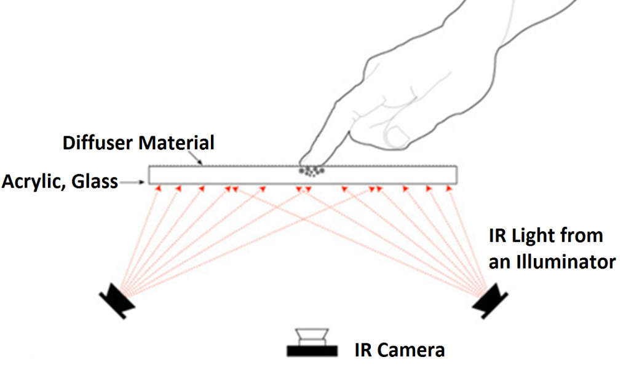

Figure 3.4: Diffuse Illumination [76]

Rong et al. describe DI systems as 'seeing' systems [79]. The processing pipeline involved in a DI system is more complex. The main disadvantage to DI systems is that they require more complex image processing in comparison to FTIR systems [79].

One limitation associated with DI sensing was recognised by Augsten et al [68]. They noticed that dark objects would not get recognised while lightly coloured objects would get recognised. This was due to dark objects absorbing IR light while lightly coloured objects would reflect IR light. Although, this was seen as a limitation in their research, other studies have taken advantage of this and have created DI systems which read interactions with finger presses and also interactions with optical tags, known as fiduciary markers or fiducials [84].

A problem associated with this sensing technology is the difficulty in achieving even illumination across the screen; this results in portions of the screen being unresponsive portions of the screen [76]. The diffuse surface illumination multi-touch sensing technology provides an elegant solution to remove this problem; it is discussed in the following section.

#### 3.2.1.4 Diffuse Surface Illumination

Diffuse surface illumination (DSI) is a camera-based multi-touch sensing technique which uses IR LEDs together with a particular type of plastic [85]. This plastic material is a speciality product according to Moore et al. [76]. An example of this material is EndLighten by plastics company, Evonik. This plastic sheet contains light-diffusing micro-particles which act like small mirrors within the plastic. For DSI setups, IR LEDs are positioned around the edges of the material and shined into its edges, similar to an FTIR system. When IR shines into the edges of the material, the light is distributed evenly across the surface, giving results similar to the DI sensing technique; this is shown in Figure 3.5.

#### 

Figure 3.5: Diffuse Surface Illumination [76]

#### 3.2.1.5 Laser Light Plane

Moore et al. [76] describe the laser light plane (LLP) multi-touch technology. This technology consists of IR lasers being positioned just above the touch surface. The lasers are passed through a line generating lens, creating a laser light plane over the surface. When an object, such as a user's finger breaks the plane by touching the screen, the resulting laser light gets scattered at the tip of the finger. Computer vision software systems can then recognise the scattered light, resulting in touch detection.

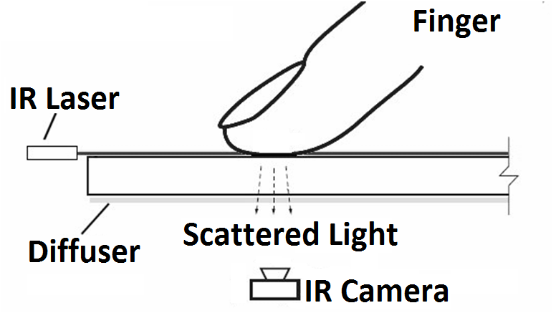

Figure 3.6: Laser Light Plane [76]

### 3.2.2 Sensor-Based Multi-Touch Systems

Sensor based multi-touch surfaces tend to be more complex and are harder to implement without the use of professional fabrication equipment. This type of touch sensing allows the form factor of the device to be generally thinner than camera based multi-touch systems. The use of sensors can limit the number of simultaneous track points compared to camera-based multi-touch sensing. Sensor-based touch sensing is used in commercial products such as mobile phones and tablet computers.

The new version of Microsoft Surface, Surface 2.0 moved away from the computer vision sensing technique. Surface 2.0 incorporates the PixelSense technology [86]. PixelSense is a sensor-based multi-touch system. PixelSense technology can be used to sense up to 50 simultaneous touch points. This technology allows the tabletop to now have just a 4 inch depth whereas the previous camera based version of Surface, Surface 1.0 had a depth of 22 inches [87].

#### 3.2.2.1 Resistive Touch Sensing

Schöning et al. [85] describe the resistance based touch screens. These touch-screens consist of two layers of conductive material which is separated by an insulating layer that is typically made of silicone dots; this can be seen in Figure 3.7.

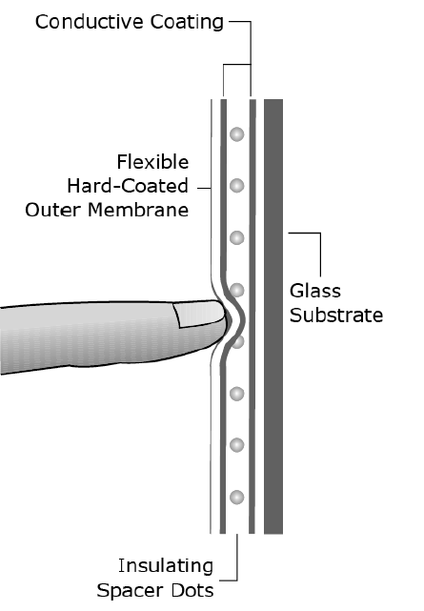

Figure 3.7: Resistive Touch Screen Layout [85]

The two conductive layers create a connection when the screen is pressed, generating a voltage. Downs [88] explains this functionality in more detail as typically a four wire resistive architectures; as seen in Figure 3.8. Voltage is applied across the screen in the y-axis; when the screen is touched, the layers touch together and the voltage can be read off the x-axis. The readings are then processed by an analog to digital converter (ADC) and processed by software to detect touch events.

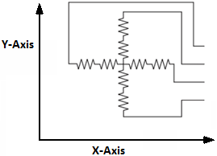

Figure 3.8: Resistive Touch Screen Circuit [88]

#### 3.2.2.2 Capacitive Touch Sensing

Capacitive touch sensing is the de facto standard in small screen consumer electronics. The most famous example of a capacitive touch screen is the Apple iPhone. The touch surface consists of an insulator such as glass. This insulating material is then coated with a transparent conductor such as indium tin oxide [85]. Moeller and Kerne describe a capacitive touch-screen sensor as a two-dimensional network of capacitors. Touching the surface changes the capacitance of the network around the touch point. The voltage is then analysed and the x and y position of the touch event is then calculated [89].

Although capacitive screens are reliable and durable, there are also some limitations of the technology. The number of simultaneous touch points which can be detected on a capacitive screen can be limited [85]. Capacitive multi-touch screens cannot be made in large form factors due to the resistive properties of indium tin oxide [89].

#### 3.2.2.3 Scanning Frustrated Total Internal Reflection

Moeller and Kerne [89] present a novel multi-touch sensing technology known as scanning frustrated total internal reflection (SFTIR). This concept is an application of FTIR multi-touch sensing [73]. SFTIR systems add multi-touch functionality to an already existing LCD display. A typical SFTIR system uses a linear array of IR sources and IR sensors placed along the edges of an acrylic sheet. The IR source is shined directly inside the acrylic sheet, making it reflect internally. Due to the large amount of IR light getting reflected internally, the corresponding IR sensor generates a large photocurrent. When a touch interaction occurs on the surface of the acrylic, the internally reflected light's path gets disturbed, causing the sensor to generate a weak photocurrent; this is demonstrated in Figure 3.9.

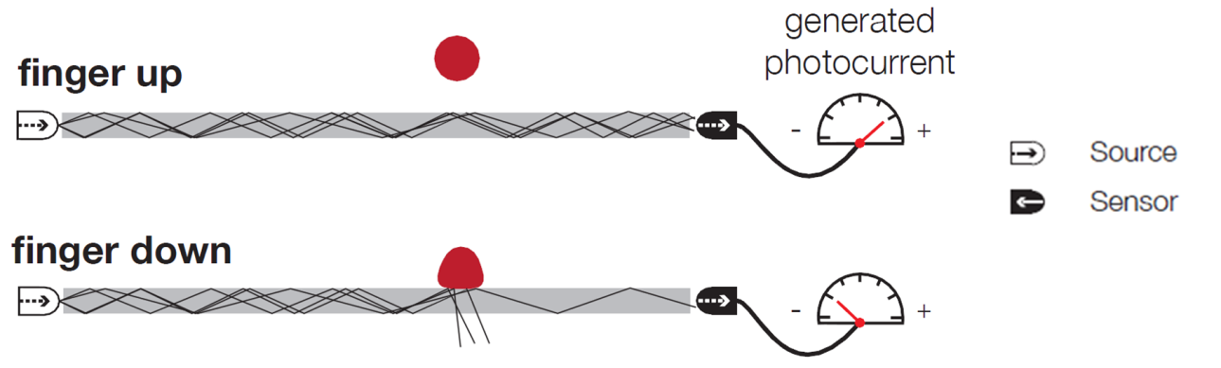

Figure 3.9: Generated Photocurrent from FTIR [89]

The layout of a SFTIR system consists of IR sources placed along one horizontal side and one vertical side of the acrylic; the corresponding IR sensors are placed on the opposite horizontal and vertical sides; as seen in Figure 3.10. The scanning area can then be thought of as a two dimensional grid with horizontal and vertical scan lines. Each cell in the grid has associated vertical and horizontal scan lines. The system iteratively switches on an IR source both horizontally and vertically, and then takes a reading from the corresponding sensors. It progresses through all the cells in the grid until the scan is complete.

After each sensor in the array has been sampled, a two dimensional greyscale image can then be constructed from all the cell readings. The constructed greyscale image can then be sent to touch detection software to extract touch events. Limitations of this technique are the scanning times and sampling times of the system; larger screen sizes would require more sensors which would result in longer scan times and could be problematic to performance of the touch system.

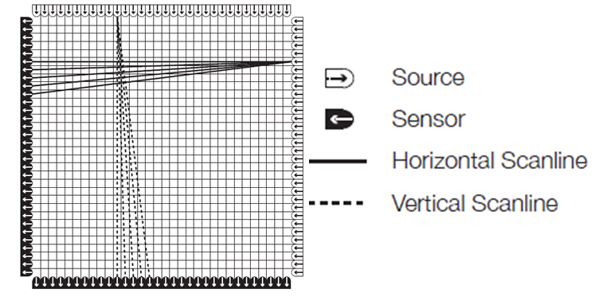

Figure 3.10: SFTIR Scan Operation [89]

#### 3.2.2.4 ThinSight

Izadi et al. [90] discuss their multi-touch system named ThinSight. This system uses a two dimensional grid of IR optical sensors known as retro-reflective optosensors. These sensors consist of both an IR light emitter and an IR light detector. The grid of optosensors is placed behind an LCD panel. LCD panels are quite transparent, allowing the emitted IR light to pass through the panel. Placing an object such as a finger tip in front of the LCD panel reflects the IR light, allowing the IR light detector to sense the reflected light; this is shown in Figure 3.11.

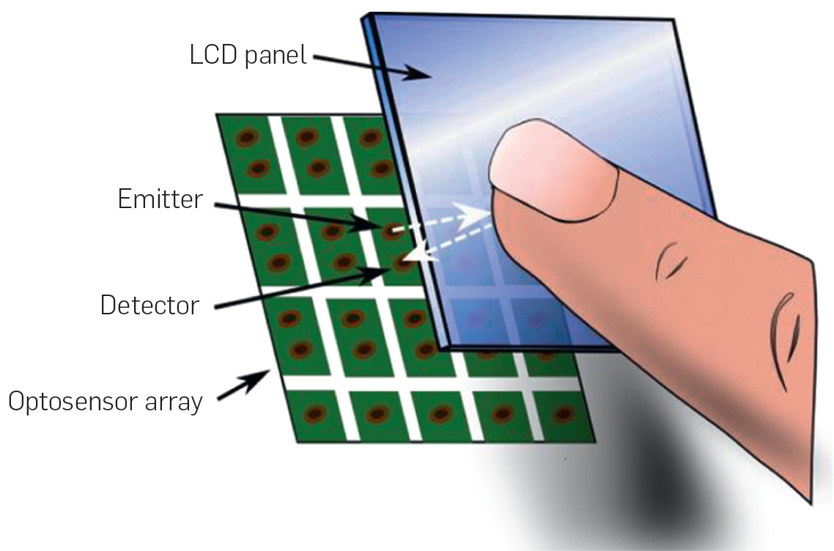

Figure 3.11: ThinSight Setup [90]

The IR light detector produces an analog voltage; each of the voltages from the sensors on the grid can be combined to produce a two dimensional greyscale image. The resolution of the produced greyscale image depends on the number of optosensors incorporated into the grid. This greyscale image can then be used by computer vision programs to recognise touch events. Since the system uses IR light, it may detect IR signal produced by other devices, allowing for remote control of the system. Due to the thickness of the optosensors, the form factor of the multi-touch device can be quite thin. However, the power needed to operate the optosensors and LCD makes this type of sensing unsuitable for mobile devices. PixelSense technology, the technology behind Microsoft Surface 2.0, is believed to be based on ThinSight technology [91].

#### 3.2.2.5 LED-Based Multi-touch

Echtler et al. developed a novel multi-touch sensor by using a matrix of LEDs [92]. Since this method uses LEDs, it is relatively inexpensive. This approach uses a grid of LEDs which act as both emitters and detectors. According to Echtler et al., LEDs can be used not only as light emitters, but also as light detectors; they further state that this practice is not commonly used [92]. Their LED sensing approach is similar to ThinSight [90], where a matrix of LEDs is positioned behind the LCD panel. The LEDs are then aimed out towards the user, through the LCD panel. The matrix is then scanned to detect touch events. During a typical scan cycle, an LED emits light while a corresponding LED is sampled. The results from the scan are then combined to create a greyscale image. This image can then be analysed by software to detect touch events.

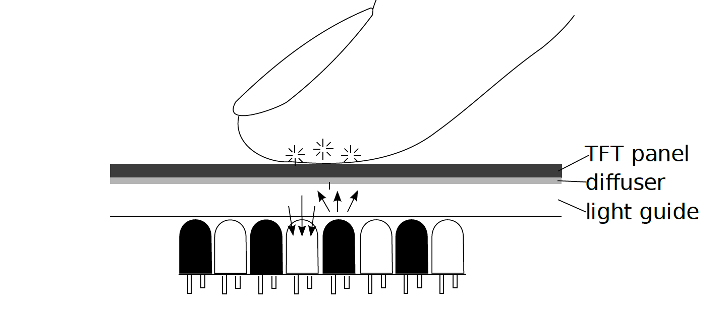

Figure 3.12: LED Based Multi-touch sensing [92]

#### 3.2.2.6 DiamondTouch

DiamondTouch [93] is a multi-user touch system which allows multiple users to interact with the touch surface simultaneously while not interfering with other users. It achieves this by individually identifying different users who interact with the system. A typical DiamondTouch setup consists of a projector, transmitter, multiple receivers and a computer; this is displayed in Figure 3.13.

Receivers are built into chairs and the transmitter is embedded into the touch surface. DiamondTouch identifies individual interactions by transmitting unique electrical signals to different parts of the table. When a user touches the surface, signals are capacitively coupled from the transmitter (touch surface), through the user and into the receiver (chair).

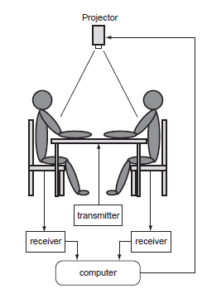

Figure 3.13: Diamond Touch System Setup [93]

## 3.3 Summary

This chapter reviewed the state of the art in multi-touch technology, in particular, multi-touch sensing. It examines both camera-based and sensor-based multi-touch sensing techniques. The next chapter discusses the approach used in conducting the research, including the research methodologies used throughout the research.

# CHAPTER 4: RESEARCH METHODS

## 4.1 Introduction

This chapter outlines the approach and methods used in the research. The research hypothesis asserts that large multi-touch surfaces offer potential benefits for elderly people, suffering with dementia, in the areas of leisure, reminiscence and creative activity thereby delivering a higher quality of life.

The principle aim of this project was to assess the suitability of using recreational applications, running on large multi-touch surfaces, as systems capable of offering an engaging, enjoyable and rewarding experience for dementia sufferers. This chapter outlines the approach taken to answering these questions.

The research methods were:

* Conduct a comprehensive literature and technology review.
* Design and develop a hardware solution for a large scale multi-touch system suitable for dementia sufferers.
* Design and develop multi-touch software solutions, specifically, a range of recreational software applications for dementia sufferers.
* Get ethical approval for the research.
* Conduct a pilot study in an Irish hospital geriatric ward.
* Gather data from the system while it is being used.
* Use collected data to assess the research, and provide answers to the research question.

These methods proved to be a sufficient way to tackle the research aim. An in-depth explanation of the objectives is described in the following sections.

## 4.2 Developing a Hardware Solution

A hardware solution with multi-touch capabilities was required for the system. Various multi-touch form factors were discussed with the consultant geriatrician for the research; from hand held tablet multi-touch devices to larger table size multi-touch devices. The consultant geriatrician felt that smaller multi-touch form factors would not be suitable for the research, including multi-touch tablets and multi-touch mobile phones. The consultant noted that small devices such as, remote controls for television sets are lost or misplaced around geriatric wards. Typically this is due to the symptoms of dementia. Also, it was believed that small multi-touch devices, such as multi-touch tablets, were quite fragile and could be easily damaged if they were used in a pilot study.

It was suggested that a larger, more robust multi-touch surface would be created for the research. A large form factor, multi-touch device was identified as a suitable multi-touch form factor for the research project. This led to various large scale multi-touch devices being researched and evaluated. The device needed a high level of robustness. It was decided that a table sized multi-touch surface would be suitable for the research. Potential multi-touch table systems were investigated, such as, Microsoft Surface. However, the high cost of the system made it unsuitable.

For these reasons, a low-cost, custom-made multi-touch system was chosen as the most suitable hardware solution. It was felt that the system could be developed from common components for a fraction of the price of the commercial equivalent.

## 4.3 Developing a Software Solution

A software solution providing recreational activities for people with dementia was required. To successfully design and develop usable software for dementia sufferers, hospital staff should be consulted and involved during the design and development stage. It has been shown that using a multi-disciplinary design team can lead to effective system design for people suffering with dementia [13].

However, there was very limited access to hospital staff for the design and development phase. It was decided, in consultation with the geriatrician, that a prototype software system should be developed in the first instance. A range of software applications, demonstrating the features the system would be developed. Since the design would not actively involve the hospital staff, the design and development of software system would be guided by referring to the literature and the geriatrician.

A suite of recreational activities was designed and developed specifically for the research. The applications were designed to be easy to use and also to provide an engaging creative platform for dementia sufferers. The suite of activities included:

* An artistic painting activity
* A musical activity
* A reminiscence activity
* A computer game
* A reaction test activity

The choice of activities followed those that have been widely accepted in dementia care [13-15, 28, 37, 38, 43]. A reaction test application was suggested by the consultant geriatrician as potentially beneficial to a patient's abilities to react to visual and auditory stimulus.

## 4.4 Acquiring Ethical Approval

The research required patient participants for the study; therefore, ethical approval was required before the research commenced. Obtaining ethical approval required completion and submission of an ethical approval application to the Galway University Hospitals Research Ethics Committee. Obtaining approval took a considerable amount of time and energy.

The application consisted of a form with various questions regarding the research project, including, the research background, research aims and objectives, and also highlighting any hazards which could occur to research participants from participating in the research study. There were other questions concerning the nature of data being collected, and also how the data was to be collected and stored throughout and after the study. Other information regarding the research project was also submitted, including, a research proposal, information sheets about the study, consent forms to potential participants and their next of kin, recruitment information, and questionnaires. Once the ethical approval application was completed, it was submitted to the Galway Hospitals Research Ethics Committee board for review and was subsequently given ethical approval by the Research Ethics Committee.

## 4.5 Conducting a Pilot Study

The pilot study was seen as a suitable method of gathering data for the research. Other studies have successfully collected data from dementia sufferers by carrying out pilot studies with prototype systems [14, 17].

Identification of a potential site for the pilot study was done in consultation with the geriatrician. A geriatric ward day-hall in Merlin Park Hospital, Galway was chosen as a suitable location for the research. The site had open access between the hours of 9:00 to 17:00. However, access to hospital staff with regards to the research project was limited.

Choosing a suitable sample size is an important factor when performing research. Riley et al. conducted a study on people with dementia with computer-based musical activities. They used 10 participants who were suffering with dementia in their study; this number proved to be a large enough dataset to provide a suitable conclusion for their research [14]. Other studies have shown that eighteen people can be a suitable dataset for researching computerised recreational activities [1]. Itwas estimated that there would be ten to fourteen people recruited in the pilot study. This would be a large enough dataset to provide a sufficient conclusion.

A method of recruiting participants for the pilot study was suggested by the consultant geriatrician; hospital staff would identify and recruit potential candidates. The inclusion criteria of participants required them to have been diagnosed with a form of dementia or other disability relating from old age.

Prior to participating in the study, patients were approached with information about the research. This was used to inform them about the study, what information was being gathered and if there were any potential hazards when participating in the research study. Participating in the study required the patient to complete consent forms before they could participate in the study. If the patient was unable to provide their own consent, the patient's next of kin was approached on the patient's behalf.

The prototype system was installed in a day-hall where patients could interact with the system at any time. Although some studies have used a structured approach to allowing patients interact with a system through pre-planned session, it has been shown that providing open access to a system is also a suitable approach and allows large amounts of data to be collected [49].

## 4.6 Collecting Data

Evaluating the system was facilitated by collecting data throughout the course of the pilot study. Both qualitative and quantitative data were collected through different means throughout the study in an effort to evaluate the system more effectively by combining and correlating the results.

An automatic quantitative data collection facility was built and embedded into the multi-touch system. This facility recorded usage statistics. Other studies have noted that observational protocols, using video recorders are useful for documenting users' behaviours [13, 14, 28]. However, these studies involved data gathering sessions being structured and pre-planned.

Allowing open access to a system and collecting data unobtrusively by a system has proven to be a useful method of gathering user data, especially over long periods of time [49]. Observing users through protocols was considered to be an invasive protocol. A less invasive approach was chosen and the system automatically recorded user interactions as they interacted with the system. This was achieved through the system gathering data unobtrusively.

Logging users' behaviour alone was not sufficient to access the users' enjoyment of using the system. Qualitative data was collected through questionnaires. The questionnaires were completed by the research participants.

The questionnaires contained both open-ended questions and close-ended questions. Close-ended questionnaires have proven to be useful in studies when gathering data from the user about their enjoyment of a system [14]. The questionnaires were designed to record the users' while using enjoyment from directly using the system.

The questionnaire and the questions within it were kept brief because of the factors related to dementia and recall. Close ended questionnaires provide qualitative data but in a quantitative form. This allowed statistics to be generated about the benefits of the system. Open-ended questionnaires allow the patients to elaborate further on their answers given in the close-ended questionnaire.

Interviews were conducted with various hospital staff and hospital departments, including:

* The art therapist
* The nursing department
* The occupational therapy department
* The physiotherapy department

Studies have shown that consulting with various disciplines proves to be effective for developing recreational computer based activities for people with dementia [13, 15]. The purpose of the interviews was to receive feedback with regards to hardware and software design. Other topics included the perceived enjoyment of the patients' using the system and any possible improvements which could be made to the system.

It has been shown that observational protocols have been beneficial in other studies [13, 14, 28], for this reason, the researcher's observations throughout the pilot study were also used to analyse the system.

## 4.7 Data Analysis

The hypothesis of the research was that large interactive multi-touch surfaces offer potential benefits to dementia sufferers by providing engaging and enjoyable experiences through recreational activities. Data was collected through different means throughout the pilot study. To assess and evaluate the multi-touch system, the collected qualitative and quantitative data from the pilot study was correlated together to derive a suitable conclusion.

The automatically gathered usage data was used to assess the system in various ways. Each software activity was analysed and assessed in terms of engagement and popularity. The engagement level of an activity was assessed by analysing how long the patients spent using the particular activity. The usage data was also used to assess the popularity of each activity by counting each time an individual activity was used. Finally, the usage data was used to generate heat-maps to provide a visual two-dimensional visual representation of the screen usage. Heat-maps were used to determine which areas of the screen were used and why. They were also used to assess if some sections of the screen were redundant.

Qualitative data was gathered through the use of questionnaires throughout the pilot study. Although qualitative data was gathered by the questionnaires, the questionnaires were analysed in a quantitative manner. The data collected was used to see how many people enjoyed using the system.

## 4.8 Summary

This chapter provided an insight into the methods used in the research. The following chapter presents the design and development of a system that delivers the principal aim of the project, namely a large multi-touch surface offering engaging, enjoyable and rewarding experiences for dementia sufferers.

# CHAPTER 5: SYSTEM DESIGN AND DEVELOPMENT

## 5.1 Introduction

Following discussions with the geriatric hospital consultant, a large form factor, multi-touch device was identified as a suitable multi-touch form factor for the research project. Consumer orientated devices were considered too fragile for deployment in the geriatric ward; damage could easily occur, from a fall or liquid spilling on the device. The device needed a high level of robustness. A table sized multi-touch surface was considered suitable for the research.

Potential commercial multi-touch table systems were investigated. This included Microsoft Surface [70]. However, the high cost of the system made it unsuitable.

A low-cost, custom-made multi-touch system was chosen as the most suitable hardware solution. It was felt that the system could be developed from common components for a fraction of the price of the commercial equivalent.

This chapter describes the design and development of a prototype multi-touch system with a suite of recreational activities for people with dementia.

## 

## 5.2 Requirements

The agreed requirements of the system were as follows:

* A robust large scale multi-touch hardware solution, suitable for dementia sufferers.
* A suite of recreational multi-touch activities for people with dementia.

## 5.3 Hardware Design

The hardware design was broken into three distinct technology independent components, including:

* a multi-touch sensor unit (MSU)
* a central processing unit (CPU)
* a visual display unit (VDU)

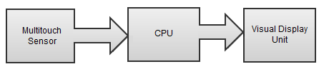

Figure 5.1: Multi-touch Component Interaction

Multi-touch sensor units are devices which sense multi-touch interactions with the touch surface. Typically, these are camera based or sensor based systems. Many of these technologies were reviewed in Chapter 3: Multi-touch Technology Review.

The central processing unit is the main processing unit for a multi-touch device. This will compute data being received by the multi-touch sensor unit, process the data, and then update the visual feedback to the user via the visual display unit. The interaction between the MSU, CPU and VDU is shown in Figure 5.1.

Visual display units are devices which provide visual feedback to the user. Projectors and LCD panels are common visual display units. LCD panels are more fragile and restrict the size of the multi-touch screen to the size of the LCD panel. Projectors are more flexible since the size of the screen can be varied by positioning the projector closer or further away from the projection surface. Projectors are suitable for multi-touch surfaces since interaction is done with the projection surface and not the projector itself. One of the requirements of the multi-touch system was that it needed to be robust; a projector met this requirement.

The system was designed in the form factor of a multi-touch table. It was expected that this would provide a more immersive experience for the end user.

## 5.4 Ergonomics

There are various ergonomic considerations to be taken into account when designing large scale multi-touch surfaces. Both the distance of the screen from the ground and the screen orientation play major roles in the interaction with large scale multi-touch systems. The screen could be orientated vertically or horizontally at an angle. There are advantages and disadvantages of orientating a touch-screen at certain angles. Interacting with vertically orientated touch-screens can lead to fatigue in the user's arms due to the arm being extended for long periods of time [51]. Horizontally orientated touch-screens could lead to neck pain when looking down on a screen for long periods of time [94]. Dix et al. [51] comment on the optimal angle for the orientation of a touch-screen (15 degrees from the horizontal). For this reason, the orientation of the touch surface of the multi-touch system was made approximately 15 degrees from the horizontal.

## 

Figure 5.2: Multi-touch Screen Design

## 5.5 Hardware Development

Initially, the FTIR technology was used to detect interactions with the multi-touch surface. Tests with FTIR sensing showed that it is difficult to implement a good quality silicone compliant surface. The compliant surface, discussed in Chapter 3, would require the user to press excessively on the surface before the touch event would be recognised. The excessive force required to generate touch events would eventually lead to fatigue in the users' hands. The FTIR sensing approach was abandoned and an alternative approach, which would trigger events with zero-force, was adopted.

A diffuse illumination multi-touch sensing system was implemented by the researcher. The sensing method used IR emitters and IR cameras to detect interactions with the surface. The components used in the diffuse illumination system are shown in Figure 5.3. Visual feedback was displayed to the user via a projector and on-screen mounted rear projection material.

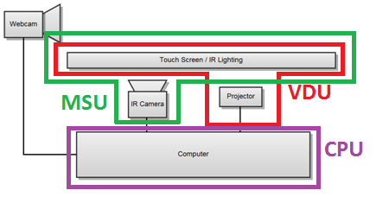

Figure 5.3: Multi-touch Hardware Solution

A wooden framework was developed for the multi-touch system. The purpose of the framework was threefold;

* Firstly, to act as a frame to support the polycarbonate screen
* Secondly, to hide all the inner components of the touch system from the user
* Thirdly, to prevent infrared light from escaping from the framework; essential for diffuse illumination systems.

The completed multi-touch frame is presented in Figure 5.4.

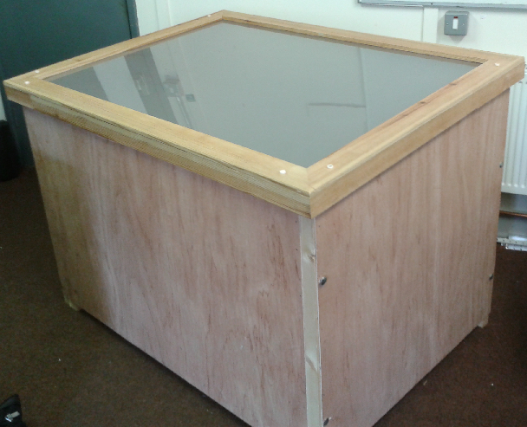

Figure 5.4: Multi-touch Frame

Appendix C provides an in-depth account of the multi-touch hardware construction process.

## 5.6 Interaction Design

Interaction design is an important factor to consider when designing multi-touch applications. There are various questions which could be asked about the interface. How will the user interact with the system? Is it intuitive?

Since the chosen interface was touch-based, interacting with the system would involve users directly touching the touch surface. However, touch-screen interfaces can facilitate various types of touch gestures. These gestures can help the users to carry out different tasks.

There are many gestures which could be used to interact with multi-touch systems. However, dementia sufferers may have difficulties remembering performing complex gestures; for this reason, only a few simple gestures were chosen as interaction mechanisms with the touch surface. Simple manual and bimanual gestures were incorporated into the interaction design. Table 5.1 presents the gestures which the system recognised.

|  |  |  |
| --- | --- | --- |
| Tap | A tap gesture involves the user touching the touch surface briefly and removing their finger from the touch surface in one swift motion. |  |
| Drag | A drag gesture involves the user to place a finger on the touch surface and move it in a certain direction while keeping their finger pressed on the surface. |  |
| Enlarge | An enlarge gesture involves the user to place two fingers on a widget. To perform the enlargement operation, the user then needs to move drag their fingers in opposite directions. |  |

|  |  |  |
| --- | --- | --- |
| Shrink | A shrink gesture is used to shrink a widget. Performing the gesture is similar to the enlargement operation, where two fingers are placed on a widget. The user is required to drag their fingers towards each other to perform the gesture. |  |
| Rotate | Rotating a widget can be achieved by the user performing a rotate gesture on it. Performing a rotate gesture requires the user to place two fingers on a widget. The rotate gesture requires one finger to be used as a pivot point while moving the other finger controls the rotation. |  |

Table 5.1: Interaction Gestures. Images courtesy of [95]

## 5.7 Software Design and Development

A suite of activities had to be developed to help keep the user engaged with the system. Since the multi-touch system was a custom-made, camera based, solution, the Windows 7 operating system could not supply native support for the system. This presented a problem for the development of the system on the Windows 7 platform.

As a design solution to this problem, a layered software architecture was developed. The architecture contained various layers including, the multi-touch tracking software, the multi-touch framework and the multi-touch application. These layers create a robust software architecture where the layers are independent of each other. This layered architecture is presented in Figure 5.5.

#### 

Figure 5.5: Multi-touch Software Architecture

### 5.7.1 Multi-touch Software Architecture

Multi-touch tracking software detects interactions with multi-touch surfaces. Detecting multi-touch interactions was achieved by tracking IR light blobs using the IR cameras. The open source multi-touch tracking software, Community Core Vision (CCV) [96], was used in the system. An in-depth report of CCV is presented in Appendix F. When interactions are detected by the tracking software, the interaction data is sent to a multi-touch framework.

The multi-touch framework provides multi-touch events to the applications. Multi-touch for Java (MT4j) [97], a multi-touch, scene-graph framework, was selected for the multi-touch framework layer. This framework is event driven and provides intuitive mechanisms to interact with various components within the framework.

The multi-touch application layer is where the multi-touch applications run. This layer receives interaction events from the multi-touch framework. The recreational software activities developed for the research are placed in the multi-touch application layer.

In addition, a data collection layer, discussed later in the chapter, provided an interface for the system applications to store data in a database. Databases provide a simple mechanism to add, update, delete and query data. Databases can also be configured to be password protected, making the stored data more secure and only reachable to those who obtain the password. The data collection facility layer and database layer are shown in Figure 5.6.

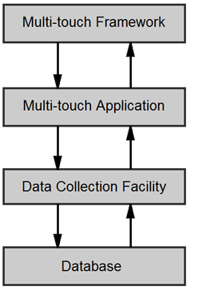

Figure 5.6: Multi-touch Application Architecture

### 5.7.2 Recreational Activity Development

Five recreational activities were developed for the system. These included a painting activity, a reminiscence activity, a music activity, a reaction test activity, and a simple game. These activities were developed using the guidelines described by Alm [1]. Alm, who states that effective user interfaces for dementia sufferers should have the following features:

* Use large fonts for text
* Use text sparingly
* Backgrounds should use muted colours, and should not be distracting
* Use an attractive design which is encouraging to dementia sufferers
* Use high contrast between text and background
* Use a simple navigational structure, ensuring that the dementia sufferer could easily navigate through all sections easily

A black background with a grey gradient was chosen as a suitable unobtrusive background colour scheme for the various activities on the system.

Simple navigational features were implemented in the system. Navigating to the various activities was done through the main menu (discussed in the next section). Returning to the main menu from the activities was achieved by the user touching the home button. This navigational feature was believed to be usable for dementia sufferers. The system's navigational behaviour is shown in Figure 5.7.

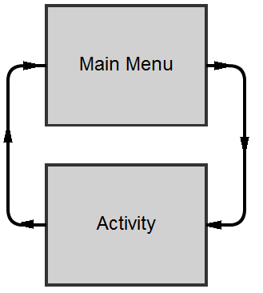

Figure 5.7: System Navigation

Each activity had a home button located at the top left hand corner of the screen. The home button displayed a home graphic, presented in Figure 5.8.



Figure 5.8: Home Button

##### Main Menu

A main menu was created which clearly, and simply, displayed all the activities available on the system. The main menu can be seen in Figure 5.9.

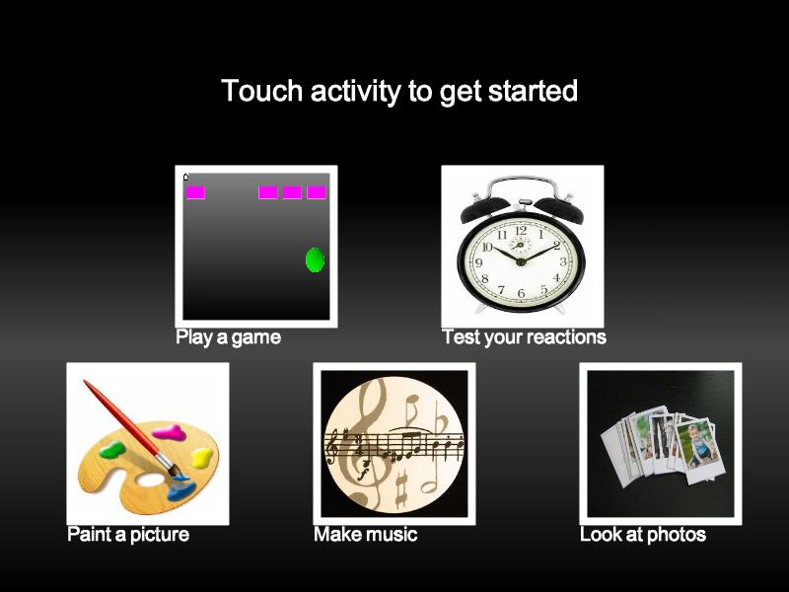

Figure 5.9: Main Menu

An instruction to the user was presented on the main menu. The instruction, "Touch activity to get started" was positioned at the top of the screen. The wording was carefully chosen so it would not be confusing or ambiguous to dementia sufferers. A study by Riley et al. [14] found that some instructions can be confusing to dementia sufferers. In their study, they prompted dementia sufferers to interact with a touch screen by using the phrase "drag your finger around the screen to play". This resulted in a dementia sufferer dragging their finger along the outer frame of the screen and not on the touch surface.

The instruction was designed to have large text for maximum impact. The colour of the instruction was white. This colour was chosen as it has high contrast with the background, making it noticeable to the user when they first see the menu.

The main menu behaved like a menu of hyperlinks. Each activity in the system had a hyperlink associated to it. This allowed users to navigate to an activity by simply tapping on its associated "picture hyperlink".

Each hyperlink contained both an image and a caption. To catch the attention of the user, the images were surrounded by white boarders. This provided a high contrast between the dark background and the images. The captions positioned underneath the images were chosen to be brief and descriptive of the activity. This simply and clearly described what each specific activity offered the user.

##### Paint activity

As discussed in the literature review, creative activities such as painting are beneficial to the well being of dementia sufferers. Painting is an existing therapy which is already used in hospitals and nursing homes. As this therapy is widely accepted, a paint activity was designed and developed for the system. The paint activity enabled dementia sufferers to express themselves creatively by painting virtual pictures.

Common computer painting applications, such as Microsoft Paint, provide a significant amount of functionality; however, a lot of this functionality was considered to be too difficult for dementia sufferers. The functionality implemented in the paint activity was deliberately limited. The functionality included, painting on the canvas, changing the paint colour, changing the stroke size and clearing the paint canvas.

The user interface of the paint activity consisted of a few simple components, including a paint canvas, colour pallet, new page button, and a slider controlling the paint stroke size. Figure 5.10 displays the design of the paint activity user interface.

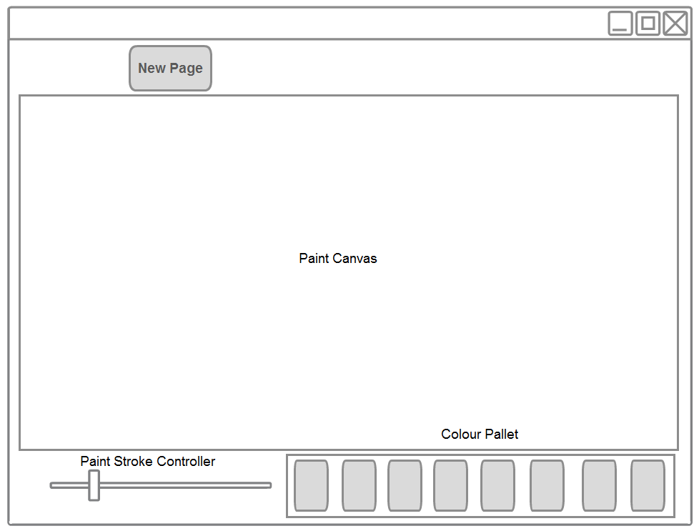

Figure 5.10: Paint Activity Interface Design

The colour pallet allowed the users to choose the colour they wished to use to paint on the screen. The pallet contained of a range of common colours. Each colour had a designated button associated with it. The paint colour was selected by simply touching the appropriate colour button. To reduce the chance of confusing the user, only one colour could be selected at a time. The currently selected colour button displayed a green rectangle surrounding it, indicating that it was selected.

The slider allowed users to change the overall size of the paint stroke. Moving the knob of the slider to the left made the size of the paint stroke smaller and moving the knob to the right made the paint stroke size larger. The slider was believed to be the most suitable solution to controlling the paint stroke size.

The new page button offered the user the choice to clear the paint canvas. The new page button was presented to the user with just the graphic of a blank page. When the user presses the new page button, the paint canvas is cleared.

Laying out the user interface was an important task which was carefully considered. The large paint canvas was positioned in the centre of the interface and occupied most of the screen. This provided a large enough surface for the dementia sufferer to express themselves creatively.

The colour pallet and slider were expected to be commonly used during the activity. These were deliberately positioned at the bottom of the screen where the user had fast and easy access to them. However, studies have found that placing widgets at the bottom of the screen can lead to accidental presses by dementia sufferers [14]. In the case of this study, accidentally pressing the colour pallet or slider did not appear to confuse or frustrate the users.

The new page button was located at the top of the screen. It was positioned there so accidental button presses would not be likely to occur. The user would need to intentionally reach out and tap the button to clear the canvas. If the new page button was positioned at the bottom of the screen, accidental button presses could cause the paint canvas to clear. This behaviour could have caused confusion or frustration to the user. The implemented paint activity is displayed in Figure 5.11.

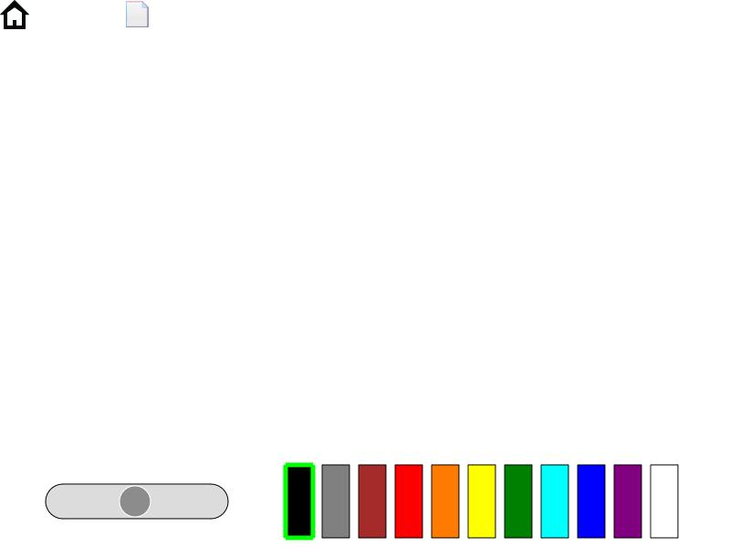

Figure 5.11: Implemented Paint Activity User Interface

Simple gestures were used to interact with the components positioned throughout the paint activity. Painting was achieved by the user dragging their finger across the paint canvas. Tap gestures were used to select specific colours from the colour pallet. Clearing the paint canvas was achieved by tapping on the new page button. Interacting with the paint application was analogous to finger painting; the user dips their finger into a paint colour by using a tap gesture and then paints on the canvas by dragging their finger across the canvas.

When an interaction with the canvas was detected, an event was triggered. The event firstly set the colour and size of the stroke which is about to be painted. The stroke was then painted on the paint canvas. Finally, the interaction with the paint canvas was logged by the system's data collection facility. This behaviour is displayed in Figure 5.12.

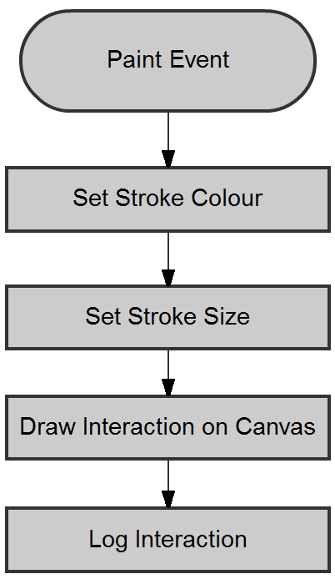

Figure 5.12: Paint Event Functionality

Typically the user accepted the default stroke size and the default colour and began painting immediately.

##### Music Activity

The music activity allowed users to express themselves creatively by playing music. However, not all people know how to play a musical instrument. The music activity was designed to only include notes which are part of the same chord, the author believes this makes it easier for people who are not musically trained to develop melodies.

A musical widget was created for the system. The widget was designed to be both easy to use and intuitive. A "grid" of notes was developed. The cells in the grid were coloured white, providing maximum contrast between the background and the cells in the grid. Playing a note was achieved by simply touching a cell in the grid. Once the cell was touched, the cell would change colour and the note for that cell was played. This made the experience both visually and aurally appealing. Sustaining the musical note required the user to keep their finger pressed on the cell, similar to the way an electronic piano behaves. The user interface of the music activity is shown in Figure 5.13.



Figure 5.13: Music Activity Interface

A 4x4 grid of notes was developed to allow the user to play music. The onboard Musical Instrument Digital Interface (MIDI) system was used to generate musical notes. Each cell in the grid represented a single note. The first column of cells represented the chord notes in the first octave; the second column of cells represented the chord notes in the second octave, etc. Each column contained the notes, E, G, B and C#; which are from the chord, C#m7 b5. The note value increased depending on the vertical position in the grid e.g. cells positioned at the bottom of the grid have a lower note value than squares positioned higher in the grid. All note values in the grid are displayed in the table below.

|  |  |  |  |
| --- | --- | --- | --- |
| Octave 1 | Octave 2 | Octave 3 | Octave 4 |
| C# | C# | C# | C# |
| B | B | B | B |
| G | G | G | G |
| E | E | E | E |

Table 5.2: Music Grid Note Structure

There were various Java classes used in creating the music activity. These included the *MusicActivity*, *MusicGrid*, *MidiSynthesizer*, and *MTKey* classes. *MusicActivity* presented the music activity to the user. The *MusicActivity* displayed a blank canvas as well as the *MusicGrid*, a widget which encapsulated the 4x4 grid of notes. Each note was modelled by the *MTKey* class. *MTKey* consisted of a unique note value and also had access to the *MidiSythesizer*, an interface to the MIDI system. This class structure is presented in Figure 5.14.

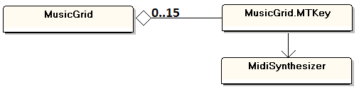

Figure 5.14: Music Activity Class Diagram

The *MTKey* was designed to trigger an event when it was pressed. When the *MTKey* triggers an event, the colour of the *MTKey* is changed to blue. The interaction with the *MTKey* is then logged and the note's time to live value is set. The time to live value was used to specify how long the note would be played for. Finally, the *MidiSynthesizer* plays the note until the time to live value reaches zero. This behaviour is displayed in Figure 5.15.

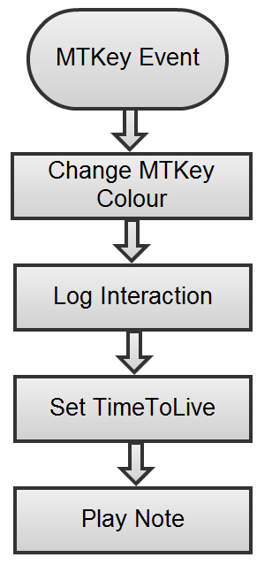

Figure 5.15: MTKey Event Behaviour

Each *MTKey* was updated every frame, the purpose of this was to decrement the time to live value. When the time to live reached zero, the associated note with the *MTKey* was stopped and the colour of the *MTKey* was changed to white, indicating it was not active. This behaviour is presented in Figure 5.15.

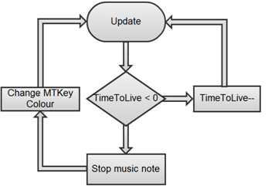

Figure 5.16: MTKey Update Functionality

##### Game activity

It is clear from the literature review that computer gaming has potential benefits for elderly people and can help improve their quality of life [49, 50]. After reviewing these benefits, a game activity was chosen to be included within the recreational activity suite. A simple bouncing ball game was seen as a suitable activity. The aim of the game was to get the user to drag a ball and release it at speed directing it against a row of blocks located at the top of the screen.

The game was intentionally simple so it would not cause difficulties for dementia sufferers. The layout of the game was also kept simple. To prevent confusion, only the necessary objects were displayed on the screen. The user interface of the game activity is shown in Figure 5.17.

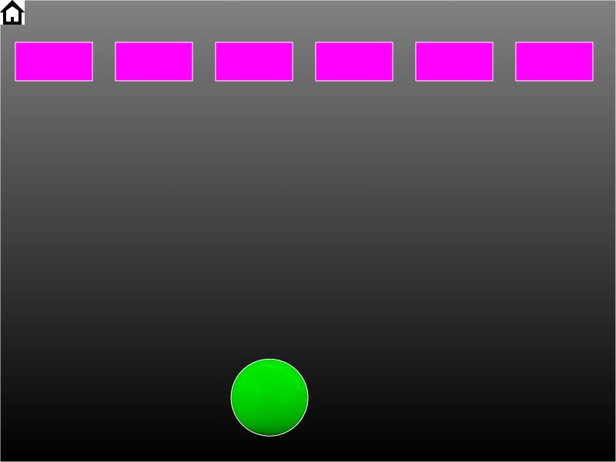

Figure 5.17: Game Activity User Interface

The game was designed so that the user could only interact directly with the ball and not with any other objects. Interacting with the ball was done through a tap and hold gesture combined with a drag gesture. Getting the ball to hit off the blocks was achieved by getting enough momentum in a drag gesture and quickly releasing the ball by the user lifting their finger from the screen.

It was decided that the movements of the ball should be restricted to the boundaries of the screen, causing less confusion to the dementia sufferer. This was achieved by creating and placing boundary shapes just to the edges of the screen. The boundaries blocked the ball from exiting the visible area of the screen. This is shown in Figure 5.18.

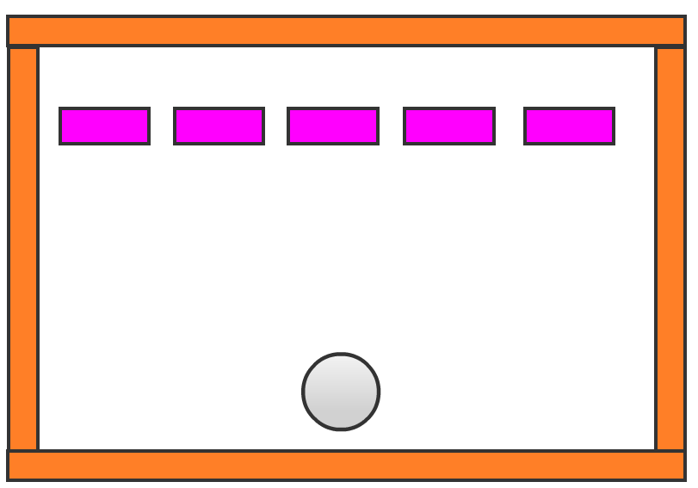

Boundary Shapes

Screen Boundary

Figure 5.18: Game Activity Layout

A downward force (akin to gravity) was applied to the ball at all times in the game. This caused the ball to continuously fall to the bottom of the screen. The force of gravity was only applied to the ball and not to the other objects in the scene, such as the blocks or the screen boundaries. This resulted in the blocks and boundaries being statically positioned throughout the game.

When a collision was detected between the ball and a block, the block was destroyed and removed from the game. The game could detect if all the blocks were destroyed. New blocks were generated when the ball was positioned towards the bottom of the screen. This method was chosen so there would be no unwanted collisions with ball and the newly generated blocks. Once all the blocks were destroyed in the game, a "game complete" message was logged. This behaviour is presented in Figure 5.19.

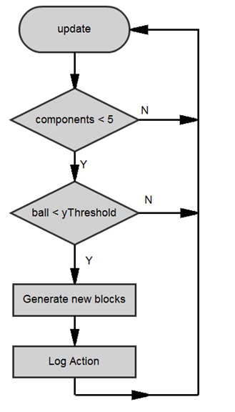

Figure 5.19: Game Activity Update Loop

To implement realistic collisions and interactions between virtual objects, a two dimensional physics engine, Box2D, was incorporated into the game. Box2D is a rigid body, two-dimensional physics engine developed by Erin Catto [98]. The engine simulates interactions between virtual objects in a virtual world and also provides a collision detection framework.

##### Reaction activity

A reaction test activity was suggested by the consultant geriatrician. This was described as potentially beneficial to elderly patients suffering from age-related disabilities. This suggestion led to the creation of the reaction activity. The purpose of the activity was to test the alertness, visual search skills and reaction time of the user through visual and auditory stimulus. The activity displayed a blank screen and at a random time, a red ellipse was displayed on the screen at an arbitrary position. Once the ellipse was displayed, an auditory cue was played to alert the user. Interacting with the ellipse was done through a tap gesture. When the ellipse was displayed, a timer was started and continued timing until the user tapped the ellipse. The reaction time was then calculated by subtracting the start time from the time of the interaction.

The user interface of the reaction activity was intentionally minimalistic, with no distracting elements in it. The colour scheme used in the activity was same as the other activities. This kept the interface consistent with the entire activity suite. The ellipse was designed to be red in colour. This gave the ellipse a large contrast to the background, making it stand out and catch the attention of the user. The user interface of the reaction activity is presented in Figure 5.20.



Figure 5.20: Reaction Activity Interface

There were various classes associated with the reaction activity. These included: *ReactionActivity*, *ReactionButton*, and *RelocateTask*. *ReactionActivity* controlled the scene and displayed it to the user. *ReactionButton* was a widget that the user interacted with. This recorded the user's reaction time when it was touched. The *RelocateTask* was responsible for positioning the *ReactionButton* at random locations around the screen.

The *ReactionButton* was positioned by the *RelocateTask*. The task was scheduled to run at random times. Positioning a *ReactionButton* on the screen at fixed intervals would not test the true reaction time of the user since they could predict when the button was about to be positioned. To stop the user from predicting this, the *ReactionButton* would appear at random times. This was achieved by generating a random number between 0 and 1. This number was then multiplied by a maximum delay, resulting in the number being between 0 and the maximum delay, as shown below.

|  |
| --- |
| *{Delay* ∈ ℝ : *0 < Delay < Delaymaximum}*  Once the value of the delay was calculated, the *RelocateTask* was scheduled to run after the delay. |

There were a number of steps required when the task was scheduled. Firstly, the task selected an arbitrary point on the screen by generating two random numbers (between 0 and 1), for x-position and for y-position. These numbers were then multiplied by the screen width and screen height, giving a random point within the confines of the screen.

When this point was calculated, the *ReactionButton* was relocated to that point. The button was then displayed on the screen, allowing the user to interact with it. A MIDI audio cue was then played to alert the user that the button was visible on the screen. The timer which records user reaction times was then started. This functionality is shown in Figure 5.21.

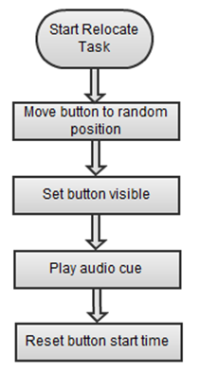

Figure 5.21: Relocate Task Functionality

After the *RelocateTask* finished executing, the user could interact with the *ReactionButton.* Once the user interacted with the *ReactionButton*, an event was generated and the reaction time was calculated. This was achieved by the following formula:

*Timereaction = Timeinteraction - Timestart*

When the reaction time was calculated, it was then logged and the *ReactionButton* was removed from the canvas. Another *RelocateTask* was then scheduled and the process repeated. This process continued until the user decided to exit the activity or if a timeout occurred (discussed later in the chapter).

##### Photo activity

A photo activity was created to aid in the reminiscence process and to initiate conversations. The photo activity presented the user with an array of photos scattered at arbitrary locations and rotations. This interface was chosen since it is similar to physical photographs being scattered over a table or surface. The interface of the photo activity is presented in Figure 5.22. The activity provided functionality for the user to interact directly with the images. It also allowed dementia sufferers to be creative by arranging photo montages.

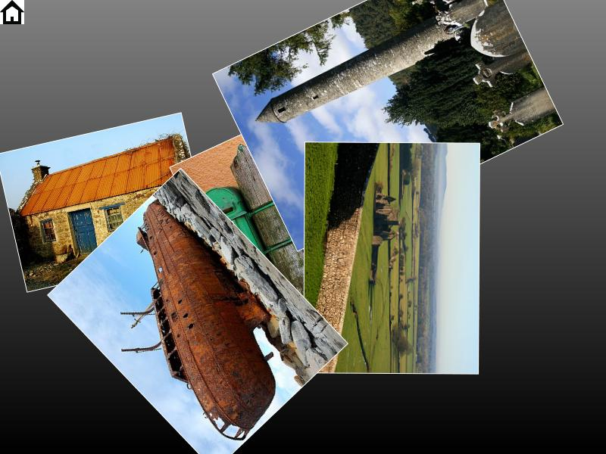

Figure 5.22: Photo Activity User Interface

The activity allowed the users to perform complex image manipulation tasks such as z-axis rotation, translation and scaling, in a very intuitive and natural manner. Typically these tasks can be quite complex when using software such as Adobe Photoshop and would require knowledge of image layers, transparency, selection and transformations. The activity was designed to be simple and all the image manipulation principles were hidden from the user. The user could interact with the photos directly without having to use transformation tools. Performing complex image manipulation operations is done through the use of three simple gestures, a one finger drag gesture, a two finger rotate gesture and a two finger enlargement gesture.

The interaction was designed to be as natural as possible. Translating an image required the user to perform a drag gesture on the image. A Z-Axis rotation required the user to perform a two-finger rotate gesture on the image. To keep the activity as intuitive as possible, rotation operations can be performed both clockwise and anticlockwise. A scale operation required the user to perform an enlargement gesture on the image.

The gestures required to manipulate the photographs were similar to real life, and could be described to dementia sufferers with an analogy of using a real photograph. Translating an image was similar to dragging a physical photo across a table. Rotating an image was also similar to rotating a physical photograph. Resizing an image is not as intuitive since there is not direct link to a physical photograph. However, the user could think that the image is being stretched out, similar to stretching an elastic material.

The photo activity contained an array of images. Each image was a rectangular shape with a texture applied to it. The images responded to only drag events, rotate events and scale events. When one of these gestures was performed, the corresponding event was executed. Each of the gesture events transform the image and then log the user interaction. This behaviour is displayed in Figure 5.23.

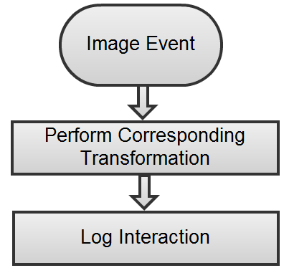

Figure 5.23: Image Event Procedure

### 5.7.3 Data Collection Facility

An automatic data collection facility was created for the multi-touch system to record user interactions with the system. The facility provided a useful, unobtrusive method of gathering user data over long periods of time. This allowed the patients to interact with the system as they required.

The creation of user accounts was considered during the design period of the system. However, the effects of dementia were expected to make the login and logout task quite difficult. The use of automatic data logging and the use of a webcam to capture an image of the user were developed to solve this problem. This data collection solution recorded user interactions and also captured an image of the user as they interacted with the system. The image of the user was then used to uniquely identify the user data.

When a user selected an activity, a new data collection session began. At the start of the session, an image was taken to identify user data. The system then recorded usage data as the user interacted with the system.

Once an interaction was detected, the interaction was logged. This process repeated until the session was terminated by either the user or by a timeout occurring (discussed later in this chapter). The functionality of the automatic data collection facility is displayed in Figure 5.24.

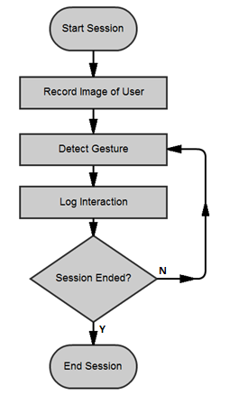

Figure 5.24: Data Collection Facility Functionality

The data collection facility was developed to be independent from the recreational multi-touch activities to allow for reuse in other systems. It was created as an independent layer to the multi-touch activity (see Figure 5.6). It was decided that the best solution for storing the data would be in a database. Databases provide simple mechanisms to storing and retrieving data.

The data collection facility was implemented through various classes in the s*essionUtils* package. The package contained the classes, *SessionManager*, *InteractiveSession*, *SessionListener* and *UpdateSessionAction*. The interaction of the various classes in the *sessionUtils* package is shown in Figure 5.25.

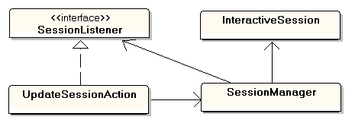

Figure 5.25: SessionUtils Class Interaction

A solution to managing the various sessions in the system was achieved by using a session manager. The *SessionManager* class was created to implement this functionality. The *InteractiveSession* class was created to keep track of the individual sessions.

Each time the user started a recreational activity, the *SessionManager* created a new *InteractiveSession* object. The session stored the session name, start time, end time, the user image and any interaction logged during the session. When an interaction was to be logged by the activity, the *InteractiveSession* stored the data in a temporary log file. Data is then logged in this file until the activity was completed. Once the activity finishes, the *SessionManager* closes the *InteractiveSession* object. The *InteractiveSession* reads the temporary log file and stores all the session data in the database. The *InteractiveSession* was then destroyed. This functionality is shown in Figure 5.26.

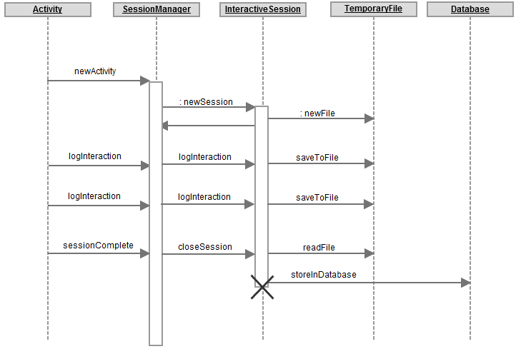Figure 5.26: Data Logging Functionality

*UpdateSessionAction* was developed as an interface to the *SessionManager* from the MT4j software framework, allowing the recreational activities easily update and access the software manager.

##### Timeout

One precaution that was considered during the design of the system was the possibility of the dementia sufferer losing interest in the current activity. Losing interest in tasks is quite common with dementia sufferers [15]. Their lack of interest could lead them to stop interacting with the system. This could cause the system to be left idle, which would leave their session open. All open sessions would record any further interaction data until the session was closed. This would be problematic if one user's session data was combined with user's session data. To combat this problem, a timeout facility was developed. This functionality was embedded into the *InteractiveSession* class. The timeout facility subtracts the time of the last interaction from the current time, if the result of this calculation was greater than a timeout threshold, a timeout message was generated.

When a timeout occurred, an exception was thrown by the *InteractiveSession* class when it was being updated. The *SessionManager* catches the exception and then informs the *SessionListener* that a timeout has occurred. The class implementing the *SessionListener* can then close the session and return to the main menu. This functionality is shown in the UML sequence diagram, in Figure 5.27.

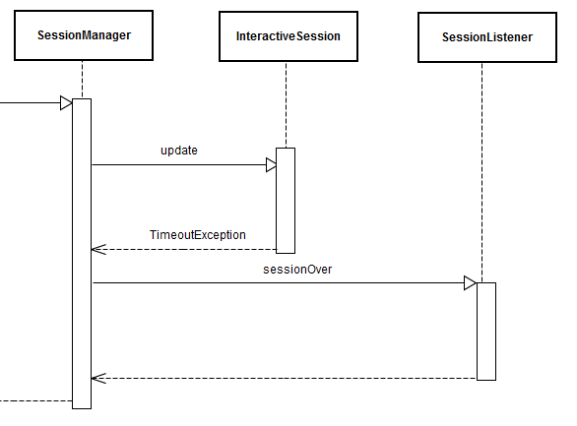

Figure 5.27: Timeout Sequence Diagram

##### Generic Activity

Each recreational activity required similar or duplicate code. Each of the activities needed to implement the data collection functionality, timeout functionality and the home button functionality. To reduce code duplication and to keep the code more manageable, it was decided that an abstract class would manage this functionality. The *GenericActivity* abstract class was created to achieve this task.

To keep the design of the system as flexible as possible, all the recreational activities inherited from the abstract class *GenericActivity*, as seen in Figure 5.28. The *GenericActivity* automatically performed logging capabilities and the timeout functionality.



Figure 5.28: Activity Inheritance Structure

The *GenericActivity* implemented the colour scheme for the activities in the system. It also added the functionality and positioning of the home button. The purpose of the home button was to allow the user to return to the main menu. The home button was positioned at the upper left corner of each activity, as seen in Figure 5.29. This was positioned there so there would be less accidental button presses. The user would deliberately have to reach out and press the home button to return to the main menu. Accidentally pressing the home button could have been frustrating to the user.



Figure 5.29: Generic Activity Layout

## 5.8 Summary

This chapter described both the design and development of a custom-made multi-touch prototype system suitable for dementia sufferers. The multi-touch prototype system was composed of various hardware and software components. The design and development of a suitable hardware solution was discussed. A software solution, consisting of a suite of recreational multi-touch activities for people with dementia, was also discussed.

The following chapter discusses the details of a pilot study, in which the multi-touch prototype system was installed in an Irish hospital geriatric ward and used by elderly people suffering with age-related disabilities.

# CHAPTER 6: PILOT STUDY

## 6.1 Introduction

This chapter describes the details of the pilot study which ran in Merlin Park Hospital, Galway, Ireland. The pilot ran from January to March 2012 inclusive. The purpose of the pilot study was to determine if large multi-touch surfaces could offer engaging and beneficial experiences to dementia sufferers through the use of recreational activities.

The pilot study had the following objectives:

* Install the prototype multi-touch system in a long stay geriatric ward
* Ensure the system could be used by the patients as they pleased.
* Automatically gather usage data while the system is in use.
* Gather qualitative data, using interviews and questionnaires from various sources, including doctors, nurses, occupational therapists and physiotherapists.

## 

## 6.2 Ethical Approval

To perform research with people, the participants must be notified of their role in the study and they must give consent to participate in the research. In a hospital setting, performing research on patients requires ethical approval. Obtaining ethical approval required the submission of the ethical approval application. The proposal outlined the research study and also various ethical approval forms. The ethical approval application was submitted to the Galway University Hospitals Research Ethics Committee. Once the ethical approval was obtained, the system could then to be installed within different wards throughout the hospital.

## 6.3 Prototype Installation

Once the ethical approval was obtained, the multi-touch system was brought to Merlin Park Hospital where it could be used by dementia sufferers and where it could also collect data. The chosen location for the system was a day-hall within the geriatric ward. This location was chosen because it is a "common area" and patients could use it freely. The room also provided shelter from direct sunlight. The sun emits a large amount of infrared light which can affect the sensitivity of the multi-touch screen and/or can contribute to sporadic behaviour by the system if the light intensity is too great.

After the system was installed, it was demonstrated to various hospital staff members. The staff members provided valuable feedback to assist in the evaluation of the system; this is discussed in the following sections.

The system was in the day-hall in the ward where patients could interact with it when they pleased. A protocol for interacting with patients was discussed with the nursing staff. This involved the author not interacting directly with the patients; rather the nursing staff would provide feedback on the patients' behalf.

Unfortunately, the multi-touch system was not used frequently in the first ward/location that had been chosen to place the system. Most of the patients in the ward were confined to wheelchairs. This was a significant obstacle for the patients in their attempts to use the system (discussed later in this chapter).

It was suggested, by hospital staff, that the system would be more suitable in a different ward where patients are not all restricted to wheelchairs. For this reason, the system was relocated to another geriatric ward in the hospital where patients were more mobile. The system was installed in the corner of the "day hall" of the new ward. The day hall was brighter than previous location and potential instability with the system, because of intense sunlight, was expected. However, this room was the only location in the ward to install the system.

## 6.4 Data Collection Methods

### 6.4.1 Automatic Data Collection

As discussed in Chapter 5, the multi-touch prototype has an automatic data collection facility which gathers usage data while the system is actively in use. To identify user data, an image capture feature was included in the design of the system. Although this image capture solution was included, it proved to be unfeasible to obtain consent from every person within the day hall at all times. The image recording facility was disbanded, resulting in all automatically gathered data being stored anonymously.

Qualitative data was gathered to assess the users' enjoyment while using the system. Completed questionnaires were collected from system users. Interviews were conducted with hospital staff. Observational methods were all used to gather qualitative data throughout the study. The collection of qualitative data provided valuable information which could not have been collected automatically by the system.

### 

### 6.4.2 Questionnaires

Questionnaires were created to obtain qualitative feedback from the participants in the pilot study. The purpose of this information was to help evaluate the multi-touch prototype. The questionnaires were broken up into two distinct sections, open-ended questions and close-ended questions. The questionnaires can be found in Appendix B.

Close-ended questionnaires have proven to be useful in studies when gathering data from the user about their enjoyment of a system [14]. However, these studies had structured interactive sessions where their research team were always present, observing and interviewing the users. This pilot study was designed so that the multi-touch system was always available to the patients, regardless of the presence of the researcher. Close-ended questionnaires were designed to record quantitative data. This indicated the amount of people who found the system easy or enjoyable to use versus the amount of people who do not find it easy or enjoyable to use. Open-ended questionnaires were designed to gather in-depth user feedback which may have been gathered if observational protocols were being used. The open-ended questionnaires were designed to gather detailed reasons of why someone liked or disliked using the system.

Before a participant was asked to fill out the questionnaires, they were shown the features the system offered and then shown how to use the system. After the introduction, the participant was asked to use to prototype for a period of time. Each of these sessions lasted between five and ten minutes in length depending on the participant. The results of these questionnaires are discussed in Chapter 7: Results.

### 6.4.3 Interviews

Several interviews were conducted as part of this pilot study; interviewees included nursing staff, occupational therapists, physiotherapists, and art therapists. The aim of interviewing different staff was to evaluate the multi-touch system from different perspectives across various disciplines. The interviews were carried out informally, on location, in Merlin Park Hospital.

The process started with the interviewee being given a demonstration of how to use the system and the various features that it offered. The interviewee was asked several questions. The questions related to:

* Usability of the system
* Interface design
* Possible improvements or modifications to the hardware and software.

The following subsections describe the various material discussed in these interviews.

#### 6.4.3.1 Occupational Therapist Interviews

Merlin Park Hospital has staff who provide an occupational therapy service to patients. The purpose of occupational therapy is to promote the well being of a patient by engaging them through purposeful and meaningful activities. The occupational therapists were approached to assess the prototype from an occupational therapists point of view. The occupational therapists were asked questions about various aspects of the system, including hardware design, software design and any other feedback related to the system.

Possible physical design features which could be included in future designs were discussed. Installing a handrail on the edge of the multi-touch screen was seen as being beneficial to patients who relied on walking frames to support themselves; it was also felt that this would allow them to use the system for longer periods of time.

The occupational therapists found that portions of the screen would become unresponsive if sunlight was intense. Patients would get frustrated with the system when it became unresponsive, especially when using the reaction activity. Due to unresponsiveness of the screen, the reaction time getting recorded by the system was not the "true" reaction time, since the user might have to press the screen a second or third time for the system to register the interaction.

When discussing the system software, the reaction test activity was described by the occupational therapist as good activity for encouraging people with spatial neglect. Spatial neglect is a syndrome which is typically an after effect of stroke; it is characterised by a failure to be aware or detect stimulus on one side of their personal or extrapersonal space [99].

The occupational therapist also stated that the reaction test activity also provides a good scanning exercise for patients. A scanning exercise was described as an exercise which causes the patients to visually scan the surrounding environment. Although the activity was created for people with dementia, the occupational therapist stated that the prototype could also be used by elderly patients who were suffering from age related disabilities, such as stroke. It was noted that the prototype's reaction test activity could have potential, along with other tests to assess if patients could discharged and would be suitable to drive again.

The occupational therapist established that the reminiscence activity was difficult for dementia sufferers to use. The scattered photograph interface proved to be too cluttered, making it difficult for the patient to view the images clearly. Also the gestures need to manipulate the photographs (two-finger scale and two-finger rotate) were seen to be too complex for some patients.

Additional potential activities were discussed and described by the occupational therapy staff, this included activities to promote handwriting. The occupational therapist staff noted that the paint activity was sometimes used by patients for handwriting and even for some games, such as "x's and o's".

#### 6.4.3.2 Physiotherapist Interviews

The physiotherapy department within Merlin Park Hospital is concerned with the rehabilitation of patients through physical exercise. Staff members of the physiotherapy department were approached to give feedback from a physiotherapist's perspective. Feedback was given through informal verbal interviews.

The physiotherapists commented that they could use some of the prototype's activities in their daily routine, including the reaction activity and the game activity. They commented that these activities were most useful from physiotherapist's standpoint. However, the music, paint and reminiscence activities were described as not very useful for a physiotherapist's daily routine.

The physical design of the multi-touch system was also discussed in the interview. The panels on the front of the screen and the static angle and height of the screen make the screen only suitable to use by patients who can stand. They felt that rotating the screen to a more vertical angle/position would make the screen more accessible to a larger number of patients.

Touch-sensing response was described by the physiotherapist as being "poor" on days with bright sunlight. The bright sunlight also caused the system to be unresponsive at times. This issue was found to be frustrating when patients were trying to use the system.

Aspects of the user interface were discussed by the physiotherapists. They found that the position and size of the home button on the screen was too far away for users to reach and the target area of the button was too small. This was problematic for patients especially the users who were physically disabled and could not reach far due to their disability. Positioning the button to the lower left hand corner of the screen was suggested as a possible position for the home button.

The reminiscence activity was described as 'too difficult' for patients to use. The enlarging image operation gesture was quite complex and caused sporadic behaviour when the system would be unresponsive due to sunlight; this behaviour sometimes confused the patients. It was noted that this confusion could prevent the patients from wanting to return to the system. Suggestions for improving the reminiscence activity were to use a more organised approach, rather than displaying all images scattered over the screen. It was also suggested that the images could be stored in a photo-album like widget where the user could navigate through 'pages'.

#### 6.4.3.3 Nursing Staff Interviews

The nursing staff were interviewed about various aspects of the multi-touch system. There were various aspects of the accessibility of the prototype which were discussed by the nursing staff. Most of the tables in the ward were adjustable (angle and height of the table). It was suggested that the system should be made in a way where both height and angle of the screen could be adjusted to accommodate most patients. Currently, the design of the multi-touch system is not accessible to wheelchair users and it does not accommodate for people to comfortably sit down in front of it. Redesigning the system, as suggested by the staff, would be expected to correct most accessibility issues.

Due to the nature of a large touch screen, a residue of dirt, from people interacting with it regularly can accumulate. This is also true if the system is used for long periods of time. The issue of hygiene was discussed by nursing staff as a potential problem associated with the touch screen if it was not cleaned on a regular basis. Given that the systems screen is made of polycarbonate, the screen could be cleaned regularly with the surface cleaners used in the hospital without damaging the surface.

At the time of the pilot study, most of the activities did not make use of audio. The nursing staff suggests that generally including more audio would make the experience more immersive. It was believed by the nursing staff that adding audio to the game when the ball would collide with objects would make the activity to be more engaging.

From the nurse's experience in traditional reminiscence sessions, images of rural Ireland and animals would invoke the most conversation. A suggestion was given to modify the theme of the photographs to include images similar to traditional reminiscence therapy sessions. Also, a facility for the patients to upload their own photos would make the system more entertaining to the patients.

The nursing staff commented that the large screen, together with the variety of colours make the system enjoyable and attractive for the patients to observe and to use. It even acted as a communication mechanism for family members when they came to visit.

Feedback from the nursing staff found that some patients with dementia within the ward would use the system, although it would vary from patient to patient. Some patients would happily use the system with a prompt from the nursing staff but some patients would completely refuse to use the system even after multiple prompts from the nursing staff.

Although some patients would use the system, the nursing staff commented that more patients would use the system if it were more accessible to them. Generally, most patients in wheelchairs would not use the system but reports from the nursing staff show that a few patients would use the surface regularly, despite being in wheelchairs.

From the nurses' observation of some patients, they found that some patients did not have enough force to move the ball in the game activity and complete the task. A suggestion was to change the game activity so the y-coordinate of the block start close to the bottom of the screen and would gradually move further away from the bottom of the screen as the patient achieves more goals in the game.

#### 6.4.3.4 Art Therapist Interview

Art therapists attend the patients in the ward, once a week, for an afternoon. They facilitate the patients and also allow them to express themselves artistically through the medium of arts and crafts.

The art therapist was approached to give feedback and help assess the prototype from an art therapist's perspective; in particular the paint activity. The paint activity was demonstrated to the art therapist, showing the various features and functionality of the system. Feedback was mostly positive but there were some suggestions and possible improvements which were offered by the art therapist; these suggestions were expected to increase the engagement of the dementia sufferer while using the activity.

The main suggestion for improvement was to include images, as inspiration, for the dementia sufferer to work with. The art therapist noted that the interface of the paint activity was a large blank canvas; in traditional art therapy sessions, patients typically use an image or an object as inspiration. This was necessary because the dementia sufferers sometimes have difficulty with creating an entire painting from memory. It was suggested that the image could be possibly placed in the upper right hand corner of the screen, still providing plenty of space for the person to complete their art work. This suggestion could make the application more engaging to the dementia than just the blank canvas.

A possible activity which was suggested by the art therapist was that of an activity which presented an interface similar to a colouring-book. This activity would outline various objects in the image and the patient would just need to choose a colour and where to apply it. Colouring in the objects in the activity could be achieved by either the user painting the entire object or by using a bucket-fill operation. This was described as helping the dementia focused on the task at hand and to keep them engaged and to help prevent them from being distracted.

### 6.4.5 Observation

Throughout the pilot study the author made some observations of patients interacting with the system. This section discusses these observations made throughout the pilot study.

In one instance, a nurse invited a patient to use the prototype. The patient, diagnosed with a moderate case of dementia, was asked to if they wanted to "use the computer". The patient replied "I wouldn't know how to use it". The patient was then prompted again to use it regardless of not knowing how to use it. The nurse demonstrated to the patient how to use the system and compared the activity to finger painting where the user must select a colour by touching it and then paint on paper with that finger. After approximately 30 seconds, the patient was using the prototype to paint. An interesting behaviour pattern of this patient using the system was that she would repeatedly select a colour before she would paint on the screen. It was discovered that the patient was doing this to "get more paint" on the patient's finger before she would paint, similar to real life painting.

Another patient was interested in the system; the patient interacted with the system despite having no computer experience and being in a wheel chair. The patient positioned the wheelchair at a 90 degree angle to the screen for easier access. The patient enjoyed looking at the various images on the screen in the photo activity. The patient would view the screen but would not interact with it. The patient would interact with the system after being prompted by the nurse. The patient tried to play the game activity on the system but it was too difficult to move the ball to hit the blocks due to the patient not having enough force to move the ball.

The system was used collaboratively by two patients one time throughout the pilot study. They used the reaction test activity. One person would control the left hand side of the screen and the other person would control the right hand side of the screen. After they used the system, they said it was fun and they would use it again.

One patient would refuse to use the system despite being prompted multiple times to use it. Although the patient would refuse to use the system, the patient looked curiously at the system while it was being used.

## 6.5 Summary

This chapter described the pilot study. The pilot study involved installing and monitoring the system in Merlin Park Hospital over a three month period, January to March 2012. The purpose of the pilot study was to gather both qualitative and quantitative data to assess the effectiveness of the prototype. This chapter outlined how data was collected and the various data collection methods used. It also described the feedback received from hospital staff throughout the pilot study. The following chapter discusses the data collected by the system and also discusses the results from the questionnaires.

# CHAPTER 7: RESULTS

## 7.1 Introduction

The literature review established that existing recreational computer based activities, designed specifically for people with dementia, are quite limited. This thesis has outlined a large scale multi-touch surface to address this problem. To validate the prototype, a pilot study was carried out in Merlin Park Hospital, Galway, Ireland.

The prototype multi-touch system was deployed in Merlin Park Hospital between January and March 2012. Data collections were undertaken to evaluate if the prototype offered a sufficient solution to the research questions. Throughout the pilot study, data was collected by various means which included, automatic session data gathering, questionnaires and observations. Verbal interviews were also conducted with hospital staff, including the nursing staff, occupational therapists and physiotherapists. This chapter presents the results from the questionnaires and the automatically collected data, examines it and finally correlates the data with the verbal feedback and observation to evaluate the prototype. The purpose of evaluating this data is to assess if large scale multi-touch surfaces can be used for recreational activities for people with dementia.

## 7.2 Quantitative data

As discussed in Chapter 5: System Design and Development, the prototype has a facility to gather session information, as well as user interactions, while the system is in use. Throughout the pilot study, information from various sessions was gathered and stored in the system database. Manually viewing the collected data from each individual session would be impractical. To assist in the evaluation of the collected data, an analysis tool was created which graphically displayed all the usability information from the prototype during the pilot study. This tool queries the database, extracts the collected data and displays it in a graphical user interface.

The tool provides functionality to view each session individually by showing the session length, session id, session start time, session end time, session data, activity used, image of the user and also all the collected data from the session. Due to the ethical impracticalities of capturing images from the pilot study, the image view was left blank when analysing data. Since there was no image data collected, the data which was collected by the system is unidentifiable, making the overall results anonymous since it is impossible to determine who was using the system at a given time.

The prototype was not used exclusively by dementia sufferers. According to reports, staff members and friends and family of the patients also used the system. For this reason, it is important not to generalise from the results of the automatically collected data.

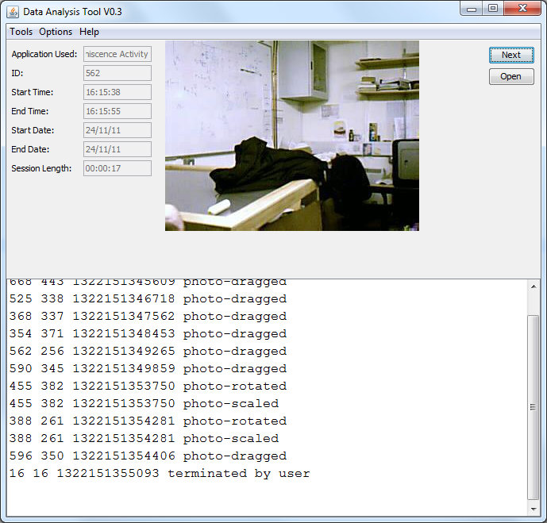

Figure 7.1: Data Analysis Tool

### 7.2.1 System Overview

As discussed previously, the prototype system automatically collects data when it is in use. This data can provide an overview of how the system was used. It can also be used to assess the systems activities in terms of popularity and in engagement. Usability information can also be used to assess probable ergonomic difficulties with the screen.

By analysing this data, it shows that the system was used 1233 times in total. This figure excludes any test and demonstration data. The system was actively used for a total of 25 hours, 32 minutes and 6 seconds, with the longest interaction session lasted for 664 seconds (11.067 minutes) and the average length of an interaction session was 74.56 seconds. From this data alone, it shows that the system was somewhat engaging and that it was commonly used throughout the pilot study.

### 7.2.2 Activity usage

It is clear from the system overview that the prototype was used frequently throughout the pilot study. However, it would be interesting to assess which activities were the most popular and which activities were the most engaging. This section delves into the collected data and examines which individual activities were most popular and most engaging.

#### 7.2.2.1 Activity Popularity

In this study, the popularity of an activity was measured as the amount of times that an activity was selected to run. In total, the system was used for 1233 individual interaction sessions. Table 7.1 further breaks down this data into the popularity of each activity throughout the pilot study; this data is graphed in Figure 7.2. Out of the 1233 activities used, the paint activity was used 373 times throughout the pilot study; this number is 30% of the entire uses of the system. This activity seemed to be the most popular activity in the pilot study. The reminiscence activity was used 258 times throughout the study; this number is 21% of the entire usage of the system. The game activity and the music activity showed to be just as popular as each other; with both of them being used 18% of the entire pilot study. The least popular activity was the reaction activity. This activity was only used 169 times throughout the entire pilot study; this number is 14% of the entire activities used and under half as popular as the paint activity.

|  |  |  |
| --- | --- | --- |
| Activity Used | Percentage usage | Number of uses |
| Paint | 30% | 373 |
| Reminiscence | 21% | 258 |
| Game | 18 % | 217 |
| Music | 18% | 216 |
| Reaction | 14% | 169 |

Table 7.1: Activity Popularity

The paint activity and the reminiscence activity account for over half of all activities used in the system. This data suggests that the painting and reminiscence activities provided by this system were most popular amongst the dementia sufferers.

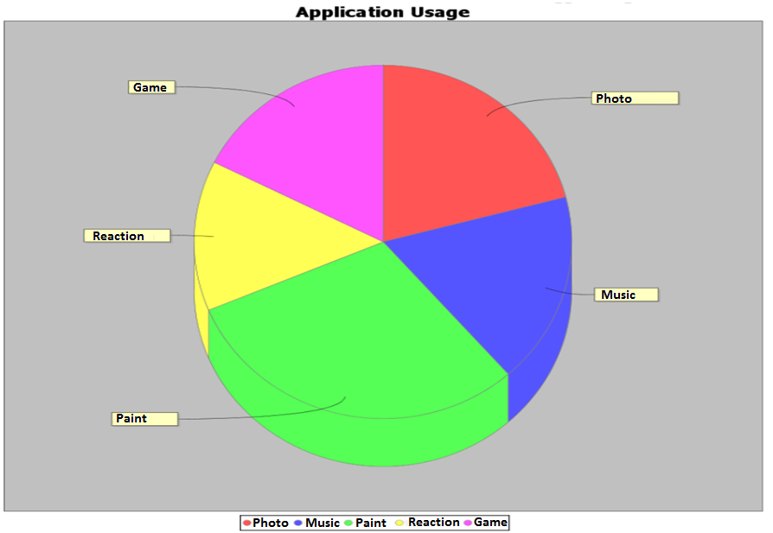

Figure 7.2: Activity Popularity

#### 7.2.2.2 Activity Engagement

If an activity is more popular, it does not necessarily mean that it is also more engaging. This section presents the engagement data from each activity from the pilot study. The measure of engagement is going to be measured by the length of time that a user spends using a particular activity. The engagement data collected by the system throughout the pilot study is presented in Table 7.2; this includes the total, longest and average length of each activity. These metrics gives an insight into how engaging the various activities were with the participants in this research. The average length of an interaction session provides a generalisation of how engaging the various activities on the system were. The longest length shows the maximum engagement of the system to a particular user. This data is useful to see how long the most engaging sessions were in the pilot study.

|  |  |  |  |
| --- | --- | --- | --- |
| Activity Used | Total Length  (seconds) | Longest Length (seconds) | Average Length  (seconds) |
| Paint | 29072 (8.07 hours) | 664 | 112.68 |
| Reminiscence | 20535 (5.7hrs) | 559 | 79.59 |
| Game | 18029 (5.01hrs) | 617 | 69.88 |
| Music | 13243 (3.68hrs) | 604 | 51.33 |
| Reaction | 11047 (3.07hrs) | 616 | 42.82 |

Table 7.2: Activity Engagement

From this collected data it can be seen that the paint activity was the most engaging activity. It was used for over 8 hours in total throughout the entire pilot study. On average, this was the most engaging activity, being used 31.63% of the entire time that the system was used. The reminiscence activity was the second most engaging activity; it was used for 22.34% of the entire project engagement time. The game activity was used for 5.01 hours or 19.61% of the entire time of the pilot study. The music activity was used for 14.41% of the entire time that the system was in use. On average, the reaction activity was the least engaging activity of all the activities; it was only used for 12% on average.

In Table 7.2, the longest length of an activity is presented. This data shows that the paint activity was the most engaging activity, with sessions being up to 11 minutes in length. The other activities were approximately equally engaging with the longest sessions being up to 10 minutes in length with exception of the reminiscence activity. Interestingly enough, the reminiscence activity, although it is the second most engaging activity on average, the longest reminiscence session lasted for approximately 9 minutes and 20 seconds in length, which was less than all other activities.

### 7.2.3 User Interface Usage

Heat-maps are a graphical way of displaying two-dimensional data; they have been used to display frequent areas of interaction with web-pages. Heat-maps were decided to help assess the user interface of this system by highlighting the areas of the user interface which are commonly used and which are not. Figure 7.3 is a heat-map which was generated by the analysis tool to give an insight into how the system was used throughout the pilot study. This data is a collection of all the interaction data which was gathered by the system. The gradient at the right hand side of the heat-map displays the colour scheme used in the heat-map. Least commonly used areas of the user interface are displayed in the heat-map with dark reds and black. The most frequently used portions of the user interface are displayed in the heat-map with white and yellow colours.

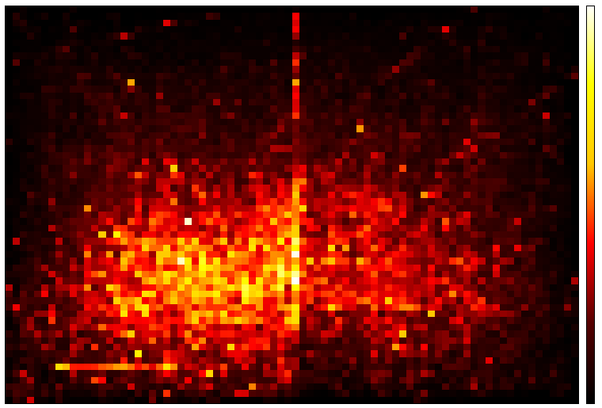

Figure 7.3: Heat-map Showing System Use

It can be seen from the heat-map that most interactions were in the lower to mid sections of the screen. The entire height of the screen was rarely used; this is probably because the user would need to extend and stretch to reach the upper area of the screen which could be uncomfortable to the user. Most of the width of the screen was used except for around the edges; this is possibly due to the user needing to reach out to the edges which could be due to comfort or to the mobility of the user. There is a strange line in the centre of the heat-map, which is believed to have occurred through noise being produced in the image stitching process.

## 7.3 User Feedback

Evaluative data was collected by different means throughout the study; questionnaires, informal interviews and observation were the methods of collecting data in this study. Observations from the pilot study and feedback from the various interviews were discussed in the previous chapter. This section discusses the results from the questionnaires.

Questionnaires were created to obtain evaluative feedback from some of the patients who participated in the pilot study. There were two questionnaires which needed to be completed by the participant after they used the prototype. Both the open-ended and close-ended questionnaires can be found in Appendix C.

The first questionnaire consisted of a five close-ended, dichotomous questions to measure enjoyment and ease of using the system. Each question was kept short and the overall questionnaire was kept brief. Answers were collected by the participant ticking a Yes/No answer check-box.

The second questionnaire consisted of five open-ended questions which facilitated qualitative data collection. The open-ended questionnaire was created to encourage the participant to express a full, meaningful answer to help assess the system. These questions examined the features of the system that were enjoyable, what was difficult about using the system and what possible improvements the participant would like to see in future revisions of the system.

Throughout the pilot study, seven participants formally used the system and filled questionnaires afterwards. Before the patient was asked to fill out the questionnaires, they were briefly shown how to use the system and what features it offered. After the introduction, the participant was asked to use to prototype for a short period of time. Each of these sessions lasted between five and ten minutes in length depending on the participant and their abilities. Although the prototype was developed for elderly people who were suffering with dementia, only three patients with dementia filled out questionnaires. These patients were diagnosed with mild to moderate cases of dementia. The other four participants were suffering from age-related physical disabilities, such as stroke.

### 7.3.1 Questionnaire Analysis

#### 7.3.1.1 Participants with Dementia

Three participants with dementia formally used the system and filled out questionnaires afterwards. These participants were suffering with mild to moderate cases of dementia. This section examines the data collected from the open-ended and close-ended questionnaires which the participants filled out. The three participants of the study who filled in questionnaires were female. The age-range of the participants was 77-81 years old; an age profile of the participants is displayed below. Two of the participants were suffering with mild cases of dementia and one person who were suffering with a moderate case of dementia.

|  |
| --- |
| Mean 79.33  Standard Deviation 1.7  Range 77-81 |

Age Profile of Participants

##### Close-Ended Questionnaire Results

The results from the close-ended questionnaires are displayed in Table 7.3. From this data it is possible to get an insight into how enjoyable the system is to use and how easy it is to use. From this data, 100% of participants noted that they enjoyed using the prototype and would use it again for longer periods of time. 33% of participants found the system was difficult to use and 66% of participants needed help while using the system. The limitation of the close-ended questionnaires is that it does not examine the reasoning behind the answers. The open-ended questionnaires, discussed in the next section, were created to do such a task.

|  |  |  |
| --- | --- | --- |
| Question | Yes | No |
| Did you enjoy the session? | 3 |  |
| Would you use the activity again? | 3 |  |
| Would you use the system for a longer period of time? | 3 |  |
| Did you need help with this activity? | 2 | 1 |
| Was the activity easy to use? | 2 | 1 |

Table 7.3: Close-Ended Questionnaire Results

##### Open-Ended Questionnaire Results

The open-ended questionnaire was created to encourage the participants to express a full, meaningful answer, to help assess the system. This section will discuss the results from the open-ended questionnaires that were filled out by the participants with dementia.

The question, *"What did you like about the using the system?"* received generic responses: Candidate A stated that "It was fun and a good idea". The reminiscence activity received positive feedback by two participants. Candidate C stated that "looking at pictures" was enjoyable, while Candidate B stated "choice of which picture to look at" were enjoyable aspects of the system. The reminiscence activity was also discussed when asked *"What was fun about using the system?"*  Candidate B noted that "Looking at pictures" was fun about using the system.

Any difficulties with using the system were gathered by the question, *"What was difficult about using the system?"* Candidate B noted that there were difficulties regarding the use of the reminiscence activity. Candidate B stated that "changing the pictures" was difficult.

The question, "*What did you dislike about using the system?*" was expected to provide valuable feedback about what aspects of the system were disliked by the participants. However, it was disappointing that there were no responses to this question. This question could have possibly offered insight into the difficulties which were noted in the close-ended questionnaires.

Potential changes of the system were discussed by the question, *"How would you change the system?"* Results from this question were related solely on the activities and not the actual hardware design of the system. Adding more activities was discussed by Candidate C as a potential change to the system; a crossword activity was discussed as a possible activity which could be included in future versions. The scattered-photo user interface in the reminiscence activity proved to have challenges with Candidate A; the participant answered the question by saying "Make it easier to see all the pictures". GIVE MORE DIRECT QUOTES HERE

#### 7.3.1.2 Participants without Dementia

The prototype was used by four patients who did not have dementia. These participants interacted with the prototype for sessions ranging from 5 - 10 minutes. Three of the participants fit the age group which is likely to develop dementia. All of the participants suffer from age related physical disabilities, mainly stroke and were admitted to hospital for rehabilitation. The age profile of the participants is displayed below. The age range of the participants was 55-70 years. From each of these participants, 1 was male and 3 were female.

|  |
| --- |
| Mean 65.75  Standard Deviation 6.260  Range 55-70 |

Age Profile of Participants

##### Close-Ended Questionnaire Results

The same questionnaire was given to the different group of participants who did not have dementia. The results of which are displayed in the Table 7.4.

|  |  |  |
| --- | --- | --- |
| Question | Yes | No |
| Did you enjoy the session? | 4 |  |
| Would you use the activity again? | 4 |  |
| Would you use the system for a longer period of time? | 3 | 1 |
| Did you need help with this activity? | 2 | 2 |
| Was the activity easy to use? | 3 | 1 |

Table 7.4: Close-Ended Questionnaire Results

Similarly to the previous dataset, it is possible to get an insight into how enjoyable the system is to use and how easy it is to use from the questionnaires. From this data 100% of participants noted that they enjoyed using the prototype and would use it again. Even though 75% of participants would use the system for longer periods of time, 25% of participants thought that the 5-10 minute time period was enough time to spend using the system. Results from the close-ended questionnaires shows that not all participants found it easy to use. 25% of participants found the system was difficult to use and 50% of participants needed help while using the system.

##### Open-Ended Questionnaire Results

With this dataset of participants, the results from the open-ended questionnaires were more involved. There was more feedback from this set than from the participants who were diagnosed with dementia.

The question, *"How would you change the system?"* received feedback about both the software and hardware. The overall form factor of the system received feedback related to the ergonomic design of the system; Candidate D stated that the system should "have more leg room" and it should be "more wheelchair accessible". The remaining answers to this question were possible software improvements. The small selection of activities was commented on by Candidate E, who wanted "more variety". The user interface of the reminiscence activity was commented on, it was suggested by Candidate F that there should be an index of all images in the right hand corner of the screen for easier access.

The prototype received positive feedback from the question, *"What did you like about using the system?"* Two participants described the system as "easy" to use. Other positive points about the system included Candidate D saying "loved the colours" of the user interface. Candidate F commented positively on the variety of activities available.

The question, *"What do you dislike about using the system?"* provided some valuable feedback about the system. Some feedback was related to the actual touch sensing of the system; Candidate D commented that they did not like the "sensitivity of touch pad". Other negative points were that some activities were too complex for another participant; Candidate D noted that "help required with some games", unfortunately, the participant did not elaborate further, stating which activity was difficult to use.

To test which aspects of the system were most enjoyable, the question, *"What was fun about using the system?"* was presented. Candidate D noted that looking at photos was an enjoyable aspect of using the system. Candidate F mentioned that the novelty of the overall system was enjoyable by the comment "the newness of the system" was enjoyable.

The question, *"What was difficult about using the system?"* received feedback similar to the question, *"What do you dislike about using the system?"* Answers to this question related to the touch sensitivity of the system and that there was help needed for some activities.

## 7.4 Summary

This chapter outlined the results from the automatically gathered usage data which was collected by the system. This data presented the engagement and popularity of each activity in the prototype system. Heat-maps were generated and displayed to visualise user interactions with the system. Qualitative data results from both open-ended and close-ended questions were also discussed.

# CHAPTER 8: CONCLUSIONS

## 8.1 Introduction

The thesis focused on the general field of human-computer interaction as applicable to dementia sufferers. The hypothesis was that a computer system combined with a large multi-touch surface offers an engaging portal to recreational activities for dementia sufferers. The research hypothesis asserted that large multi-touch surfaces offer potential benefits for elderly people, suffering with dementia, in the areas of leisure, reminiscence and creative activity thereby delivering a higher quality of life.

The project required work to be carried out in many disciplines. These included:

* Interface design
* Interaction design
* Hardware design and development
* Software design and development

The project delivered the following:

* A comprehensive literature review in the following areas:
  + Dementia
  + Human Computer Interaction
  + Multi-touch technologies
* A suitable prototype computer-system with a large multi-touch screen for dementia sufferers.
* Computer applications, offering engaging recreational activities.
* Ethical approval for the study
* A successful pilot study of the system in an Irish geriatric hospital ward.
* Data collected from the pilot study.

## 8.2 Conclusions

From the data collected throughout the research, there are a number of conclusions which can be drawn.

Firstly, it is possible to successfully design and develop custom-made large scale multi-touch user interfaces for people with dementia. Custom-made multi-touch systems can be developed for a fraction of the price of the commercial equivalent. Inexpensive multi-touch table systems can be developed using components such as: frosted polycarbonate, infrared illuminators, infrared cameras, a projector and computer.

A suite of recreational multi-touch applications can be designed, developed and deployed on custom-made multi-touch hardware systems. Custom-made recreational multi-touch activities can also be developed for people with dementia.

The usage data identification mechanism used in the project, which captures an image of the user and couples the image with usage data, proved to be an inelegant and insensitive solution to identifying usage data. Recording images of people is a sensitive issue especially in common areas in a hospital; other patients, who do not give consent to participate in the study are likely to be located in these areas. This is problematic if their image was captured through the image recording facility.

Results from the pilot study show that people with mild to moderate cases of dementia can successfully interact with large multi-touch systems with only a brief training session. The symptoms of dementia do not prevent patients from interacting with the multi-touch system. Although patients can interact with the system, patients usually required some degree of prompting to encourage them to use the system.

Large multi-touch systems offer enjoyable recreational experiences to people with dementia. The pilot study showed that 100% of participants with dementia enjoyed using the multi-touch system. Large multi-touch systems provide an engaging activity for elderly people, this can be seen through the questionnaire results; 66.7% of participants with dementia say that they would stay engaged with the system for longer periods of time. Usage data shows that a recreational multi-touch activity can keep people engaged for up to 11 minutes in some cases.

Designing multi-touch interaction gestures is an important factor in the design of multi-touch systems for dementia sufferers. The research shows that some gestures may not be intuitive, such as a two finger enlargement; the photo-enlargement operation proved to be difficult for dementia sufferers to perform.

People with dementia are able to be creative with large multi-touch surfaces. Large multi-touch surfaces allow patients to express their creativity in various ways. The research found that the multi-touch system developed enabled patients to express their creativity through painting artistic pictures, playing music and rearranging images in a creative fashion.

The research showed that large multi-touch surfaces, offering recreational activities, can be used in collaboration between two dementia sufferers, promoting friendships and communication.

Large multi-touch surfaces can be used by people who suffered from older age physical declines, such as stroke. Recreational multi-touch activities offer enjoyable experiences to stroke patients. As discussed in Chapter 7, the data collected in the pilot study showed that 100% of stroke participants enjoyed using the system. The research shows that large multi-touch surfaces can be used not just for recreational purposes but also has a large potential for rehabilitation.

Infrared technologies can be affected by environmental conditions. Diffuse illumination multi-touch sensing can be affected by intense sunlight, resulting in an unresponsive touch surface. To achieve best results, diffuse-illumination multi-touch systems should be used in areas with controlled environmental lighting.

Through the collection of usage data and heat-maps, it is possible to evaluate which portions of a multi-touch surface are being used most frequently and which portions of the surface are never used or seldom used. Collected heat-maps from the pilot study suggest that the aspect ratio of the multi-touch system could be modified since the upper portion of the screen was rarely or never used.

## 8.3 Recommendations for Further Work

Due to the small number of participants in this study, it is difficult to make generalisations or a universal comment about this system and people with dementia. The research could further refined by getting a larger dataset of research participants. Research has shown that 10-18 participants is a large enough dataset of participants [1, 14].

Accessibility for wheelchair users was the main drawback of the multi-touch system according to hospital staff. This was due, in part, to the large area needed beneath the multi-touch screen for infrared cameras. The area needed underneath the screen could be reduced by including more infrared cameras and positioning them closer to the screen. It is believed that this modification could make the screen more accessible for wheelchair users.

Most of the furniture used in the hospital can be adjusted, making it accessible to all people. The static nature of the multi-touch system made the system only accessible to people who were not restricted to wheelchairs. The system could be further developed so the height and angle of the multi-touch screen could be adjustable.

Although the suite of activities proved to be enjoyable, feedback from research participants suggests that the size of the activity suite was not adequate. The activity suite could be further expanded, including more creative and recreational activities. The inclusion of more recreational activities could engage people for longer periods of time.

Sensitivity of the touch surface was reliant on lighting in the surrounding environment. Intense sunlight would cause the system's touch facility to be unresponsive. The multi-touch system's touch sensing facility could be further developed to work flawlessly in a range of different environments. This could be further developed by using a different multi-touch sensing method, such as a using a sensor-based touch detection system which is not reliant on infrared technology.

As discussed in Chapter 6: Pilot Study, the usage data identification system used in the study proved to be impractical in the research. A more elegant, patient sensitive approach to gathering and identifying usage data should be developed further.

# REFERENCES

[1] N. Alm, R. Dye, A. Astell, M. Ellis, G. Gowans, and J. Campbell, "Making software accessible to people with severe memory deficits," ed, 2005.

[2] United Nations. (2011). *World Population Prospects: The 2010 Revision*. Available: http://esa.un.org/unpd/wpp/Analytical-Figures/htm/fig_overview.htm

[3] M. A. Blythe, A. F. Monk, and K. Doughty, "Socially dependable design: The challenge of ageing populations for HCI," *Interact. Comput.,* vol. 17, pp. 672-689, 2005.

[4] K. Ritchie and S. Lovestone, "The dementias," *The Lancet,* vol. 360, pp. 1759-1766, 2002.

[5] Alzheimer's. Disease International.. *World Alzheimer Report 2010*. Available: http://www.alz.co.uk/research/files/WorldAlzheimerReport2010.pdf. Last accessed: 27/01/2011.

[6] The Alzheimer Society of Ireland. *Irish Statistics*. Available: http://www.alzheimer.ie/eng/Media-Centre/Facts-About-Dementia/Irish-Statistics. Last accessed: 27/01/2011.

[7] C. B. Peterson, A. Mitseva, A. Mihovska, N. R. Prasad, and R. Prasad, "The phenomenological experience of dementia and user interface development," in *Applied Sciences in Biomedical and Communication Technologies, 2009. ISABEL 2009. 2nd International Symposium on*, 2009, pp. 1-5.

[8] Z. Roupa, M. Nikas, E. Gerasimou, V. Zafeiri, L. Giasyrani, E. Kazitori, and P. Sotiropoulou, "The use of technology by the elderly," *Health Science Journal,* vol. 4, p. 9, 2010.

[9] N. Doulamis, "Iterative motion estimation constrained by time and shape for detecting persons' falls," presented at the Proceedings of the 3rd International Conference on PErvasive Technologies Related to Assistive Environments, Samos, Greece, 2010.

[10] C. Müller, L. Wan, and D. Hrg, "Dealing with wandering: a case study on caregivers' attitudes towards privacy and autonomy when reflecting the use of LBS," presented at the Proceedings of the 16th ACM international conference on Supporting group work, Sanibel Island, Florida, USA, 2010.

[11] A. Mihailidis, J. Boger, M. Canido, and J. Hoey, "The use of an intelligent prompting system for people with dementia," *interactions,* vol. 14, pp. 34-37, 2007.

[12] Y. Theng, A. B. Dahlan, M. L. Akmal, and T. Z. Myint, "An exploratory study on senior citizens' perceptions of the Nintendo Wii: the case of Singapore," presented at the Proceedings of the 3rd International Convention on Rehabilitation Engineering \& Assistive Technology, Singapore, 2009.

[13] N. Alm, R. Dye, G. Gowans, J. Campbell, A. Astell, and M. Ellis, "A Communication Support System for Older People with Dementia," *Computer,* vol. 40, pp. 35-41, 2007.

[14] P. Riley, N. Alm, and A. Newell, "An interactive tool to promote musical creativity in people with dementia," *Computers in Human Behavior,* vol. 25, pp. 599-608, 2009.

[15] S. Blunsden, B. Richards, J. Boger, A. Mihailidis, T. Bartindale, D. Jackson, P. Olivier, and J. Hoey, "Design and prototype of a device to engage cognitively disabled older adults in visual artwork," presented at the Proceedings of the 2nd International Conference on PErvasive Technologies Related to Assistive Environments, Corfu, Greece, 2009.

[16] C. O'Brien and C. Taylor, "Life expectancy still improving for all but men narrow the gap," in *The Irish Times*, ed, 2009. Last accessed 27/05/2011

[17] A. J. Astell, M. P. Ellis, L. Bernardi, N. Alm, R. Dye, G. Gowans, and J. Campbell, "Using a touch screen computer to support relationships between people with dementia and caregivers," *Interacting with Computers,* vol. 22, pp. 267-275, 2010.

[18] M. Mulvenna, S. Martin, S. S, venstedt, J. Bengtsson, F. Meiland, R. M. Dr, es, M. Hettinga, F. Moelaert, and D. Craig, "Designing \& evaluating a cognitive prosthetic for people with mild dementia," presented at the Proceedings of the 28th Annual European Conference on Cognitive Ergonomics, Delft, Netherlands, 2010.

[19] A. Singh-Manoux and M. Kivimäki, "The importance of cognitive ageing for understanding dementia," *AGE,* vol. 32, pp. 509-512, 2010.

[20] W. Ijsselsteijn, H. H. Nap, Y. d. Kort, and K. Poels, "Digital game design for elderly users," presented at the Proceedings of the 2007 conference on Future Play, Toronto, Canada, 2007.

[21] F. Boller and M. M. Forbes, "History of dementia and dementia in history: An overview," *Journal of the Neurological Sciences,* vol. 158, pp. 125-133, 1998.

[22] D. B. Kaplan and B. Berkman, "Dementia care: A global concern and social work challenge," *International Social Work,* vol. 54, pp. 361-373, 2011.

[23] D. Lalanne and E. v. d. Hoven, "Supporting human memory with interactive systems," presented at the Proceedings of the 21st British HCI Group Annual Conference on People and Computers: HCI...but not as we know it - Volume 2, University of Lancaster, United Kingdom, 2007.

[24] N. Alm, R. Dye, G. Gowans, J. Campbell, A. Astell, and M. Ellis, "Designing an interface usable by people with dementia," presented at the Proceedings of the 2003 conference on Universal usability, Vancouver, British Columbia, Canada, 2003.

[25] R. D. Terry, "Alzheimer’s Disease and the Aging Brain," *Journal of Geriatric Psychiatry and Neurology,* vol. 19, pp. 125-128, 2006.

[26] N. C. Berchtold and C. W. Cotman, "Evolution in the Conceptualization of Dementia and Alzheimer's Disease: Greco-Roman Period to the 1960s," *Neurobiology of Aging,* vol. 19, pp. 173-189, 1998.

[27] E. Dishman and M. C. Carrillo, "Perspective on everyday technologies for Alzheimer's care: Research findings, directions, and challenges," *Alzheimer's and Dementia,* vol. 3, pp. 227-234, 2007.

[28] N. Caprani, N. Dwyer, K. Harrison, and K. O. Brien, "Remember when: development of an interactive reminiscence device," presented at the CHI '05 extended abstracts on Human factors in computing systems, Portland, OR, USA, 2005.

[29] J. Chen, K. Lin, and Y. Chen, "Risk Factors for Dementia," *Journal of the Formosan Medical Association,* vol. 108, pp. 754-764, 2009.

[30] Alzheimer's Society. *What is vascular dementia?* Available: http://alzheimers.org.uk/site/scripts/documents_info.php?documentID=161. Last accessed: 20/03/2012.

[31] E. O'Shea. *Implementing Policy for Dementia Care in Ireland*. Available: http://www.alzheimer.ie/eng/Resources/Research/Implementing-Policy-for-Dementia-Care-in-Ireland-The-Time-for-Action-is-Now. Last accessed: 16/05/2011.

[32] F. Makedon, R. Zhang, G. Alexandrakis, C. B. Owen, H. Huang, and A. J. Saykin, "An interactive user interface system for Alzheimer's intervention," presented at the Proceedings of the 3rd International Conference on PErvasive Technologies Related to Assistive Environments, Samos, Greece, 2010.

[33] C. Hsieh, C. Chang, S. Su, Y. Hsiao, Y. Shih, W. Han, and C. Lin, "Reminiscence Group Therapy on Depression and Apathy in Nursing Home Residents With Mild-to-moderate Dementia," *Journal of Experimental & Clinical Medicine,* vol. 2, pp. 72-78, 2010.

[34] H. Sung, S. Chang, W. Lee, and M. Lee, "The effects of group music with movement intervention on agitated behaviours of institutionalized elders with dementia in Taiwan," *Complementary Therapies in Medicine,* vol. 14, pp. 113-119, 2006.

[35] M. V. Baldelli, R. Boiardi, P. Ferrari, S. Bianchi, and M. H. Bianchi, "Dementia and occupational therapy," *Archives of Gerontology and Geriatrics,* vol. 44, Supplement, pp. 45-48, 2007.

[36] M. V. Baldelli, J. M. Pradelli, P. Zucchi, B. Martini, F. Orsi, and A. Fabbo, "Occupational therapy and dementia: The experience of an Alzheimer special care unit," *Archives of Gerontology and Geriatrics,* vol. 44, Supplement, pp. 49-54, 2007.

[37] D. Cosley, K. Akey, B. Alson, J. Baxter, M. Broomfield, S. Lee, and C. Sarabu, "Using technologies to support reminiscence," presented at the Proceedings of the 23rd British HCI Group Annual Conference on People and Computers: Celebrating People and Technology, Cambridge, United Kingdom, 2009.

[38] N. Kuwahara, S. Abe, K. Yasuda, and K. Kuwabara, "Networked reminiscence therapy for individuals with dementia by using photo and video sharing," presented at the Proceedings of the 8th international ACM SIGACCESS conference on Computers and accessibility, Portland, Oregon, USA, 2006.

[39] L. Mudiwa. The online future of reminiscence therapy. *Irish Medical Times*. Last accessed: 26/11/2010.

[40] *Creativity*. Available: http://en.wikipedia.org/wiki/Creativity. Last accessed: 25/01/2012.

[41] B. T. Hannemann, "Creativity with Dementia Patients," *Gerontology,* vol. 52, pp. 59-65, 2006.

[42] "IS185 Creativity and the human brain," *Journal of the Neurological Sciences,* vol. 238, pp. S32-S32, 2005.

[43] P. Topo, O. Maki, K. Saarikalle, N. Clarke, E. Begley, S. Cahill, J. Arenlind, T. Holthe, H. Morbey, K. Hayes, and J. Gilliard, "Assessment of a Music-Based Multimedia Program for People with Dementia," *Dementia,* vol. 3, p. 331.

[44] E. H. Toughill, "Creativity can make a difference," *Geriatric Nursing,* vol. 11, pp. 276-277.

[45] S. Douglas, I. James, and C. Ballard, "Non-pharmacological interventions in dementia," *Advances in Psychiatric Treatment,* vol. 10, pp. 171-179, 2004.

[46] A. Mihailidis, S. Blunsden, J. Boger, B. Richards, K. Zutis, L. Young, and J. Hoey, "Towards the development of a technology for art therapy and dementia: Definition of needs and design constraints," *The Arts in Psychotherapy,* vol. 37, pp. 293-300, 2010.

[47] T. Apted, J. Kay, and A. Quigley, "Tabletop sharing of digital photographs for the elderly," presented at the Proceedings of the SIGCHI conference on Human Factors in computing systems, Montr\&\#233;al, Qu\&\#233;bec, Canada, 2006.

[48] Tril Centre. *The Power of Participatory Design*. Available: http://www.trilcentre.org/component/content/article/2-default/137-the-power-of-participatory-design.html. Last accessed: 03/03/2011.

[49] J. B. Jimison, M. Pavel, J. Pavel, and J. McKanna, "Home monitoring of computer interactions for the early detection of dementia," in *Engineering in Medicine and Biology Society, 2004. IEMBS '04. 26th Annual International Conference of the IEEE*, 2004, pp. 4533-4536.

[50] Y. Jung, K. J. Li, N. S. Janissa, W. L. C. Gladys, and K. M. Lee, "Games for a better life: effects of playing Wii games on the well-being of seniors in a long-term care facility," presented at the Proceedings of the Sixth Australasian Conference on Interactive Entertainment, Sydney, Australia, 2009.

[51] A. Dix, J. Finlay, G. D. Abowd, and R. Beale, *Human-Computer Interaction*, Third ed.: Prentice Hall, 2004.

[52] Hewett, Baecker, Card, Carey, Gasen, Mantei, Perlman, Strong, and Verplank. *Definition of HCI*. Available: http://old.sigchi.org/cdg/cdg2.html. Last accessed: 03/02/2011.

[53] J. Preece, Y. Rogers, H. Sharp, D. Benyon, S. Holland, and T. Carey, *Human-Computer Interaction*: Addison-Wesley Longman Ltd., 1994.

[54] R. J. K. Jacob, "Human-computer interaction: input devices," *ACM Comput. Surv.,* vol. 28, pp. 177-179, 1996.

[55] A. C. McLaughlin, W. A. Rogers, and A. D. Fisk, "Using direct and indirect input devices: Attention demands and age-related differences," *ACM Trans. Comput.-Hum. Interact.,* vol. 16, pp. 1-15, 2009.

[56] N. Charness, P. Holley, J. Feddon, and T. Jastrzembski, "Light Pen Use and Practice Minimize Age and Hand Performance Differences in Pointing Tasks," *Human Factors,* 2004.

[57] J. Abascal, "Human-computer interaction in assistive technology: from "Patchwork" to "Universal Design"," in *Systems, Man and Cybernetics, 2002 IEEE International Conference on*, 2002, p. 6 pp. vol.3.

[58] F. Nunes, P. A. Silva, and F. Abrantes, "Human-computer interaction and the older adult: an example using user research and personas," presented at the Proceedings of the 3rd International Conference on PErvasive Technologies Related to Assistive Environments, Samos, Greece, 2010.

[59] S. J. Czaja and C. C. Lee, "The Human-Computer Interaction Handbook," A. Sears and J. A. Jacko, Eds., 2 ed: L. Erlbaum Associates Inc., 2008, pp. 777-792.

[60] *Visual Acuity*. Available: http://en.wikipedia.org/wiki/Visual_acuity. Last accessed: 15/05/2012.

[61] M. Costabile, F. Paternò, K. Siek, Y. Rogers, and K. Connelly, "Fat Finger Worries: How Older and Younger Users Physically Interact with PDAs," in *Human-Computer Interaction - INTERACT 2005*. vol. 3585, ed: Springer Berlin / Heidelberg, 2005, pp. 267-280.

[62] *Peripheral Vision*. Available: http://en.wikipedia.org/wiki/Peripheral_vision. Last accessed: 14/05/2012.

[63] L. J. Vorvick and F. W. Lusby. (2010). *Presbyopia*. Available: http://www.umm.edu/ency/article/001026.htm. Last accessed: 14/05/2012.

[64] J. P. Hourcade and T. R. Berkel, "Simple pen interaction performance of young and older adults using handheld computers," *Interacting with Computers,* vol. 20, pp. 166-183, 2008.

[65] Joao. B. Lopes, "Designing user interfaces for severely handicapped persons," presented at the Proceedings of the 2001 EC/NSF workshop on Universal accessibility of ubiquitous computing: providing for the elderly, Alc\&aacute;cer do Sal, Portugal, 2001.

[66] J. Hoey, K. Zutis, V. Leuty, and A. Mihailidis, "A tool to promote prolonged engagement in art therapy: design and development from arts therapist requirements," presented at the Proceedings of the 12th international ACM SIGACCESS conference on Computers and accessibility, Orlando, Florida, USA, 2010.

[67] B. Buxton. *Multi-Touch Systems that I have known and loved*. Available: http://www.billbuxton.com/multitouchOverview.html. Last accessed: 18/05/2011.

[68] T. Augsten, K. Kaefer, Ren, Meusel, C. Fetzer, D. Kanitz, T. Stoff, T. Becker, C. Holz, and P. Baudisch, "Multitoe: high-precision interaction with back-projected floors based on high-resolution multi-touch input," presented at the Proceedings of the 23nd annual ACM symposium on User interface software and technology, New York, New York, USA, 2010.

[69] K. Grønbæk, O. S. Iversen, K. J. Kortbek, K. R. Nielsen, and L. Aagaard, "IGameFloor: a platform for co-located collaborative games," presented at the Proceedings of the international conference on Advances in computer entertainment technology, Salzburg, Austria, 2007.

[70] Microsoft Corporation. *Microsoft Surface*. Available: http://www.microsoft.com/surface/. Last accessed: 16/03/2011.

[71] *Perceptive Pixel*. Available: http://www.perceptivepixel.com/. Last accessed: 18/05/2011.

[72] *NUI Group*. Available: http://nuigroup.com/. Last accessed: 24/05/2011.

[73] J. Y. Han, "Low-cost multi-touch sensing through frustrated total internal reflection," presented at the Proceedings of the 18th annual ACM symposium on User interface software and technology, Seattle, WA, USA, 2005.

[74] C. Freudenrich. *How Fibre Optics Work*. Available: http://communication.howstuffworks.com/fiber-optic-communications/fiber-optic6.htm. Last accessed: 24/05/2011.

[75] *Total Internal Reflection*. Available: http://en.wikipedia.org/wiki/Total_internal_reflection. Last accessed: 03/05/2012.

[76] C. Moore, A. Teiche, A. Kumar Raim, C. Yanc, D. Solms, G. Çetin, J. Riggio, N. Ramseyer, P. D'Intino, L. Miller, R. Khoshabeh, R. Bedi, M. Taha Bintahir, T. Hansen, T. Roth, and S. Sandler. (2009). *Multi-Touch Technologies (1 ed.)*. Available: http://nuicode.com/projects/wiki-book/

[77] Ahsanullah, A. K. B. Mahmood, and S. Sulaiman, "Design and implementation of multi-touch system using FTIR technique for optimization of finger touch detection," in *Information Technology (ITSim), 2010 International Symposium in*, 2010, pp. 1-7.

[78] F. Echtler, A. Dippon, M. T, nnis, and G. Klinker, "Inverted FTIR: easy multitouch sensing for flatscreens," presented at the Proceedings of the ACM International Conference on Interactive Tabletops and Surfaces, Banff, Alberta, Canada, 2009.

[79] C. Rong, W. Feng, and Y. Pengfei, "A Survey on the Development of Multi-touch Technology," in *Wearable Computing Systems (APWCS), 2010 Asia-Pacific Conference on*, 2010, pp. 363-366.

[80] *Diffuser (optics)*. Available: http://en.wikipedia.org/wiki/Diffuser_(optics). Last accessed: 20/06/2012.

[81] M. Ringel, H. Berg, Y. Jin, and T. Winograd, "Barehands: implement-free interaction with a wall-mounted display," presented at the CHI '01 extended abstracts on Human factors in computing systems, Seattle, Washington, 2001.

[82] S. S. A. Sheikh, S. M. Hanana, Y. Al-Hosany, and B. Soudan, "Design and implementation of an FTIR camera-based multi-touch display," in *GCC Conference & Exhibition, 2009 5th IEEE*, 2009, pp. 1-6.

[83] P. Baudisch, T. Becker, and F. Rudeck, "Lumino: tangible blocks for tabletop computers based on glass fiber bundles," presented at the Proceedings of the 28th international conference on Human factors in computing systems, Atlanta, Georgia, USA, 2010.

[84] J. G. Sheridan, J. Tompkin, A. Maciel, and G. Roussos, "DIY design process for interactive surfaces," presented at the Proceedings of the 23rd British HCI Group Annual Conference on People and Computers: Celebrating People and Technology, Cambridge, United Kingdom, 2009.

[85] J. Schöning, P. Brandl, F. Daiber, F. Echtler, O. Hilliges, J. Hook, M. Löchtefeld, N. Motamedi, L. Muller, P. Olivier, T. Roth, and U. von Zadow, "Multi-Touch Surfaces: A Technical GuideTechnical Report TUM-I0833."

[86] *Microsoft and Samsung Unveil the Next Generation of Surface*. Available: http://www.microsoft.com/Presspass/press/2011/jan11/01-06MSSurfaceSamsungPR.mspx. Last accessed: 23/05/2011.

[87] *Physical Features of a Microsoft Surface Unit*. Available: http://technet.microsoft.com/en-us/library/ee692114(Surface.10).aspx. Last accessed: 23/05/2011.

[88] R. Downs. (2005), Using resistive touch screens for human/machine interface. Available: http://www.ti.com/lit/an/slyt209a/slyt209a.pdf

[89] J. Moeller and A. Kerne, "Scanning FTIR: unobtrusive optoelectronic multi-touch sensing through waveguide transmissivity imaging," presented at the Proceedings of the fourth international conference on Tangible, embedded, and embodied interaction, Cambridge, Massachusetts, USA, 2010.

[90] S. Izadi, S. Hodges, A. Butler, D. West, A. Rrustemi, M. Molloy, and W. Buxton, "ThinSight: a thin form-factor interactive surface technology," *Commun. ACM,* vol. 52, pp. 90-98, 2009.

[91] C. Wimmer. (2011). *Surface 2.0*. Available: http://www.engadgeted.net/2011/01/12/surface-2-0/. Last accessed: 03/05/2012

[92] F. Echtler, T. Pototschnig, and G. Klinker, "An LED-based multitouch sensor for LCD screens," presented at the Proceedings of the fourth international conference on Tangible, embedded, and embodied interaction, Cambridge, Massachusetts, USA, 2010.

[93] P. Dietz and D. Leigh, "DiamondTouch: a multi-user touch technology," presented at the Proceedings of the 14th annual ACM symposium on User interface software and technology, Orlando, Florida, 2001.

[94] J. G. Young, M. Trudeau, D. Odell, K. Marinelli, and J. T. Dennerlein, "Touch-screen tablet user configurations and case supported tilt affect head and neck flexion angles," *Work: A Journal of Prevention, Assessment and Rehabilitation,* vol. 41, pp. 81-91, 2012.

[95] *Multi-touch*. Available: http://en.wikipedia.org/wiki/Multi-touch. Last accessed: 30/05/2012.

[96] NUIGroup. *Community Core Vision*. Available: http://ccv.nuigroup.com/. Last accessed: 04/03/2012.

[97] C. Ruff. *MT4J*. Available: http://mt4j.org. Last accessed: 16/03/2011.

[98] E. Catto. *Box2D | A 2D Physics Engine for Games*. Available: http://box2d.org/. Last accessed: 29/05/2012.

[99] A. Parton and M. Husain, "Spatial Neglect," *Advances in Clinical Neuroscience and Rehabilitation,* vol. 4, pp. 17-18, 2004.

# APPENDICES

## Appendix A: Presentations Associated with this Research

The following peer reviewed abstract 'Developing a Computer-based Recreational Tool for Dementia Sufferers to Improve Quality of Life' was presented by the author at the Centre for Ageing Research and Development in Ireland (CARDI) Conference on Ageing Globally-Ageing Locally'. The Conference was held on the 2nd-3rd of November 2011, at Croke Park, Dublin. This abstract was on page 87 of the conference proceedings.

**Mr Andrew McGlynn**

Department of Electronic Engineering

Galway-Mayo Institute of Technology, Galway Ireland

**Mr Paul Dunne**

Department of Electronic Engineering

Galway-Mayo Institute of Technology, Galway Ireland

**Dr Shaun O'Keeffe**

Irish Centre for Social Gerontology

National University Ireland, Galway, Ireland

Title: **Developing a Computer-based Tool for Dementia Sufferers to Improve Quality of Life**

Dementia is a neurodegenerative disorder. Research has shown that engaging in meaningful activities can improve quality of life for dementia sufferers. The needs and capabilities of the dementia sufferer need to be closely considered when designing recreational and creative activities, particularly when they are computer-based. The design and development of a bespoke computer system with a large, intuitive, multitouch interface for people with dementia is presented. Novel computer applications are described. A variety of techniques to gather human-computer interaction metrics in a non-intrusive fashion are described.

## Appendix B: Published work associated with this research

The peer reviewed paper 'HCI for Dementia Sufferers: Developing a Large Multitouch System for Recreational Activities' was presented by the author at the fifth year of the annual Irish Human-Computer (iHCI) Conference on 'integration and practice' and 'inclusivity in design'. The Conference was held on the 8th-9th of September 2011, at the Cork Institute of technology. This paper was published on pages 42-45 of the conference proceedings.

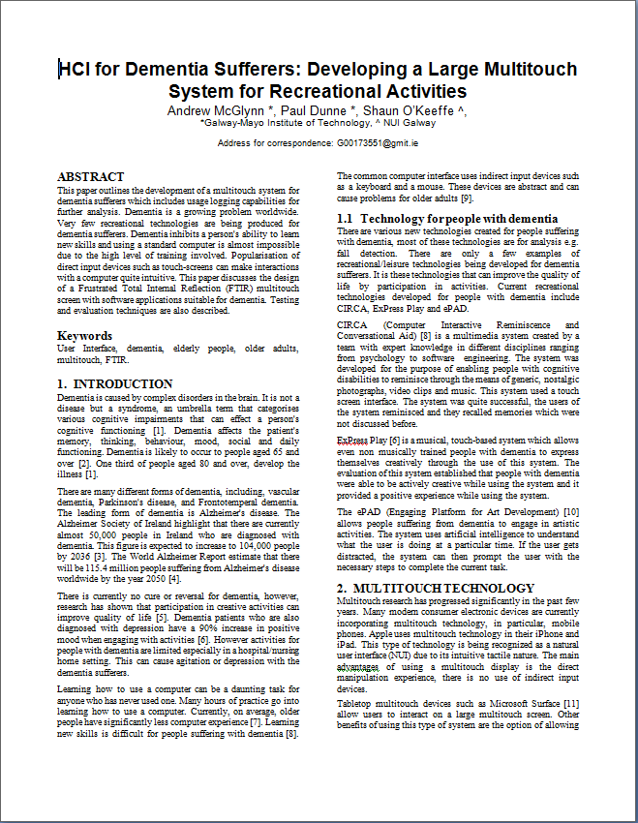

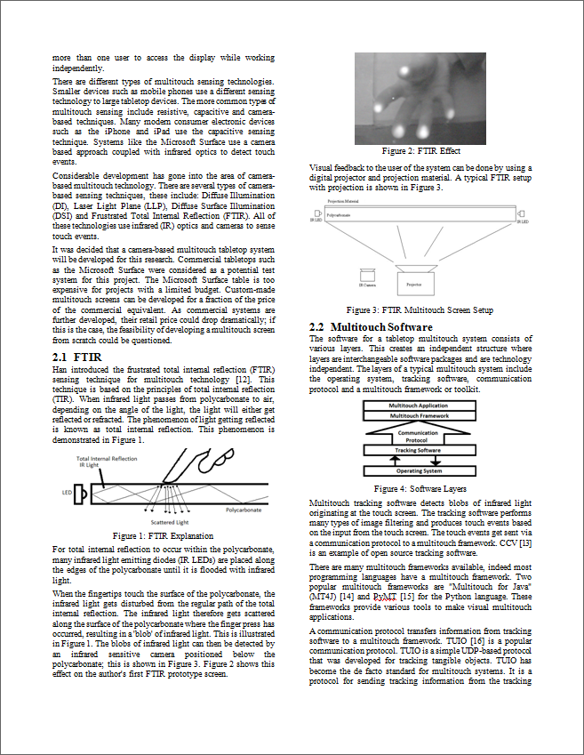

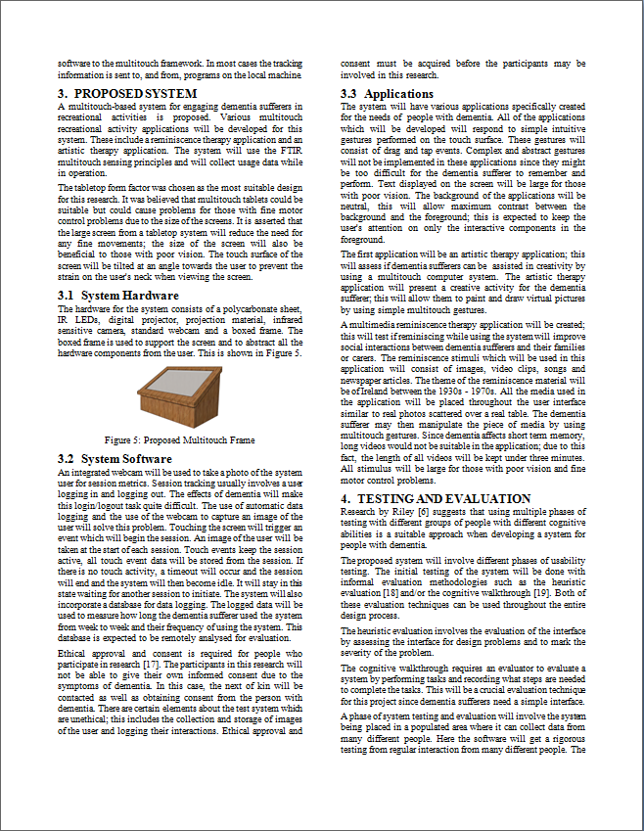

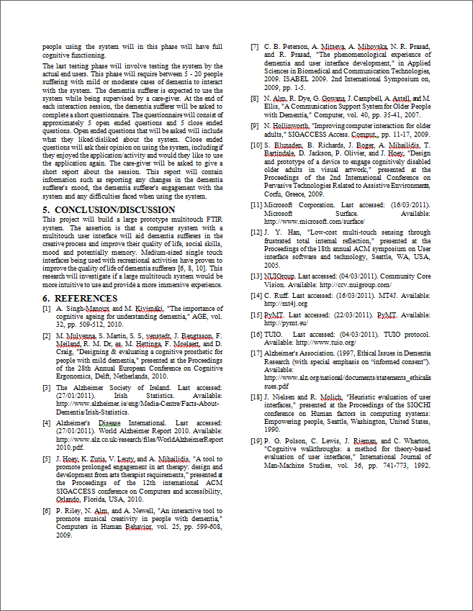

## Appendix C: Pilot Study Forms and Questionnaires

This section presents both the open-ended and close-ended questionnaires which were presented to patients after using the multi-touch system in Merlin Park Hospital, Galway, Ireland. Letters of invitation, consent forms and participant detail sheets are presented.

Assessment of Recreational Multitouch System

Dear ____________________

* You have recently used our system
* We want to know how you found using the system
* This will help us to improve and assess the system
* Please complete this short questionnaire and return it to the nursing staff
* Your reply will be treated as confidential
* Thank you for your cooperation

Yours Sincerely,

___________________________________

Andrew McGlynn

Researcher

**Questionnaires**

Name: __________________________________

Location: __________________________________

Date: __________________________________

Assistance Needed: Nurse/Family Member/Carer/Alone

Activity Used: Memory Montage /Painting Application/Game/Reaction test / Therapeutic Application

**Section 1**

1. Did you enjoy the session? *(Tick box)*

Don't know 

No 

Yes 

1. Would you use the activity again?

No 

Yes 

1. Would you use the system for a longer period of time (if available)?

No 

Yes 

1. Did you need help with this activity?

No 

Yes 

1. Was this activity easy to use?

No 

Yes 

**Section 2**

1. How would you change the system?

_____________________________________________________________________

1. What did you like about using the system?

_____________________________________________________________________

1. What did you dislike about using the system?

_____________________________________________________________________

1. What was fun about using the system?

_____________________________________________________________________

1. What was difficult about using the system?

___________________________________

**Consent Forms**

**Consent Form**

***Re: Enabling Creativity in Dementia Suffers Using Novel Human-Computer Interaction Mechanisms***

Please complete this form and return it, along with the Participant Questionnaire, using the stamped addressed envelope provided.

* I have read the information letter pertaining to this study and I understand what this study is about.
* I am aware that my participation in this study is both voluntary and anonymous.
* I agree to participate in this study.
* I am aware that interactions with the system will be recorded.
* I am aware that the research team will anonymise the results.
* I agree to share my system interaction results with the research team
* I am aware that my photograph will be taken when I am using the system

_____________________________ ____________________________

Name (please print) Signature Date

_____________________________ ____________________________

Researcher’s Name Signature Date

**Letters and Consent Form**

**PARTICIPANT INVITATION AND INFORMATION LEAFLET**

My name is Andrew McGlynn and I am from the Department of Electronic Engineering in the Galway-Mayo Institute of Technology. Thank you for reading this leaflet; this leaflet outlines a pilot study which will be taking place as part of a research project. For this research project, I will be collaborating in conjunction with Mr. Shaun O'Keeffe in the design, development and testing of a novel computer system designed for people suffering with dementia. We would like to invite you to take part in this study but before agreeing to do so it is important that you understand what your role will be and that any concerns you may have are addressed.

**Background**

Research has shown that participation in meaningful activities can improve quality of life. Dementia patients who are also diagnosed with depression have a 90% positive increase in mood when engaging with meaningful activities. However recreational activities for people with dementia are limited especially in a hospital/nursing home setting. This can often lead to agitation or depression with the dementia sufferers.

**What is the study about?**This study is attempting to see if a computer based system could provide people with dementia a means to enjoy novel recreational activities.

Participants in this study will use a number of the systems recreational/leisure activities.

The study will be measuring;

* the user’s sense of enjoyment
* their engagement with the system
* their sense of ease while using the system

We will be attempting to see if there is an improvement in the user’s mood and reduction in their anxiety having used the system. The participant is expected to have little or no previous computer skills.

**What will your role be?**

Your role will be to interact with the system as a recreational resource.

**Will I be identified in the study?**

The system will take your photograph. This photograph is used to differentiate people in the study. Once the identification has taken place, the photograph will be destroyed and your participation in the study will be anonymous.

**Study findings**

The data collected in this pilot study will be used in writing academic papers. Nobody will be identifiable using this data.

**Do I have to take part?**

Your participation in this research is completely voluntary. If wish to withdraw from the study, you may do so at any time.

**If I have other questions?**

Please feel free to contact me should you have any other questions or concerns before signing the consent form. My phone number is 087-7424330 and my email address is G00173551@postgrad.gmit.ie

If you decide to take part in this research please sign the consent form.

_______________________________________

Andrew McGlynn

Dept. of Electronic Engineering,

Galway-Mayo Institute of Technology,

Dublin Road,

Galway.

References

P. Riley*, et al.*, "An interactive tool to promote musical creativity in people with dementia," *Computers in Human Behavior,* vol. 25, pp. 599-608, 2009.

**Letter of Invitation**

Dear ________________________,

My name is Andrew McGlynn and I am in the Department of Electronic Engineering in the Galway-Mayo Institute of Technology. I am completing a Master’s Degree in Computer and Electronic Engineering. I am building a computer based recreational system for dementia suffers. I am trying to show that dementia suffers can use, enjoy and benefit from using this system. I am collaborating with Mr. Shaun O’Keeffe, Merlin Park, on this project.

Currently we are recruiting dementia patients for a pilot study which will take place in Merlin Park Hospital. I intend to gather data from patient’s interactions with the system. This type of data includes duration of use, recreational activities used and frequency of use.

The system will take your photograph. The photograph allows me to identify who is using the system. This photograph allows me to identify you as “Patient A” or “Patient B”. Once the identification has taken place the photograph will be destroyed and your role in this pilot study will be completely anonymous.

I also intend to get feedback from the users of the system through interviews and questionnaires. This will help to identify if the system is easy of use, if it is enjoyable to use, if there are any difficulties etc. I am most interested in your enjoyment of the system and your ease of using the system.

I would like to invite you to participate in this study. Your participation is completely voluntary. Should you wish to withdraw, you may do so at any time.

Further information on the study and your potential role is included in the accompanying information sheet.

Thank you.

Yours sincerely,

_________________________________________

Mr. Andrew McGlynn, B. Eng.

Dept. Electronic Engineering,

Galway-Mayo Institute of Technology,

Dublin Road,

Galway.

**Letter to next of kin**

Dear _________________

My name is Andrew McGlynn and I am part of the Department of Electronic Engineering in Galway-Mayo Institute of Technology. Currently we are recruiting for a pilot study. In this study, we wish to assess if novel computer systems with intuitive interfaces are suitable for people suffering with dementia. For this study, a novel computer based system with recreational/leisure activities will be provided.

While the system is operating, it collects information from the user discretely as they interact with it. The information collected will consist of duration of interaction, frequency of use and the system facilities used. A photograph of the user is taken by the system when they first interact with it. Any photos taken by the system will be destroyed once manual identification has taken place. Any information which will be collected by the system will be encrypted for maximum security. The research team members are the only people who may access this information. There are no hazards when using this system.

We would like to invite ______________ to participate in this pilot study. _________________'s participation in this study is completely voluntary. If _____________ wishes to withdraw from this study, he/she may do so at anytime.

Further information on the study and ________________'s potential role is included in the accompanying information sheet.

Thank you.

Yours sincerely,

_____________________________________

Mr. Andrew McGlynn, B. Eng.

Dept. Electronic Engineering,

Galway-Mayo Institute of Technology,

Dublin Road,

Galway.

**Consent Form**

***Re: Enabling Creativity in Dementia Suffers Using Novel Human-Computer Interaction Mechanisms***

Please complete this form and return it, along with the Participant Questionnaire, using the stamped addressed envelope provided.

* I have read the information letter pertaining to this study and I understand what this study is about.
* I am aware that my participation in this study is both voluntary and anonymous.
* I agree to participate in this study.
* I am aware that interactions with the system will be recorded.
* I am aware that the research team will anonymise the results.
* I agree to share my system interaction results with the research team
* I am aware that my photograph will be taken when I am using the system

_____________________________ ____________________________

Name (please print) Signature Date

_____________________________ ____________________________

Researcher’s Name Signature Date

**Participant Details**

|  |  |
| --- | --- |
|  | **Please clearly print your name here**  **Name ­­­­­­­­­­­­­­______________________________________________________________**  **Middle Initial:** |
|  | **Date of birth dd/mm/yyyy** |
|  | **Contact Phone Numbers**  **Work ___________________________________________________________**  **Mobile __________________________________________________________**  **Please indicate if there is a time of day when you would prefer to be contacted**  **_________________________________________________________________** |
|  | **Email address**  **____________________________________________________________________** |
|  | **Home Postal address** |
|  | **Gender- Please tick the appropriate box**  **Female  Male ** |

**Signature of participant:**

_____________________________________________________________________

## Appendix D: Multi-touch Hardware Development

### 

An in-depth explanation of the design and development of the multi-touch hardware solution used in the research is described. Comparisons of two multi-touch sensing technologies is presented and the tests which were conducted within the construction period.

**MTmini**

As a starting point to constructing a multi-touch table, a Multi-touch Mini (MTmini) was created. MTmini is an inexpensive multi-touch pad which was first developed by Seth Sandler[1]. MTmini was designed to test the various software components used in a fully functional camera-based multi-touch pad. The system consists of inexpensive hardware components which include: a sheet of plastic or glass, a sheet of paper, an empty cardboard box, a computer and a webcam. The glass and paper make up the touch surface of the MTmini. Paper is fixed on top of the glass using tape. The system uses diffuse illumination to detect multi-touch interactions. Diffuse illumination touch sensing commonly uses an IR light source positioned behind a touch surface; however this design uses ambient light from the surrounding environment to illuminate the touch surface. A webcam, positioned underneath the touch surface is used to sense interactions; this is presented in Figure 1(a). This is achieved by detecting shadows which are present on the touch surface. A cardboard box is then used to support the touch surface; this is shown in Figure 1(b).

|  |  |
| --- | --- |
| (a) MTmini camera | (b) MTmini |

Figure 1: MTmini

MTmini is simply an interaction mechanism and does not provide any visual feedback to the user, but it provides a valuable aid to in understanding camera-based multi-touch systems.

**FTIR Prototype**

After the successful implementation of the MTmini system, a miniature FTIR system was created to test the fundamentals of the FTIR phenomenon. The Siemens SFH 485 P is an infrared emitter and was assessed as a suitable IR emitter for an FTIR setup. The SFH 485 P datasheet states that the applications of this IR emitter include fibre optic transmission. Fibre optic technologies rely on the TIR phenomenon; this suggests that this IR emitter would also be suitable for an FTIR system.

An infrared camera was required to detect interactions with the touch surface. For a responsive multi-touch system, the camera needed to operate at high frame rates. However, IR cameras which operate at high frame rates can be expensive. After reviewing several cameras, the PlayStation 3 Eye (PS3 Eye) camera was chosen as the most suitable camera. The disadvantage of using this camera is that it contains an IR blocking filter. However, the camera can be easily modified to act as an infrared sensing camera; the steps involved in modifying the PS3 Eye camera are presented in Appendix D.

After obtaining the IR emitters and IR camera, it was possible to test the FTIR effect. The initial test involved shining a row of IR emitters into the edge of a polycarbonate sheet. The results from this test are shown in Figure 2. When finger tips would come into contact with the screen, blobs of IR light would be produced on the touch surface.

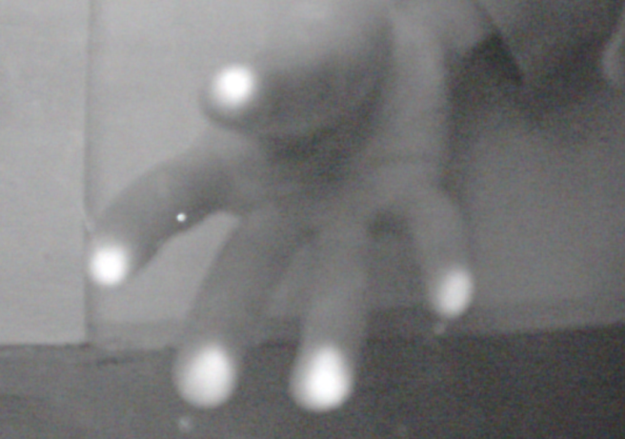

Figure 2: FTIR Effect

After triggering the FTIR effect, a small scale FTIR prototype screen was developed using the polycarbonate sheet, IR emitters, IR camera, digital projector and computer; this is presented in Figure 3. IR emitters were positioned at the edge of the polycarbonate sheet, as before. Tracing paper was fixed to the polycarbonate to act as the projection surface. The projector was directed at the tracing paper, providing visual feedback to the user. The camera was then used to track interactions with the screen. This test showed potential as a fully functional FTIR system.

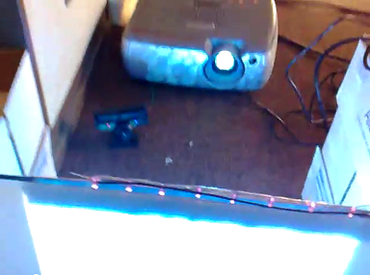

Touch Surface

(Polycarbonate & Tracing Paper)

IR Emitters

Projector

IR Camera

Figure 3: FTIR Prototype

**Large Scale FTIR Prototype**

A large multi-touch screen was constructed with a piece of polycarbonate. The dimensions were 1200mm x 900mm, giving an aspect ratio of 4:3. Polycarbonate was chosen because it is does not to scratch easily, in comparison to other plastic materials.

A wooden frame was built to hold and support the polycarbonate screen; the wooden frame is shown in Figure 4. The frame was later "boxed off" to hide the inner workings of the multi-touch system from the user.

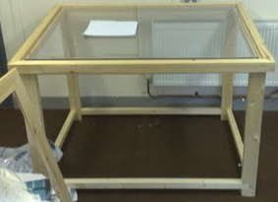

Figure 4: Touch-screen Frame

Mounting the IR emitters around the edge of the polycarbonate was accomplished with an aluminium L-Frame. Several holes were drilled into this frame to hold the IR emitters in place. The emitters were spaced approximately 25mm apart, providing enough IR light to trigger noticeable blobs of IR light. The aluminium L-Frame is shown in Figure 5.

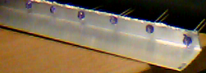

Figure 514: Aluminium L-Frame

168 IR emitters were used in the large scale prototype. Aluminium L-Frames were positioned at each edge of the FTIR system. The large scale FTIR touch surface can be seen in Figure 6.

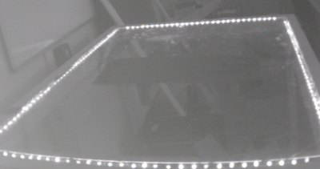

Figure 6: Large Scale FTIR Touch Surface

Displaying visual feedback on the underside of the polycarbonate surface was accomplished with a digital projector. Projection material was also affixed to the upper side of the polycarbonate.

There are several factors to consider when developing a system with digital projectors; Appendix E describes the factors involved in choosing a projector and projection material.

**Projector Selection**

Initial projector tests were conducted with the InFocus LP640 digital projector. This projector supports both 16:9 and 4:3 aspect ratios. The contrast ratio of the projector is 400:1. It has a throw distance from 1.6:1 up to 1.9:1. This projector operates in two modes of brightness, "High Bright" mode and "ECO" mode. High Bright mode has a brightness of 2200 ANSI Lumens; the brightness of ECO is not specified. The projector is compatible with VGA, SVGA, XGA, SXGA, SXGA+ but has a native resolution of XGA.

The InFocus is compatible with a throw distance of 1.6:1 - 1.9:1. With a screen of width 1200mm, the projector needed to be positioned between 1920 mm - 2280mm from the projection screen. This was tested by using a mirror to reflect the projected image on to the projection screen. The results from this test can be seen in Figure 7. Although it is possible to successfully project the image to the screen, an extremely large throw distance was required for this projector. This made it impractical to be used for the FTIR system. Another projector was chosen for the FTIR system. A projector was required that had a relatively short throw distance.

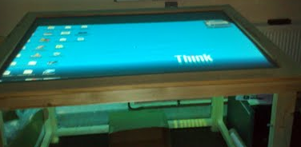

Figure 157: Using a mirror with the InFocus LP640 digital projector

The Hitachi ED-A220NM ultimate short throw projector was chosen as a suitable projector for this system. It has a throw ratio of approximately 0.35:1, which gives a throw distance of 420mm; this is sufficient for the FTIR system. The projector has two modes of brightness, Normal mode (1500 ANSI Lumens) and Bright mode (2200 ANSI Lumens). The native resolution of the projector is XGA and has a contrast ratio of 2000:1.

#### Comparison of Compliant Surface Overlay Materials

The purpose of a compliant surface is to mimic the properties of greasy skin. Dry skin generates a weaker blob of infrared light than greasy or wet fingertips. Rosco Dark Grey rear projection material was chosen as the projection screen and it was also chosen as the compliant surface overlay.

Although the screen gave reasonable results for projection, it provided poor results when it was tested as a compliant surface overlay. The Rosco projection material did not trigger the FTIR effect with "zero force". It required excessive pressure to trigger the FTIR effect. Due to the poor of the sensitivity of the Rosco material, a silicone layer was created as a compliant surface overlay.

Dean Segovis has documented his approach to applying a silicone based compliant surface onto projection material[2]. This approach requires thinning a silicone sealant by diluting it with a solvent, Xylene. The diluted solution is then rolled on to the projection material using a foam rubber paint roller, creating a fine silicone layer. The texture of the foam roller produces tiny bumps over the material. This method was thoroughly tested on the large scale FTIR system. Many different compliant layers were created by changing the ratio of Xylene to Silicone and using various numbers of silicone layers. These tests gave undesirable results due to the excessive force needed to trigger the FTIR effect. Although excessive force was still needed to trigger the FTIR effect, there was less force needed to trigger the FTIR effect (in comparison to having no compliant surface).

Further tests were conducted to improve the responsiveness of the compliant surface. Silicone was rolled onto the projection surface without being thinned. This test proved to give an unpleasant tactile feeling in comparison to the textured silicone. It also gave the similar results to the thinned silicone method, requiring excessive force to trigger the FTIR effect. This excessive force needed to interact with the surface would potentially lead to fatigue in the user's hands.

At this stage of the testing process, the silicone sealant product itself was replaced by aquarium grade silicone, containing 100% pure silicone. Similar tests were conducted with this product. There was not a noticeable difference between the aquarium grade silicone and the silicone sealant.

After many unsuccessful tests with silicone products, it was decided that another compliant surface overlay would be required. An online resource[3] suggested a product, "Fluid Film" acts well as a suitable compliant surface. This product comes in an aerosol which can be sprayed directly onto a polycarbonate surface. Fluid Film can then be smoothed out by rubbing it into the polycarbonate. The product produces a non-greasy layer which acts as a compliant surface. The product lubricates the user's fingers when they come into contact with the screen, generating IR blobs. The projection material was applied below the polycarbonate sheet. Some projection materials are unusable for this type of set up. The Rosco projection material absorbs too much of the IR light for it to be used as a suitable projection material.

Although Fluid Film worked well as a compliant surface, it deteriorated over time and needed to be reapplied to the polycarbonate surface. When the compliant surface starts to deteriorate, the screen becomes less responsive, making it undesirable for a compliant layer on most FTIR systems.

After researching and testing various materials as compliant surfaces, it was clear that the compliant layer determines the overall sensitivity and usability of an FTIR multitouch system. Due to the complex nature of constructing a responsive compliant surface, it was decided to abandon the FTIR sensing method and use a different sensing technique. The diffuse illumination sensing technique was chosen as a suitable alternative.

**Diffuse Illumination Prototype**

A small scale diffuse illumination prototype was constructed to test the properties and responsiveness of a diffuse illumination touch screen. The prototype consisted of a cardboard box with an infrared camera placed inside it. Eight IR LEDs were placed on the floor of the box and were directed upwards at the screen. Resting on top of the box was a sheet of polycarbonate and Rosco projection material was placed directly on top of the polycarbonate; this is shown in Figure 8. The prototype's touch sensing was tested but it was unsuccessful due to the Rosco projection material absorbing too much of the IR light. Diffuse illumination touch screens require projection screen to be transparent enough to allow some infrared light to pass through the material. The projection material must also be opaque enough to provide a clear, projected image. Tracing paper was used as a substitute projection material

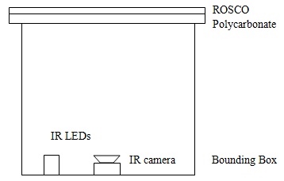

Figure 8: Prototype DI System

The most significant improvement with this sensing technique was that touch events could be triggered by zero force. After the success of the initial diffuse illumination prototype, the wooden frame used in the FTIR prototype was modified to support diffuse illumination touch sensing.

IR spotlights were developed by created a bank of IR emitters. The spotlights were strategically positioned and aimed at different parts of the screen to achieve even illumination and even touch sensing; this is presented in Figure 9. The software was then adjusted and recalibrated for optimal touch detection.

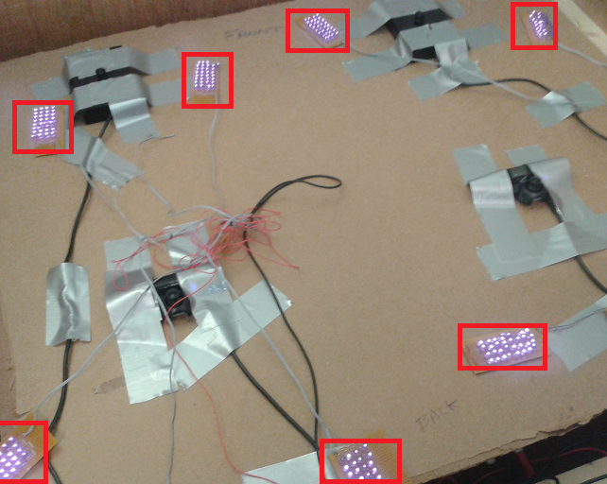

Figure 9: IR Spotlight Placement

Tracing paper was used for projection material. Fixing the tracing paper to the screen was done with double sided tape. This solution was satisfactory for short periods of time. The sheet would need to be reapplied every day before use, due to it sagging in the centre. The sagging of the tracing paper gave undesirable results; it caused the projected image to distort. The sagging also affected the sensitivity of the touch sensing, causing poor touch recognition.

Glass Static, a product by ***d-c-fix*** was used as an alternative to the tracing paper. The material is a white, semi transparent film made for providing extra privacy to windows. The film is held on to a surface by static electricity. This material was tested as projection material. It gave reasonable projection results but a visible hotspot was present when the system was run from the projector; this can be seen in Figure 10. This film was applied to the underside of the sheet of polycarbonate. Projection gave satisfactory touch sensing results but after approximately 36 hours of applying the film, it would start to loss the static bond with the polycarbonate sheet. The material would start to sag in various areas of the screen. This sagging resulted in the projected image getting distorted and the touch sensing would be less responsive.

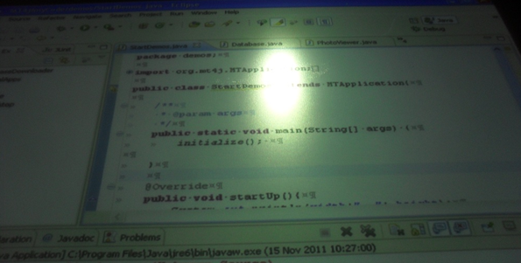

Figure 10: d-c-fix Film

A solution to the sagging problem with the d-c-fix film and tracing paper problems was to apply a material permanently to the polycarbonate sheet. *Humbrol* *Glass Etch*, an aerosol product for adding a frosted glass finish to a clear surface was tested. The aerosol substitute was tested which was tested on a small piece of polycarbonate. The aerosol was sprayed onto the polycarbonate in layers. After 12 layers of this product being sprayed onto the polycarbonate, it gave a white matt finish on the polycarbonate. This was tested for both touch sensing and for projection quality. It responded reasonably well to touch events and the projected image appeared clear with good contrast and colour range. Unfortunately, due to supplier issues, it was not possible to purchase more of this product. As a substitute, another similar product was purchased to produce a frosted glass finish on either glass or plastics. *Rust-oleum Frosted Glass* was a substitute product to replace *Humbrol Glass Etch*. The substitute product was applied to a large sheet of polycarbonate. This was applied in layer upon layer. After approximately 20 layers of this product being applied, it still produced poor results. The aerosol started to leave a grainy residue on the screen; also the residue was still transparent, making it unsuitable for a projection screen.

|  |  |
| --- | --- |
| (a) Humbrol Glass Etch | (b) Rust-oleum Frosted Glass |

Figure 11: Frosted Glass Aerosols

An alternative to applying the aerosols was to get a frosted glass finish applied to the polycarbonate through sandblasting. The polycarbonate was sandblasted by a glass decorating company. The sandblasted polycarbonate gave good results for touch detection. Although this acted well for touch detection, it gave poor results for when it was used as a projection screen. There was a significant hotspot present in the centre of the projected image but the outer area of the projected image had limited brightness and poor contrast; this can be seen in Figure 12.

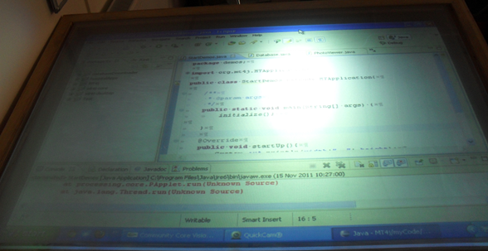

Figure 12: Sandblasted Polycarbonate Projection Screen

A professional white rear projection screen, produced by *Glimm Screens*, was tested both for sensing and projection capabilities. This screen was tested firstly as a projection screen and then secondly for touch sensing. The rear projection screen gave reasonable results when it was used as a projection screen. There was no hotspot visible to the user and the screen gave acceptable contrast between dark and bright colours; this can be seen in Figure 13. Touch sensing was impossible to achieve with this projection screen. The screen captures too much IR light, making unsuitable for diffuse illumination screens.

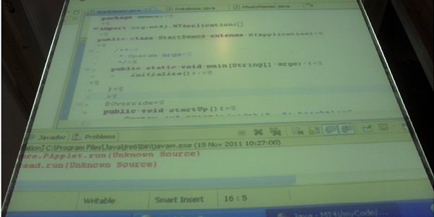

Figure 13: Rear Projection Screen from Glimm Screens

A professional rear projection film was selected for projection and touch sensing. The film was a dark grey rear projection material, produced by *ProLight Films*.



Figure 14: ProLight Dark Grey Film

The film had an adhesive layer on one side so that it could be applied directly to any clear surface. A thin plastic covering was applied to the adhesive layer, as shown in Figure 15. Applying the film to a surface requires the covering to be removed and the adhesive layer to be pressed on to the surface.

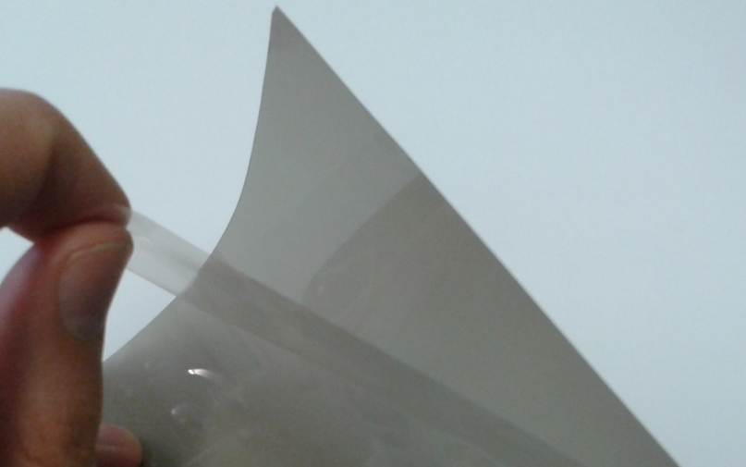

Plastic

Covering

Adhesive

Layer

Figure 15: ProLight Film Adhesive Layer and Plastic Covering

The projection film was professionally applied to polycarbonate. The film was rolled on to the polycarbonate using a rolling machine. Unfortunately, when the plastic covering the adhesive layer was removed, static electricity caused small grains of dust and dirt in the air to adhere to the adhesive layer; once the film was pressed on the polycarbonate, air bubbles were produced due to the grains of dust and dirt. This type of film would need to be applied in a cleaner environment (perhaps a clean room environment).

A frosted glass adhesive film was tested as a projection screen and touch surface. The frosted glass film had a small hotspot present in the projected image but it was not overpowering; this can be seen in Figure 14. The film worked well as a projection screen by providing acceptable but contrast was poor at some areas of the screen if there was much ambient light in the surrounding environment. This material also gave reasonable results when used as a touch surface.

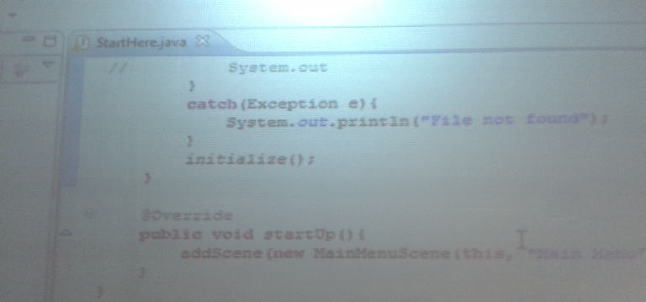

Figure 15: Frosted Glass Film Projection Screen

**Summary**

This paper described the construction and testing of both FTIR and DI multi-touch systems. Both of these sensing techniques have both advantages and disadvantages. The limitations of FTIR systems are that the sensitivity of the system is completely reliant on the compliant surface. DI systems provide zero touch but finding suitable projection screens proved to be difficult.

The final outcome was the construction of a 1200x900mm (59 inch diagonal) diffuse illumination multi-touch screen. The screen used four modified PlayStation 3 Eye cameras to detect interactions with the touch surface. Banks of infrared emitters were used to illuminate the touch surface from underneath. The multi-touch system responded well to touch sensing, as well as detecting objects and fiducials (optical tags).

## Appendix E: PlayStation 3 Eye Camera Modifications

The PlayStation 3 Eye (PS3 Eye) camera can be used as an inexpensive infrared camera with high frame rates. The camera typically operates at 60 frames per second (fps), but can operate at 120 fps with a lower resolution. This high frame rate makes it suitable for multi-touch tracking. The camera can be used on many of the major operating systems, including, Microsoft Windows, Apple OS X and some Linux distributions. Although the camera's high frame rates make it suitable for multi-touch sensing, the camera has an infrared blocking filter built into its lens. This is problematic for multi-touch systems that rely on infrared light for touch recognition. Although the camera blocks infrared light, it can be modified to act as an infrared camera. This document describes the steps involved in modifying the PS3 Eye camera.

Modifying the PS3 Eye camera required outer case to be disassembled and the circuit board to be extracted. The original lens, containing an IR blocking filter needs to be removed; this was done by unscrewing two screws securing the lens to the circuit board. The image sensor was then identified on the circuit board under the lens. The image sensor is shown in Figure 1.

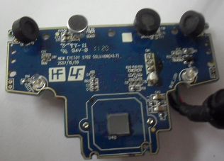

Image Sensor

Figure 1: PS3 Eye Circuit Board

After removing the original lens, the camera was able to detect both infrared and visible light. Detecting just infrared light required an infrared band-pass filter to be placed over the image sensor. This filter passes the infrared light component and blocks the visible light component. An 880nm band-pass filter was chosen as a suitable filter. The positioning of the filter is shown in Figure 2 (a). Visible light was filtered out because images from the projector would interfere with any image processing blob detection algorithms.

|  |  |  |
| --- | --- | --- |
| (a) Placing the band-pass filter | (b) Installing M12 Lens Mount | (c) Positioning Lens |

Figure 2: PS3 Eye Modifications

The filter was then fixed to the circuit board by it being positioned underneath the lens mount, shown in Figure 2 (b). The camera required a lens to focus the image. A 4.3mm lens was chosen as a suitable lens for this application. The lens was secured to the circuit board by fixing it to the lens mount; this is presented in Figure 2 (c). After all of these steps were completed, the camera functioned as an infrared camera with high frame rates.

## Appendix F: Projectors and Projection Materials

There are two main projection methods, front projection and rear projection. Both methods need a projector and a projection screen or surface. The main difference between these methods is the position of the projector relative to the viewer. Both front and rear projection setups offer their own advantages and disadvantages.

Front projection involves the projector being positioned in front of the projection screen. Most opaque surfaces can be used for front projection e.g. walls, floors, etc. The main disadvantage of this projection method is that if an object occludes the projection path, portions of the projected image are occluded. This setup is commonly used in cinemas and presentation halls. An example of front projection is displayed in Figure 1 (a).

Rear projection requires the projector to be placed behind the screen. Rear projection setups are less prone to image occlusion since objects are less likely to intersect the projection path. Typical opaque projection screens are not suitable for this display method. Rear projection setups require a particular type of projection material, known as rear projection material. Rear projection material is slightly transparent; this level of transparency allows the projected image to be viewed on both sides of the material. A rear projection setup is displayed in Figure 1 (b). The main disadvantage to rear projection setups is that there needs to be a large distance between the projector and the back of the projection material. However, this can be reduced using short-throw projectors.

|  |  |
| --- | --- |
| (a) Front Projection | (b) Rear Projection |

Figure 1: Front vs. Rear Projection

#### Projection Material

Projection material is the surface which displays the projected image. Projection material has different properties depending on whether it will be used for front projection or rear projection. Rear projection material tends to be more transparent than front projection material. Professional projection screens can be purchased from companies such as Glimm Screens[4]1, ProLight[5]2 and Rosco[6]3. Generally, professional projection screens can be expensive. Inexpensive solutions for projection screens can be found with common materials. An inexpensive solution for both rear and front projection material is paper. It provided sufficient contrast between the light and dark colours and also produces a clear projection image.

#### Throw Distance

The throw distance specifies the distance from the projector lens to the projection surface; this is presented in Figure 2 (a). The throw distance can be calculated by using the throw ratio. A throw ratio is the distance from the lens of the projector to the screen divided by the width of the projected image. The equation below can be used to calculate the throw distance; *d* is the distance from the lens to the projection surface, *w* is the width of the projected image and t is the throw ratio of the projector.

*d = wt*

The physical distance from the projector to the projection surface can be decreased and redirected through the use of mirrors; shown in Figure 2 (b).

|  |  |
| --- | --- |
| (a) Throw Distance | (b) Using a Mirror to decrease throw distance |

Figure 2: Projector Throw Distance

#### Aspect Ratio

The aspect ratio specifies the shape of the projected image. Commonly, the aspect ratio is written in the form A:B. This means that for every 'A' units of width, there will be 'B' units of height. Common aspect ratios are 4:3 and 16:9. Newer televisions are adopting the 16:9; these aspect ratios are shown in Figure 3.

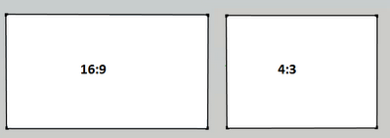

Figure 3: Common Aspect Ratios

#### Resolution

The resolution of a projector states how many pixels are displayed in the projected image. Resolution is usually measured as number of pixels wide multiplied by the number of pixels high. The picture detail is proportional to the number of pixels in the resolution. A common resolution is the Super Video Graphics Array (SVGA), which has a resolution of 800 x 600 pixels. Other common resolutions include the Extended Graphics Array (XGA) and the Super Extended Graphics Array (SXGA) which have 1024 x 768 pixels and 1280 x 1024 pixels respectively.

#### Contrast Ratio

The contrast ratio is a property which states the ratio of the brightness of the brightest colour in the image to the brightness of the darkest colour. Contrast is an important factor to consider when choosing a projector. Projectors with a low contrast ratio can produce images which are unclear and dull. Contrast ratio is typically documented as x:1. This means that the brightest colour (white) is x times brighter than the darkest colour (black). A high contrast ratio is typically required because it can produce more picture detail than a lower contrast ratio.

#### Brightness

The brightness states how bright the outputted image of a projector is. The brightness of a projector is measured in ANSI Lumens. There are different factors in choosing the brightness of the projector so choosing the brightest projector may not be the best solution at all times. The type of projection material, ambient lighting, and the application in which the projector is used are all factors which need to be considered when choosing a brightness of a projector. Brightness of projectors can vary from less than 2000 ANSI Lumens to upwards of 4500 ANSI Lumens.

## Appendix G: Community Core Vision

Community Core Vision (CCV) is an open source program which can detect and track interactions with multi-touch surfaces. CCV provides functionality to detect and track finger presses, objects and optical tags known as fiducials. CCV can interface with simple web cameras and also the PlayStation 3 Eye gaming camera. At the time of writing this document, the current version of CCV was version 1.5.

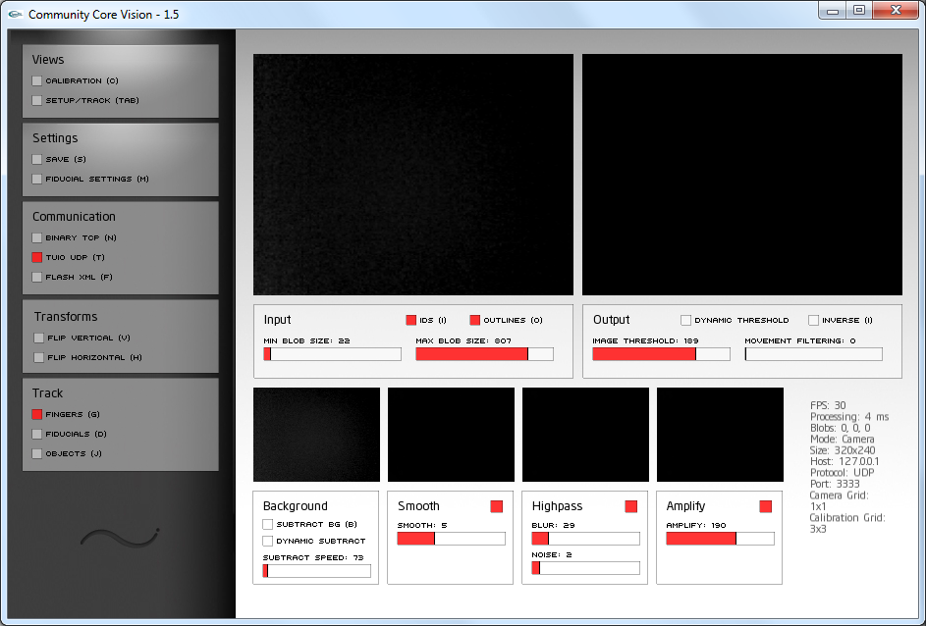

Figure 1: CCV V1.5 User Interface

Prior to version 1.4.1a, CCV only allowed input from a single camera. CCV version 1.4.1a[7]1, developed by Anatoly Churikov, provides flexible camera stitching functionality for multi-touch surfaces which use multiple cameras.

There are many stages in the CCV image processing pipeline, including the image source, camera stitching / calibration, background subtraction, smoothing, high-pass filtering, amplification, thresholding and tracking; these stages are presented in Figure 2. The first stage of the CCV pipeline involves receiving frames from the image source, typically one or more cameras. The next stage is camera stitching / calibration.

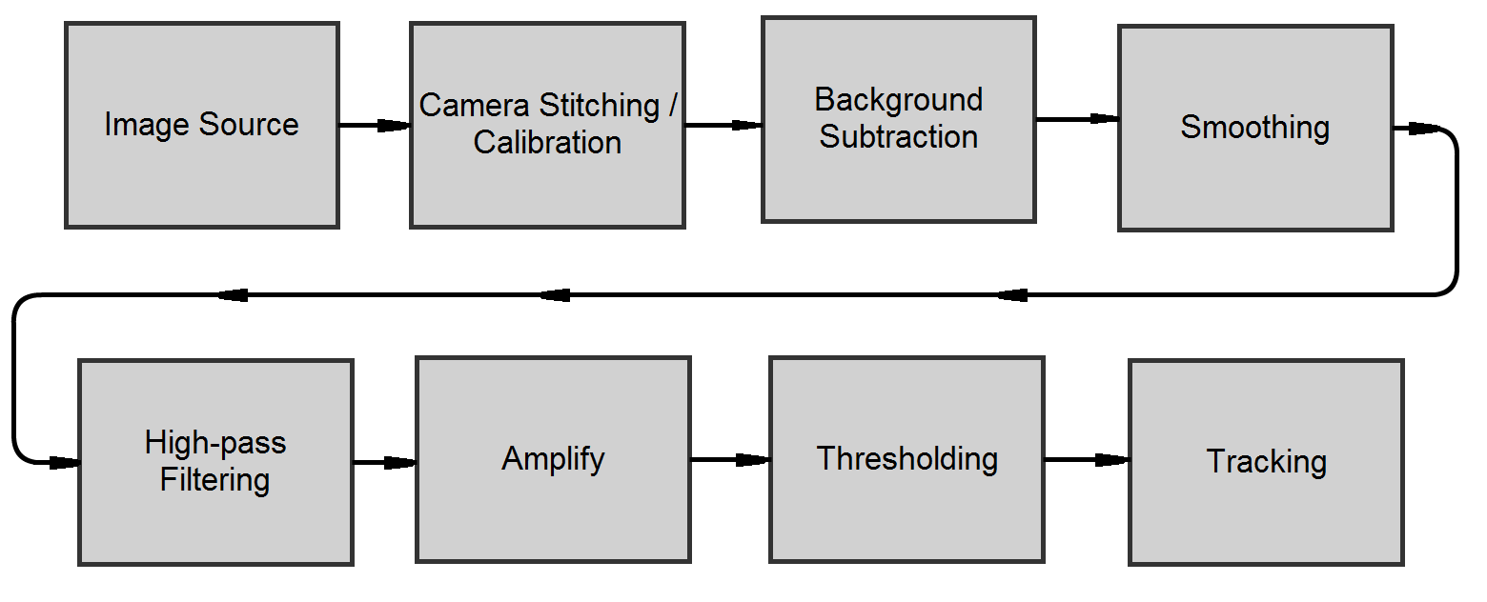

Figure 2: CCV Image Processing Pipeline

Camera stitching is a procedure which seamlessly stitches images produced by various cameras into one image. Figure 3(a) displays the feed from four cameras before image stitching operation has occurred. Figure 3(b) shows the resulting image after image stitching and calibration operation took place. The calibration stage translates the camera space to screen space and also marks out regions of interest and discards portions of the image outside that region. After these operations have occurred, a background subtraction is performed.

|  |  |
| --- | --- |
| (a) Before Camera Stitching | (b) After Camera Stitching |

Figure 3: Image Stitching

CCV provides functionality for dynamic or static background subtraction. Statically removing the background should be done when the screen is idle with no fingers or objects interacting with the screen. Dynamic background subtraction is used in environments where it is susceptible to environmental lighting changes. The process of dynamic background subtraction periodically subtracts the background image from the source image. After the background subtraction has taken place, the resulting image is passed to the smoothing stage.

Smoothing is an image processing operation which removes or reduces some random noise that is present in the image. The resulting image from this operation is passed to a high-pass filter.

High-pass filtering is typically used to sharpen the edges contained within an image, by enhancing contrast between different areas of the image. This operation removes blurry parts of the image, leaving only shaper parts of the image. The filtered image is then passed to an amplification stage.

The amplify stage amplifies weak pixels within the image. This operation scans through the image and tests if there are weak pixels, if there are, the amplification stage will make the pixel colour stronger.

The final stage of the filtering pipeline is the thresholding stage. Thresholding converts a greyscale image to binary image resulting in the output image only consisting of black and white pixels. The resulting thresholded image is then used to detect fingers, objects, and fiducials. Once interactions are detected, they are compared to the previous frame for tracking purposes.

The tracked data is then broadcasted by CCV to allow multi-touch frameworks to receive the multi-touch data. CCV can communicate the data in different formats including, TUIO, raw binary, and XML.

1. Multi-touch Mini (MTMini) - How To: http://sethsandler.com/multitouch/mtmini/
2. Casting Textured Silicone: http://nuigroup.com/forums/viewthread/2383/
3. One quick tip to super improve your FTIR multi-touch: http://nuigroup.com/forums/viewthread/11629/
4. 1 Welcome to Glimm Screens: http://www.glimmscreensinternational.com/
5. 2 Prolight Films: http://prolightfilms.com/
6. 3 Rosco Laboratories: http://www.rosco.com
7. 1 http://nuigroup.com/forums/viewthread/12393/